Unit E – Year 4 – Jesus Light of the World and Beloved Son
Unit scripture
Lk. 2: 22-40 – The Presentation of Jesus in the Temple Mt. 3: 13-17 – The Baptism of Jesus Mt. 7: 1-3 – The Transfiguration of Jesus Lk. 9: 25-36
The Presentation of the Lord:
https://www.youtube.com/watch?v=ho_3gvIWzbw Saddleback Kids
The Baptism of Jesus:
https://www.youtube.com/watch?v=88JYcN2-FiQ
https://www.youtube.com/watch?v=lMzlB185JSc Superbook
https://www.youtube.com/watch?v=n-omZQ5NOHs -The Miracle Maker

The Transfiguration of Jesus:
https://www.youtube.com/watch?v=D302i8nPnGs Share Faith Kids
https://www.youtube.com/watch?v=sT-S1F3gsVI LEGO

Scripture and teaching activities:
https://missionbibleclass.org/new-testament/part1/life-of-christ-middle/transfiguration/

Baptismal ceremony:
www.bustedhalo.com/video/baptism
https://www.catholicicing.com/catholic-baptism-video/ American ceremony
http://flameoffaith.org.au/baptism/ Australian ceremony

Key questions
Read the piece of scripture for:
Lk. 2: 22-40 – The Presentation of Jesus in the Temple
Mt. 3: 13-17 – The Baptism of Jesus
Lk. 9: 25-36 The Transfiguration of Jesus
What are the main events?
What do we learn about Jesus in these pieces of scripture?
What do you think it means when Jesus is called the Light of the World?
What do you think it means when Jesus is called the Beloved Son of God?
How is Christ like a light for people today? Can you give some examples?
Can you explain the meaning of the symbols of baptism?
What do you think is the most powerful symbol used in baptism and explain why?
Why do you think parents have their children baptised?
What are the beliefs about God the Father, God the Son and God the Holy Spirit expressed in the Baptismal Promises?
Catholics are baptised with water and enrobed in a white garment. Why is this?
Activities
Write down three little pledges (promises) that you are going to keep to be Christ-like, a shining light in the world.
Pinterest printable candle template for activity:
https://www.pinterest.co.uk/pin/63331938493397964/

Draw a cartoon strip of:
The Presentation of Jesus
The Baptism of Jesus
The Transfiguration of Jesus
Research some religious artwork of Jesus’ baptism, below are three examples:
e.g. https://www.heqiart.com/store/p59/17a_Baptism-of-Jesus_Artist_Proof.html

What is the artist trying to say about Jesus and Baptism in this painting?
Record any questions which you wonder about this unit or anything you are puzzled by.
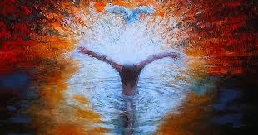
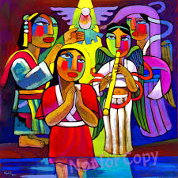

He Qi – Baptism of Jesus Unknown - Baptism of Jesus

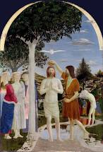

Piero Della Francesca: Baptism of Christ

