Unit E – Year 2 – Parables and Miracles
Unit scripture
Jn. 2: 1-2 – The Wedding Feast at Cana - https://www.youtube.com/watch?v=7plJa_qnVug (SaddleBack Kids)
Mk. 4: 35-41 – The Calming of the Storm - https://www.youtube.com/watch?v=ZzPwRXytr7U (Kidshub TV)
Lk. 7: 1-10 – The Healing of the Centurion’s Servant - https://www.youtube.com/watch?v=kyJ5w9cXjBQ (The Holy Tales: Bible)
Mt. 25: 14-30 – The Parable of the Talents - https://www.youtube.com/watch?v=UbLAZDPu3Pg (Lifekids)
Mk. 4: 1-9 – The Parable of the Sower - https://www.youtube.com/watch?v=oKdpM41cCJA (The Animated Bible)
Lk. 15: 11-32 – The Parable of the Prodigal Son – https://www.youtube.com/watch?v=DJgROx4wFKM&t=150s (Saddleback Kids)
Lk. 12: 22-30 – The Birds of the Air and the Lilies of the Field - https://www.youtube.com/watch?v=XgAVWKqcyMU (LifeKids)
Parables of Jesus Video – 15 minute lesson (https://www.youtube.com/watch?v=dcBR3JoaAAs – SaddleBack Kids)
Sacrament of the Sick – https://www.youtube.com/watch?v=aGVym96GWW0 – (Theo Matters)
Suggested Activities

- Research the Catholic Sacrament of the sick.
- Lead a time of prayer for those that are sick with family at home
- Make a list of the miracles you can remember and explain what was extraordinary about each miracle.
- After watching the miracles, record the miracle of each story, give reasons why Jesus performed the miracle. What was the reaction of those who witnessed what happened?
- Choose one of the stories, write a report and include why people asked Jesus for help and what we learn from each story.
- Look at some artwork for some of the miracles. Which is your favourite and why? Which picture best represents the Bible text.
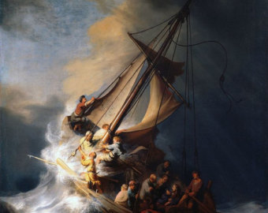
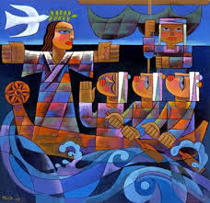
He Qi – Calming of the Storm Rembrandt – Storm of the Sea of Galilee

Key Questions
What do you wonder about Jesus’ miracles?
How would you react if a miracle happened in front of you?
If you were to pray for a miracle, what would you pray for?
Why do you think we use oil to anoint a sick person?
What makes a good teacher?
How did Jesus teach?
How does the parable of the sower tell us something about the choices we make?
Out of all the stories, which did you prefer and why? Which one told you the most about Jesus?

