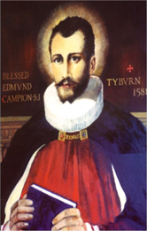 St. Edmund Campion Pray for Us

Dear Parents and Carers

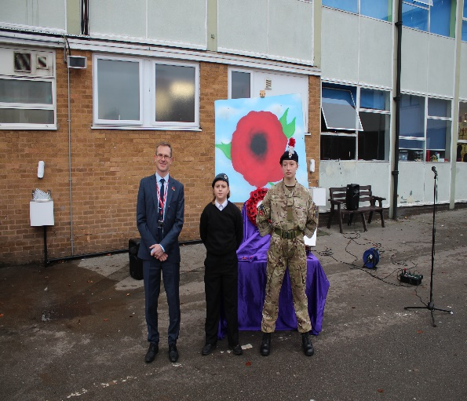
The school day on Wednesday 11th November began with a Service of Remembrance in the playground for each year group. It was a very prayerful, respectful and moving experience with two of our students, representing the Army and the Royal Airforce in their roles as cadets, laying a wreath in honour of those who gave their lives in war for our freedom.
Each form class then watched and listened to an ‘Assembly for Remembrance’ that had been prepared by Class 7I assisted by Mrs. Quoroll. Thank you to Class 7I for sharing this with us. The presentation can be viewed on the further attachment to this parentmail.

At 11am the school fell silent for two minutes.
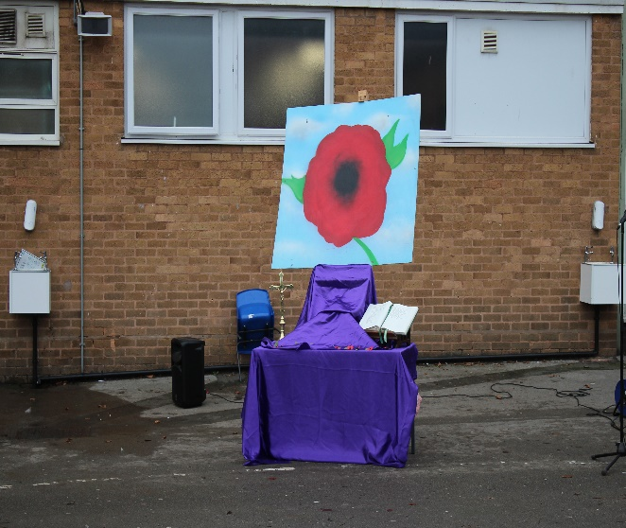
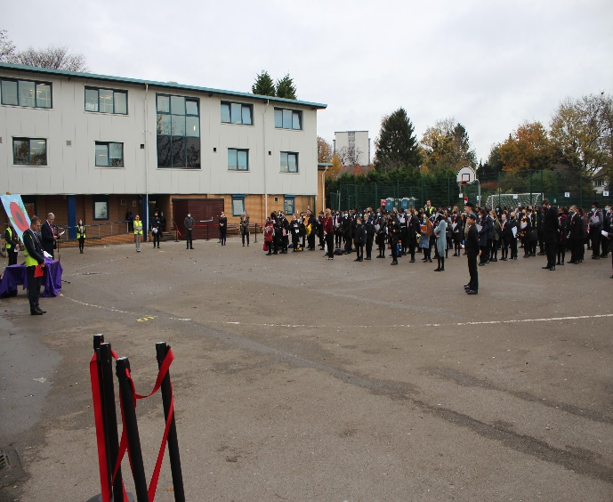

It’s been a few weeks now since the clocks were turned back an hour to mark the end of summer time and the beginning of winter. What this means is that darkness comes more quickly each evening and we need to adjust to the light disappearing. It’s not until we don’t have something that we appreciate it all the more.
Light is important for life, and is an important symbol of hope. Within Christianity this is signified clearly when Jesus says, ‘ I am the light of the world, whoever follows me will have the light of life and will never walk in darkness. ‘ (John 8:12)

Light is also an important element of other religious faiths. Diwali this year falls on Saturday 14th November, and is a festival of lights. The word Diwali means ‘a row or cluster of lights’ and the festival is celebrated by Hindus and Sikhs where homes are decorated with lights, there are firework displays and gifts are exchanged.

Above all there is hope for the future.

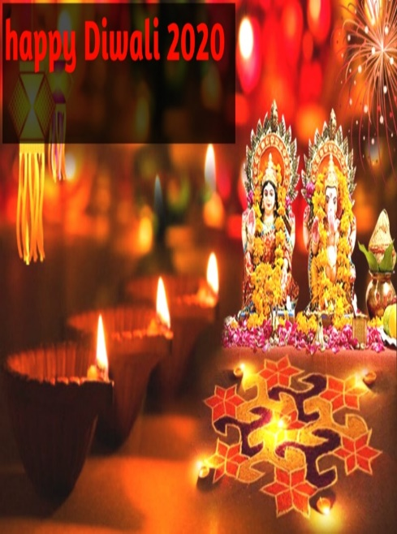
The Times of India summed up the meaning of Diwali:
‘ Regardless of the mythological explanation one prefers, what the festival of lights really stands for is a reaffirmation of hope, a renewed commitment to friendship and goodwill, and a celebration of the simple – and some not so simple – joys of life.’
As with the Christian celebration of Easter this year Diwali is taking place at a time when the usual form of celebrating the Festival of Lights may be different. We pray that our Sikh and Hindu brothers and sisters are still able to participate and enjoy this important festival of light and hope throughout the world.

Churches in the Chapel
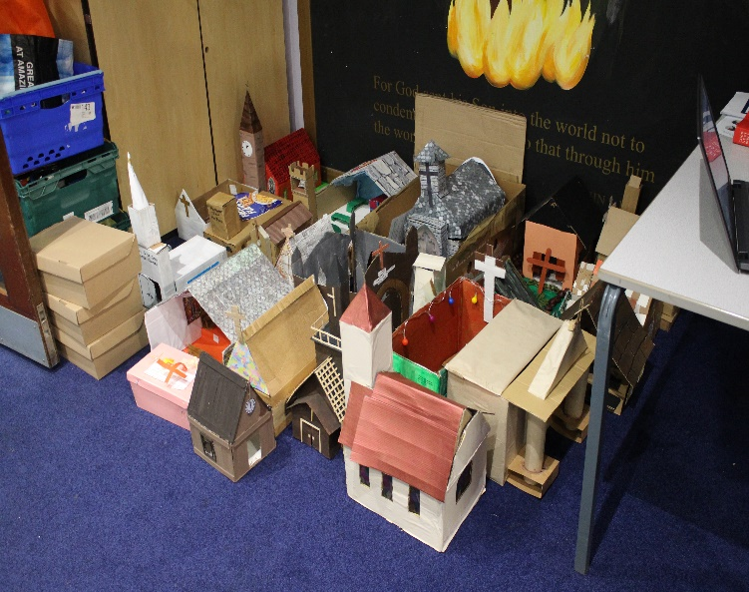
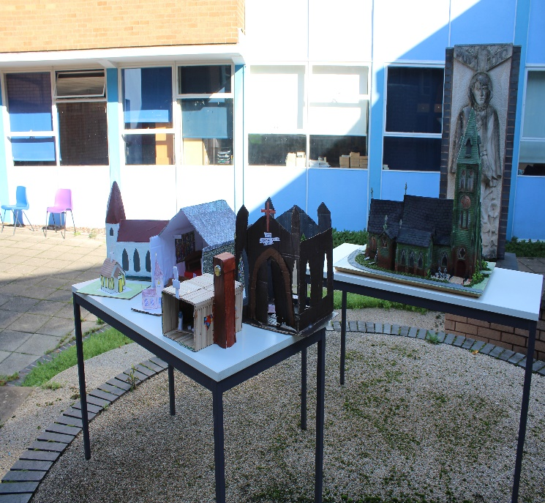
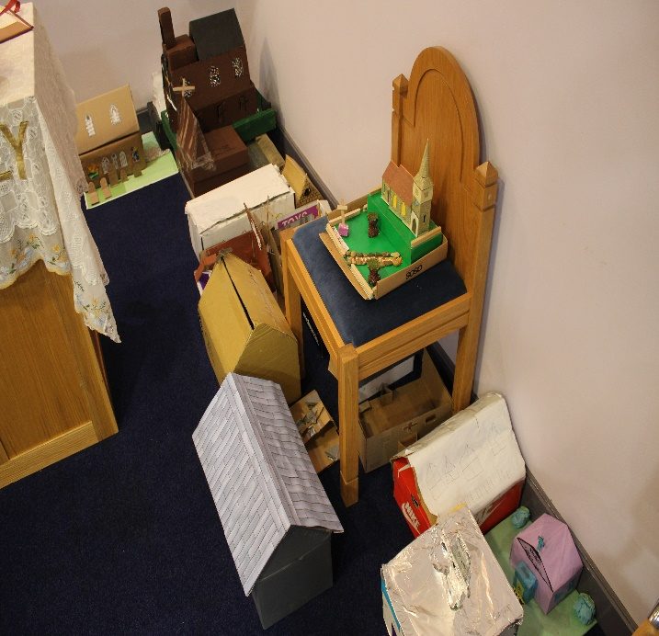
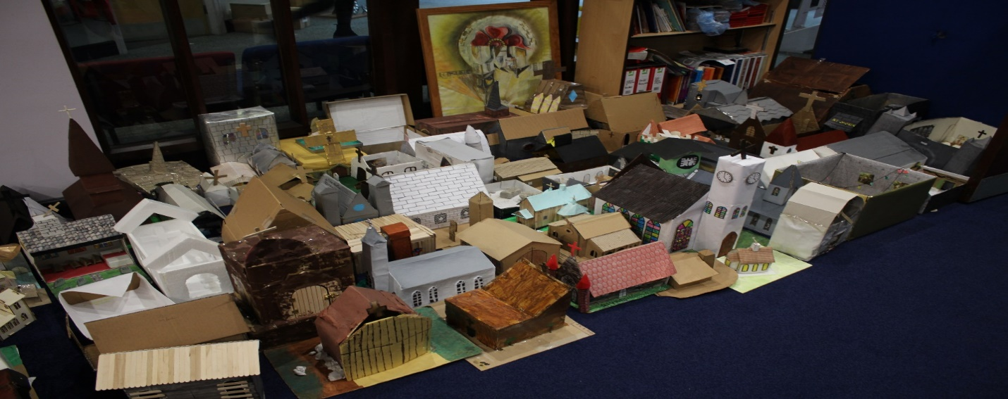
Our Year 7 group were given a homework project before the half term break to create a 3D Church. The results were fantastic as you can see from the photos below. We have a mixture of modern and traditional interpretations of the Church building using all sorts of different materials all currently being kept in the School Chapel. Well done to everybody for their efforts!

What’s Going On in our Local Parish Communities

Here is a link to the Erdington Abbey newsletter:
http://www.erdingtonabbey.co.uk/eacontent/uploads/2020/11/Bulletin-32nd-Sunday-in-Ordinary-Time-8-Nov-2020.pdf

Here is a link to the parish newsletter of St. Nicholas Church in Boldmere:
https://www.stnicholasboldmere.co.uk/uploads/6/2/5/9/62597781/32b.pdf

Here is a link to the parish newsletter of St. Margaret Mary’s Church in Perry Common:
https://www.stmgtmry.bham.sch.uk/newsletters/parish201108.pdf

Here is a copy of the parish newsletter of Christ the King Church in Kingstanding:
Here is a link to the parish newsletter of Holy Cross & St. Francis Church in Walmley:
https://www.hcsf.org.uk/bulletin-for-the-week-beginning-8th-november-the-thirty-second-sunday-in-ordinary-time/

Mass Online
You will be able to access mass each day and every Sunday streamed live from St. Chad’s Cathedral and here is the link to access these:
www.stchadscathedral.org.uk

Redemptorist Publications also continue to make Sunday mass available online after 12 midday every Saturday. Mass is celebrated by Fr. Denis McBride C.Ss.R from the Redemptorist community in Chawton, Hampshire.
www.rpbooks.co.uk/holy-mass-online

This Sunday, 15th November is designated in the church’s year as the World Day of the Poor. In his thoughts on this, when we are asked to remember and pray for all those in the world who struggle to live each and every day, Pope Francis says:

‘Now is a good time to recover the conviction that we need one another, that we have a shared responsibility for others and the world. Until we revive our sense of responsibility for our neighbour and for every person, grave economic, financial and political crises will continue.’
Gospel Reflection – 33rd Sunday in Ordinary Time– Matthew 25:14-30

Each and every person is unique. There are no two people the same. As we are created in this way in the image of God we each have gifts and talents that we need to nurture, develop and use for the greater good.

The message in today’s gospel is a simple one. Our unique gifts and talents should not be hidden away and never used.

Education by definition is about being taught things and learning things and of course schools exist to provide this. However, they should also be places where we begin the process of discovering and understanding our
gifts and talents. Schools should be places where we are nurtured to develop these talents and not be afraid to allow them to grow so that we can become the best that we can be.

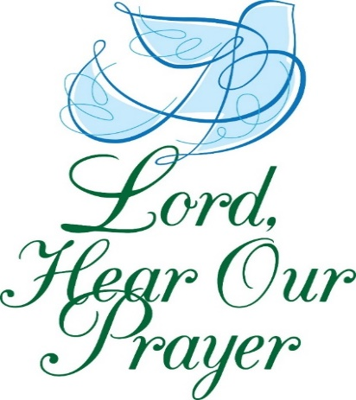
Let us Pray

Heavenly Father,
we thank you for the
gifts and talents that
you have blessed us with.
We ask that you help us
to treasure them and
use them for your glory.
Amen.

