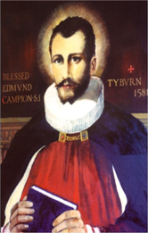 St. Edmund Campion Pray for Us

Dear Parents and Carers
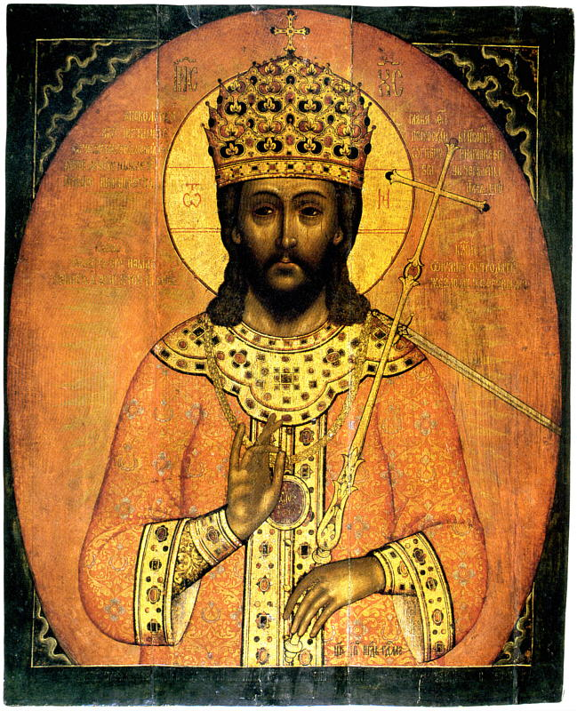
This coming Sunday the church’s liturgical year ends, and we conclude the year with a solemnity where we honour Jesus as Christ the King.
Within the context of the history of the church it is a fairly new feast and title, which was established by Pope Pius XI in 1926. Pope Pius XI served as Pope at a time when the First World War had only recently ended. However, although the fighting had stopped a true peace had not been achieved and he believed that this could only happen through seeing Jesus as the ‘Prince of Peace’.
To paraphrase his encyclical ‘Quas Prima’, in which Pope Pius XI explained the title of ‘Christ the King’ – ‘if Jesus has been given all power in heaven and on earth and that this power embraces us all, then every part of us should be used to praise him. He must reign in our minds, in our wills, in our bodies and in our hearts.’
The church has always tried to help our understanding of Jesus the Son of God in human terms. Pius XI was no different. People are aware of what a king is, of the power that they can have and the respect that is due to them because of that position. Pope Pius wanted to use that in his description of Jesus to show the world what kingship should actually look like.
It is worth noting that Jesus himself did not refer to himself as a king. The first person to do that was Pontius Pilate when he ordered that a sign be put above his head on the cross that read ‘King of the Jews’. This links the promise to King David in the Old Testament that he would have a successor but with a significant difference – that his kingdom would last forever.
As the church’s year comes to an end with us proclaiming Jesus as the King of the Universe, the new one begins with Advent in preparation for Christmas when we celebrate the birth of Jesus and give glory to the new-born King.
National Youth Day

This Sunday, the feast of Christ the King, is also National Youth Day. The theme of this day throughout the country is being ‘Together’. A video has been produced to help families focus on the importance of being together and praying together. The link for this video from the Birmingham Diocesan Trust can be found below and can be used to bring everyone together at a time when being apart from people we love and care about is something that everyone is experiencing:

https://youtu.be/FlonXWKmnRA

“To come out of this crisis better than before, we have to do so together; together, not alone. Together. Alone no, because it cannot be done. Either it is done together, or it is not done. We must do it together, all of us, in solidarity.”
Pope Francis, September 2020

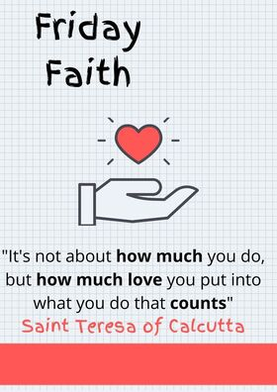

What’s Going On in our Local Parish Communities

Here is a link to the Erdington Abbey newsletter:

http://www.erdingtonabbey.co.uk/eacontent/uploads/2020/11/Bulletin-33rd-Sunday-in-Ordinary-Time-15-Nov-2020.pdf

Here is a link to the parish newsletter of St. Nicholas Church in Boldmere:

https://www.stnicholasboldmere.co.uk/uploads/6/2/5/9/62597781/33.pdf

Here is a link to the parish newsletter of St. Margaret Mary’s Church in Perry Common:

https://www.stmgtmry.bham.sch.uk/newsletters/parish201115.pdf

Here is a copy of the parish newsletter of Christ the King Church in Kingstanding:
Here is a link to the parish newsletter of Holy Cross & St. Francis Church in Walmley:

https://www.hcsf.org.uk/bulletin-for-the-week-beginning-15th-november-the-thirty-third-sunday-in-ordinary-time/

Mass Online
You will be able to access mass each day and every Sunday streamed live from St. Chad’s Cathedral and here is the link to access these:
www.stchadscathedral.org.uk

Redemptorist Publications also continue to make Sunday mass available online after 12 midday every Saturday. Mass is celebrated by Fr. Denis McBride C.Ss.R from the Redemptorist community in Chawton, Hampshire.
www.rpbooks.co.uk/holy-mass-online

Gospel Reflection – Our Lord Jesus Christ, King of the Universe – Matthew 25:31-46
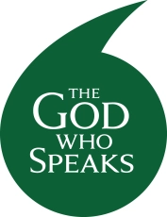
Trying to describe God is at the heart of the bible stories in the Old and the New Testament. It is also something that the great scholars and theologians of the Church wrestled with, and tried to interpret, so that we can begin to understand who God is and what God is like.

Our problem is that we can only think of God within the constraints of our human existence here on earth.

In the gospel this week Jesus tells a parable that cuts through this dilemma of understanding the divine from our everyday life experiences by emphasising that each of us are created in the image of God.

How we treat and look after one another with this knowledge will determine whether we have seen God and be welcomed into the Kingdom that has been prepared for us.

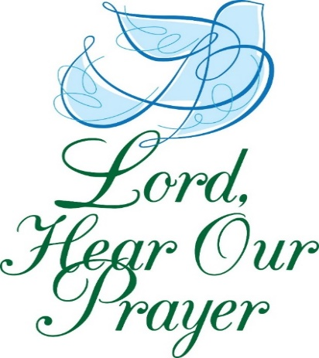
Let us pray

Almighty ever-living God,
whose will is to restore all things
in your beloved Son, the King of the universe,
grant, we pray, that the whole creation,
set free from slavery, may render your majesty service and ceaselessly proclaim your praise.
Through our Lord Jesus Christ, your Son,
who lives and reigns with you
in the unity of the Holy Spirit,
one God, for ever and ever . Amen
(Opening Prayer from the mass of Christ the King)

