*Wellbeing*



**St Benedict’s**

Catholic High School and Sixth Form

**Is*sue 2***

Building resilience…

*Psychological resilience* is defined as an individual's ability to properly adapt to stress and adversity. Stress and adversity can come in the shape of family or relationship problems, health problems, school or financial worries. Resilience is not a rare ability; in reality, it is found in the average individual and it can be learned and developed by virtually anyone. Resilience should be considered a process, rather than a trait to be had.

How can I achieve it?

To be resilient you need to experience 8 of 10 emotions on a regular basis:

1. **Joy; Gratitude; Serenity; Interest; Hope; Pride; Amusement; Inspiration; Awe; Love.**
2. These don't always find you. You have to be pro- active in seeking them out! Take time to think… Do you feel these emotions regularly? Why not? What can you do (more of) to feel these? What do you need to stop doing to feel these?

Am I resilient?

If you are unsure if you are resilient or how resilient you are, have a go at the quiz below…

<https://www.schoolwellbeing.co.uk/uploads/chronicler/document/document/434/Resilience_Quiz.pdf>

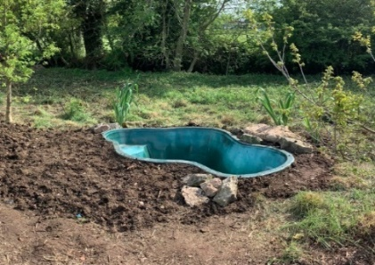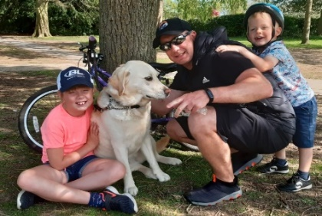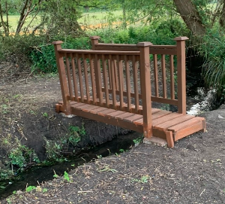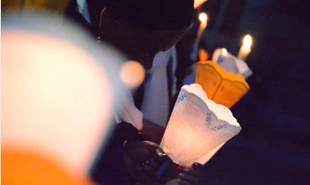

**Next addition… If there is anything you would like to see on the next newsletter or have anything you would like to share please email: fisher.f1@st-benedicts.org**

Connect… with your family…

What is Mr Singleton doing in Lockdown?

*“The Singleton’s have gotten into a good routine that involves the following: Home-schooling; morning walks to horses and cows with my son Will; cycling and running for exercise; visiting train stations to see trains with Will; Walking/ exercising guide dogs for a family friend and working on some gardening and landscaping projects’*

Mr Singleton has found spending time with his family and forming a routine really beneficial during this difficult time. Have you found spending time with your family helpful? What routines have you build into your day? What could you do to try to build a routine into your day?

… with your Faith…

Half term week has seen a first: The Diocesan’s first **VIRTUAL** pilgrimage to Lourdes! I know some of you (myself included have joined in this pilgrimage) from your home. It is so awe- inspiring to know that we are part of a community who share in prayer and the hopefulness that the Covid 19 pandemic will be over soon.

“Having found a personal faith, I developed resilience based on the hope of my faith as well as the personal inner strength we believe is divinely given, not a force but a person, a friend who I could tell anything to.”

Anonymous

Our Diocesan Ministry for youth- Kenelm Youth Trust has put together a special lockdown ministry over this time- here is the link:<http://www.kenelmyouthtrust.org.uk/lockdown-ministry.html>

Well worth a visit as they are offering spiritual support especially designed for young people!

Taking Notice… Building resilience**:**

*A gratitude diary*

Use a resource like a gratitude diary to help you to recognise and appreciate the positive things that are happening for you at the moment.

For example, on one day write down:

1. Something I accomplished today ...
2. Something funny that happened today...
3. Someone I am thankful for today…

**Focusing on positive things like this will lift your mood- focussing on the positive forces the negative thoughts away!**

**“It’s not happy people who are grateful, but grateful people who are happy”**



Keep Learning…

Trying a new skill or brushing up on a hobby or skill you already have is an excellent way OR improving your mood!

Here are what some of your peers have recommended that is working well for them…

***“I can suggest Quizlet or Kahoot which are learning apps - Quizlet is great for Spanish flashcards, and Kahoot has lots of fun, short quizzes on a range of different subjects.”*** Aisling McVeigh 10M

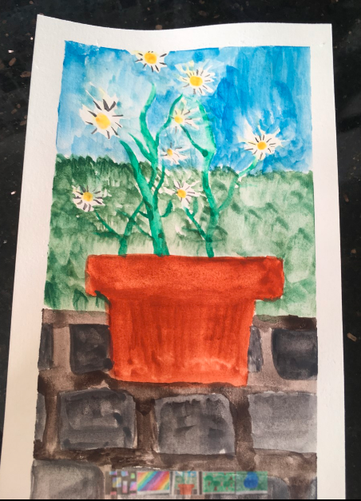



What new skill could you try this week?

Give… Making new friends

Since lockdown started, myself and my children, along with other families in my village, have been corresponding with the residence in our local nursing home. Our village school has close links with the nursing home and we wanted to keep this up.

With a new topic each week we create something for the residence; artwork, poetry or even a letter- anything really! It is safely collected on a Friday and there is a fresh delivery on the following Friday for us to collect. We have made friends with two ladies: Joyce and Dee. My girls think they are wonderful as they write cards to them and attach stickers (my girls are 5 and 7 so stickers are perfect!) We have sent them pictures, paintings, letters, stories; we had to write about our pets (Toffee our cat and Biscuit our puppy). We even sent posters and bunting for VE Day. We have loved building our friendship with our nursing home friends and we look forward to receiving our letters and news from them. It is something we are going to keep up once we return to school: keep writing to our pen pals a real positive in these strange times.





Staff have also been busy too! This week Mrs Williams wanted to share a hobby she has been working on- a stunning embroidery project:

Roisin Bokota has been spending time on her hobbies at home; particularly painting- she is very clearly talented!

Be Active…

Have you visited the **Action for Happiness** website yet?! Its brilliant! I have attached a link to their calendar for June -you can download it from the site <https://www.actionforhappiness.org/joyful-june>

A daily action designed to bring positive mental health through appreciating what we have in our lives.

They also have an app to download <https://www.actionforhappiness.org/app>

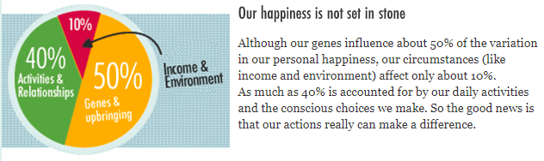

Where to access support…

**@school:**

[Wheeler.k1@st-benedicts.org](mailto:Wheeler.k1@st-benedicts.org) Miss Wheeler

<https://www.st-benedicts.org/family-support/>

**Your Form Tutors (just type their surname into your school email)**

**Outside organisations:**

If you are struggling at the moment mentally and feel that family and school are not where you want to get advice and support, perhaps contact:

Young minds: [www.youngminds.co.uk](http://www.youngminds.co.uk)

Childline**: 0800 1111**

Kooth: [www.kooth.com](http://www.kooth.com)

<https://www.nhs.uk/conditions/stress-anxiety-depression/mental-health-helplines/>

**: 0800 1111I0800 111**

*Another packed issue for you! I really want this newsletter to be a student led, community based, Wellbeing Bulletin. This means it needs YOU and your contribution to truly make an impact on our school community. Thank you to Aisling McVeigh and Roisin Bokata for their contributions to this addition as well as Mr Singleton and Mrs Williams sharing what they are doing for their Wellbeing at home! More next week- I look forward to hearing from YOU!*

*Mrs Fisher*