

***To be transformed…***

**What three areas of current practice in your school needs to be transformed?**

***Transformational…***

***What three transformational practices take place in your school?***

*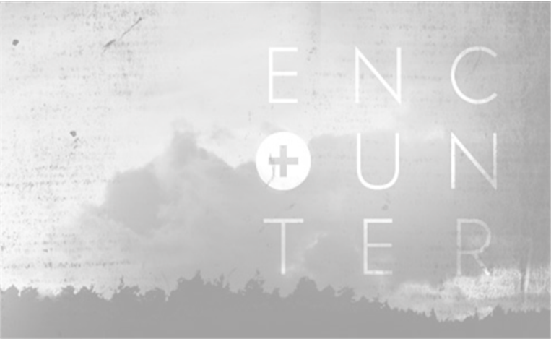****Transformational Catholic Life***

***COMMITMENT***

**Where are we at now?**

**How can we improve?**

***GLORY***

**Where are we at now?**

**How can we improve?**

***VALUE***

**Where are we at now?**

**How can we improve?**

***FEAR***

**Where are we at now?**

**How can we improve?**

***ENCOUNTER***

**Where are we at now?**

**How can we improve?**