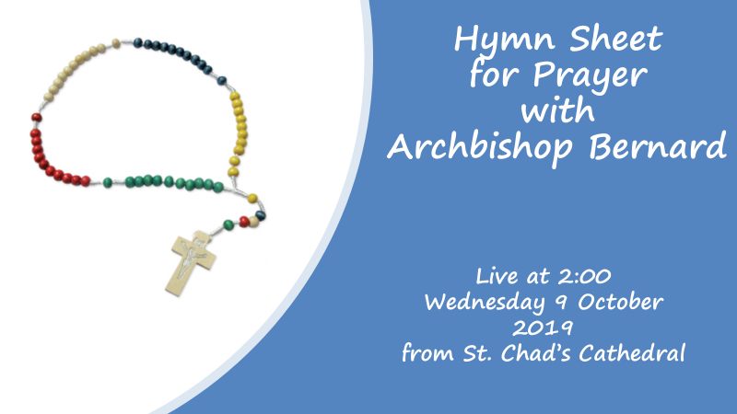
Be still, for the presence of the Lord
(© Kingsway’s Thankyou Music)

- Be still, for the presence of the Lord,
the Holy One is here.
Come, bow before Him now,
with reverence and fear.
In Him no sin is found,
we stand on holy ground.
Be still, for the presence of the Lord,
the Holy One is here.

- Be still, for the glory of the Lord,
is shining all around;
He burns with holy fire,
with splendour he is crowned.
How awesome is the sight,
our radiant King of light!
Be still, for the glory of the Lord,
is shining all around.

- Be still, for the power of the Lord
is moving in this place.
He comes to cleanse and heal,
to minister his grace.
No work too hard for Him,
in faith receive from Him.
Be still, for the power of the Lord,
is moving in this place.

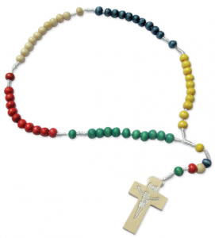

Oh Mary, gentle one
(© Kevin Mayhew Ltd)

Oh Mary, gentle one,
teach us to love your Son.
Oh Mary, humble one,
help us to serve him.

Chorus
Teach us to answer Him,
as once you answered Him:
‘Let it be done to me
according to your Word.’

Oh Mary, peaceful one,
help us to know your Son,
Oh Mary, hopeful one,
teach us to trust him.

Oh Mary, grateful one,
teach us to thank your Son,
Oh Mary, joyful one,
help us to praise him.

Firmly I Believe
(© Mike Stanley (2) John Henry Newman)

- Firmly I believe and truly
God is Three, and God is One;
and I next acknowledge duly
manhood taken by the Son.
And I trust and hope most fully
in that Manhood crucified;
and each thought and deed unruly
do to death, as he has died.

REFRAIN 1:
I believe, I believe,
O firmly I believe that it's true!

VERSE 2:
Simply to his grace and wholly
light and life and strength belong,
and I love supremely, solely,
him the holy, him the strong.
And I hold in veneration,
for the love of him alone,
holy Church as his creation,
and her teachings as his own.

REFRAIN 2:
I believe, I believe,
O firmly I believe,
I believe, I believe,
O firmly I believe that it's true!

FINAL VERSE:
Adoration aye be given,
with and through the angelic host,
to the God of earth and heaven,
Father, Son and Holy Ghost (repeat)
REFRAIN 3:
I believe, I believe,
O firmly I believe,
I believe, I believe,
O firmly I believe that it's true

God is three, God is one
God is holy, God is strong
God is three, God is one
He is Father, Spirit, Son x2

REFRAIN 4:
I believe, I believe,
O firmly I believe (x 4)
that it's true!

