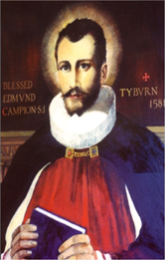 St. Edmund Campion Pray for Us

Dear Parents and Carers

We know only too well the great difficulty and upheaval being caused by the recent lockdown in terms of education and the challenges faced in remote learning for our students, staff and you as parents and carers.

As things stand at the moment churches and places of worship are able to remain open and Bishop John Sherrington, Auxiliary Bishop of Westminster has issued the following letter, which explains the position and role of Catholic Churches during the current lockdown:

“We are aware that questions are being asked as to why churches remain open during this National Lockdown. We are also aware that many local authorities are calling for places of worship to close. We wish to respond to these concerns.

Churches are allowed to open for prayer and communal worship at this time according to the provision of the most recent national legislation and Government guidance.

This decision is based on two factors: the recognition that our churches are safe, and that the service they offer is essential.

The safety of our churches has been affirmed by Public Health England (PHE) in its current advice to the Government. This is publicly recognised to be the result of the great efforts made by many people in the implementation of procedures mandated by PHE and thereby establishing the necessary conditions within churches for their safe use.

Our churches are making a significant contribution to the personal resilience and inner strength of people which is much needed at this time. Many are hubs from which essential support is offered especially to those most in need, extending well beyond the faith communities which use them. This includes the regular provision of food; the care of the homeless; and being a place of peace and reflection (which is safe) for many whose living conditions are very limited. This will become more appreciated as the programme of vaccination increases. The vital link between prayer and action is important to maintain this service.

At this phase of the pandemic, which is causing alarm and fear, our churches will exercise their role with increased diligence to ensure continuing safety and service.
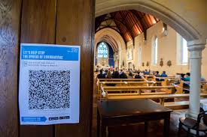
Our clergy will ensure that all are aware that there is no duty or responsibility to come to church and communicate to all there is no obligation to attend Mass on Sunday. They will review, in each local area, the provision offered by the church in order to ensure that the highest standards of safety are maintained. This will include a review of the role of stewards, the provision of additional social distancing within the church, a review of cleansing routines, and consideration of the personal circumstances of the priest(s) and people. On this basis there will be a local evaluation and decision about the possible reduction in the times of opening and the frequency of communal worship.

In conclusion we recognise the higher levels of fear and anxiety which the new strain of the virus has prompted and we have a very proper awareness of the care which must be exercised by everyone, under the guidance of PHE health professionals.
We recognise, too, that isolation is having a profound detrimental effect on people and that the role of churches in easing that isolation in ways which are safe and supportive has been recognised as a positive and beneficial contribution to the common good.

We pray for the dedicated work of the NHS and continue to provide spiritual support to staff and patients through the network of chaplains working both in the hospitals and the community.”

Children’s Liturgy

A short liturgical resource to help you with praying together and listening to the Word of God as a family has been prepared by Redemptorist Publications and can be viewed on the link below:

https://youtu.be/RnVcjADw5T0

During Advent the Catholic Bishops of England and Wales encouraged us to reflect on our vocation – our calling to live a life of holiness in our every day lives. To help with this the National Office for Vocation produced a series of Advent reflections to make us think about the types of life that God can call individuals to. The reflection for Week 4 was not available before the Christmas break and was on the call to the religious life. The link to this is below:
https://youtu.be/Jx0ApTse9l0

What’s Going On in our Local Parish Communities

Here is a link to the Erdington Abbey parish newsletter:
http://www.erdingtonabbey.co.uk/eacontent/uploads/2021/01/Bulletin-Baptism-of-the-Lord-10-Jan-21.pdf

Here is a link to the parish newsletter of St. Nicholas Church in Boldmere:
https://www.stnicholasboldmere.co.uk/uploads/6/2/5/9/62597781/baptism_a3.pdf

Here is a link to the parish newsletter of St. Margaret Mary’s Church in Perry Common:
https://www.stmgtmry.bham.sch.uk/newsletters/parish210110.pdf

Here is a copy of the parish newsletter of Christ the King Church in Kingstanding:

Here is a link to the parish newsletter of Holy Cross & St. Francis Church in Walmley:
https://www.hcsf.org.uk/bulletin-for-the-week-beginning-9th-january-the-baptism-of-the-lord/

Mass Online
You will be able to access mass each day and every Sunday streamed live from St. Chad’s Cathedral and here is the link to access these:
www.stchadscathedral.org.uk

Redemptorist Publications also continue to make Sunday mass available online after 12 midday every Saturday. Mass is celebrated by Fr. Denis McBride C.Ss.R from the Redemptorist community in Chawton, Hampshire.
www.rpbooks.co.uk/holy-mass-online
Scripture Reflection – 2nd Sunday in Ordinary Time – 1 Samuel 3:-10,19
John 1:35-42
The ability to listen is a key theme of the readings at mass this Sunday. John the Baptist had a message that he needed people to listen to – that he was preparing the way for someone greater than he. And when he saw Jesus and proclaimed him as the ‘Lamb of God’ the two of his disciples who were with him then followed Jesus. The role of John in recognising who Jesus was and guiding those around him to follow Jesus was fulfilled.

The first reading from the book of Samuel tells us how Samuel began to understand when God was calling him. Initially when he heard his name being called he thought it was Eli that had called him. Eli told him how to respond to the call of the Lord – ‘Speak, Lord, your servant is listening.’ He understood that God can be heard if we open ourselves up to listen.

In our world – probably now more than any time in history – there is a lot of noise. We need to find ways to block out the noise so that we can truly listen to what the Lord wants of us in our lives. We also need to truly listen to one another. Only by doing this can we live in harmony and peace.
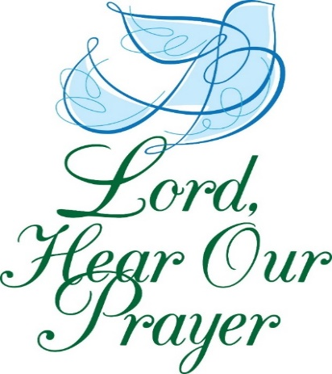
Be still, and know I am with you,
Be still, I am the Lord.
I will not leave you orphans.
I leave you with my world. Be one.
You fear the light may be fading,
You fear to lose your way.
Be still, and know I am near you.
I'll lead you to the day and the sun.
Be glad the day you have sorrow.
Be glad, for then you live.
The stars shine only in darkness,
and in your need I give my peace. Amen
(Anne Conway)

