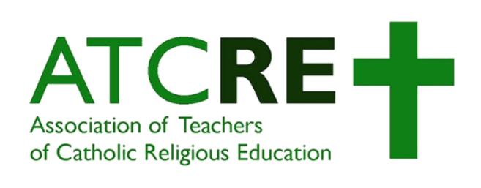

|  |  |  |
| --- | --- | --- |
| |  |  | | --- | --- | | |  | | --- | | **RESOURCES: 24/4/20** | | |

|  |  |
| --- | --- |
| |  | | --- | | * **CAFOD**   + [Home Learning Hub for Young People](https://cafod.org.uk/Education/Secondary-and-youth-resources/Home-learning-young-people) * **GCSE Bitesize Lessons**   + [All here](https://www.bbc.co.uk/bitesize/subjects/zh3rkqt) * **Dawn Cox Resources**   + BBC Bitesize videos <https://t.co/M87NYhydML>   + BBC RE video collections <https://t.co/bXbWClH4Xh>   + Independent working resources (also good for teacher subject knowledge) <https://t.co/mR1SKVYukR> * **NATRE Free Resources**   + <https://www.natre.org.uk/about-natre/free-resources-for-you-and-your-pupils/> * **The Jewish Museum**   + [Online learning now LIVE](https://jewishmuseum.org.uk/virtual-classrooms/) * **Westminster Diocese**   + [The Rosary 4 - The Ascension PPT](https://mcusercontent.com/8c3ccb22521d017db641bf551/files/333e530d-3f5c-4de8-bca5-65329e3e627c/200424_Praying_the_Rosary_4_Ascension.pptx)   + [Video](https://youtu.be/C3ahZOc_e_Q) * **Raymond Friel**   + [Prayers for the pandemic](https://twitter.com/friel_raymond/status/1252487312363212801?s=11) * **Oxford University Press**   + [Available support here](https://global.oup.com/education/secondary/campaigns/school-closure-support/?region=uk)   + [Free GCSE Home Learning packs](https://global.oup.com/education/content/secondary/key-issues/secondary-school-resources/?region=uk) * **Ten Ten Resources**   + [Sunday Liturgy resources](https://www.tentenresources.co.uk/primary-subscription/prayers-for-home/sunday-liturgy-for-families/) * **Miss C**   + [Judaism Home Learning Pack](https://teachreuk.school.blog/2020/04/16/home-learning-judaism-home-learning-booklet/) * **Aid to the Church in Need**   + [Child's Bible Project](https://acnuk.org/resource/childs-bible-project/) * **Sophia Smith Galer**   + [BBC reporter - thread of religious articles for RE teachers](https://threadreaderapp.com/thread/1250074651394523138.html) * **Emily Pearson**   + [Holy Week Resources](https://drive.google.com/file/d/16Vzfjn1K2kwT78YlzA4vYAV24L6_DOb-/view?usp=sharing) * **McCrimmons**   + [Be The Change resource](https://www.mccrimmons.com/library/files/BTC-Colouring-v3.pdf) * **Miss Moran**   + [Keep Learning RS resources](https://mail.google.com/mail/u/0/#inbox/FMfcgxwHMZTKKRlgZJxvmDSQbKTbtPsz?projector=1) * **AudioPi**   + [Podcasts (currently FREE)](https://www.audiopi.co.uk/subjects/religious-studies/gcse/) * **University of Cambridge**   + [NT Greek starter course!](https://www.greek.divinity.cam.ac.uk/) * **Mission Together**   + [Home Learning Resources](https://missiontogether.org.uk/school-closures-home-activities/) * **Teach RE**   + [Free self study module](https://www.teachre.co.uk/teach-re-course/teachre-free-self-study-module/) | |