

NOCN
GENERAL RELIGIOUS EDUCATION QUALIFICATIONS

TEACHER HANDBOOK

Version 3 – June 2010


Contents | Page
1. Introduction | 3
2. Summary of Arrangements | 3
3. NOCN General Religious Education Qualifications - Roles and Responsibilities | 4
4. NOCN Documents | 7
5. NOCN General Religious Education Qualifications – Process Flowchart | 8
6. Schedule for Heads of RE and Teachers – 2010-2011 | 9
7. Key Things Teachers Need to Know | 10
8. Assessment  - Appendix 1 – A/01 - Assessment Definitions  - Appendix 1 – A/02 - Guidelines for Assessment  - Appendix 1 – A/02.1 - Assessment Strategy  - Appendix 1 – A/03 - Assessment Task Sheet templates  - Appendix 1 – A/04 - Technical Specification – Level Descriptors | 13  16  30  32  35  37
9. Internal Verification  - Appendix 2 – IV/01 - Guidelines for Internal Verification  - Appendix 2 – IV/02 - Checklist for Internal Verifiers  - Appendix 2 – IV/03 - Internal Verification Planning  - Appendix 2 – IV/04 - Guidelines for Sampling – Internal Verification  - Appendix 2 – IV/05 - Guidelines for Factors to consider for Sampling and Internal Verification  - Appendix 2 – IV/06 - Internal Verification Sampling Record  - Appendix 2 – IV/07 - Internal Verification Report Form  - Appendix 2 – IV/08 - Guidelines for Completing the Internal Verification Report Form | 38  39  41  43  45  47  48  49  53
10. Standardisation  - Appendix 3 – S/01 - Standardisation – Purpose  - Appendix 3 – S/02 – Standardisation at Diocesan and National Levels  - Appendix 3 – S/03 - Standardisation Flowchart  - Appendix 3 – S/04 - Standardisation – SF1  - Appendix 3 – S/05 - Standardisation – SF2  - Appendix 3 – S/06 - Standardisation – SF3 | 56  56  57  58  59  62  64
11. Policies  - Appendix 4 – P/01 - Reasonable Adjustments and Special Considerations Policy  - Appendix 4 – P/02 - Application/Record for Reasonable Adjustment NQ12-13  - Appendix 4 – P/03 - Enquiries, Appeals and Complaints Policy  - Appendix 4 – P/04 - Code of Practice – Suspected Malpractice | 66  67  71  72  77
12. Venue Checklist | 83
13. Administrative Guidelines | 84
1. Introduction

This handbook is intended to help Teachers understand their role and responsibilities and those of the Schools/Colleges in their diocese, in the delivery of the NOCN Awards in General Religious Education.

2. Summary of Arrangements

NBRIA, the National Board of Religious Inspectors and Advisers, has been approved by NOCN as the lead organisation for the qualifications. NBRIA has responsibility for ensuring that agreed quality assurance procedures are in place and implemented in each venue wishing to offer the qualifications.

Schools/Colleges are NBRIA approved venues for delivery of the qualifications.

NB: Venues is the term used throughout this document for schools and colleges.

3. NOCN General Religious Education Qualifications Roles and Responsibilities

3.1 NOCN

3.1.1 Key officers
Director of Quality, Director of Business Development, Executive Director of Corporate Strategy and Development

3.1.2 Role:
As the recognised and regulated awarding body, to develop and implement a strategy for General Religious Education qualifications, and to ensure that that processes and procedures meet regulatory requirements.

3.1.3 Responsibilities:
- Liaising with NBRIA as the approved centre
- Communicating with Diocesan Advisers and approved venues regarding registration and awards processes
- Appointing the Lead Officer
- Appointing Quality Reviewers
- Developing qualifications
- Registering students
- Certificating successful students
- Ensuring that registration, quality assurance and awards processes and procedures are clear and efficient
- Reviewing and improving processes and procedures

3.2 NBRIA

3.2.1 Key Officer
Named Centre contact

3.2.2 Role:
As the approved NOCN centre, to ensure that the agreed national arrangements for General Religious Education qualifications are implemented through the dioceses in approved venues.

3.2.3 Responsibilities:
- Approving new venues
- Liaising with NOCN Lead Officer
- Briefing, supporting and coordinating Diocesan Advisers
- Attending national standardisation events
- Providing information to NOCN as required
- Responding to budget/funding queries from Diocesan Advisers and venues
- Identifying additional staff development needs
3.3 Diocesan Advisers

3.3.1 Role:
To monitor, evaluate and report on the implementation of agreed national arrangements at a diocesan level and at respective individual venues.
3.3.2 Responsibilities:
- Liaising with NBRIA
- Liaising with their allocated NOCN Quality Reviewer
- Briefing, supporting and directing teachers in venues
- Carrying out a schedule of Diocesan Verification activities with venues to ensure appropriate Internal Verification arrangements have been securely undertaken for all respective venues
- Identifying a Diocesan Standardisation event date
- Organising and co facilitating the Diocesan standardisation event with the NOCN Quality Reviewer
- Contributing to the Diocesan standardisation report
- Checking for accuracy and countersigning the NOCN Internal Verification Report: IV07 and the completed RACs for respective venues
- Attending and participating in national standardisation events
3.4 Venues

3.4.1 Role:
To deliver the General Religious Education qualifications in accordance with NOCN quality assurance requirements.

3.4.2 Responsibilities:
- Liaising with Diocesan Advisers
- Ensuring the venue is registered with NOCN
- Ensuring learner registrations are completed by published dates
- Ensuring all staff delivering the qualifications are briefed and have access to all NOCN guidance documents
- Ensuring an appropriate Assessment Strategy and annual Assessment Plan are in place
- Developing assessment tasks that meet all Learning Outcomes and Assessment Criteria
- Assessing and marking students’ work
- Ensuring an appropriate Internal Verification (IV) plan and process is in place
- Carrying out IV
- Completing the NOCN Internal Verification Report: IV07
- Attending regular meetings with the Diocesan Adviser
- Providing samples of assessed and marked work for diocesan and national standardisation
- Attending and participating in diocesan standardisation events
- Completing and signing Recommendations for the Award of Credit (RAC) for students who have successfully achieved the respective unit

3.5 NOCN Lead Officer

3.5.1 Role:
To maintain an overview of the NOCN General Religious Education qualifications, ensuring that agreed processes and procedures are implemented and reviewed, and to contribute to the development and implementation of NOCNs strategy with NBRIA

3.5.2 Responsibilities:
- Liaising with/meetings with NOCN
- Liaising with/meetings with NBRIA
- Liaising with QCDA and other bodies as appropriate
- Holding regular meetings and briefing the Diocesan Advisers
- Organising and facilitating the NOCN/NBRIA national standardisation event
- Supporting, managing and developing the team of Quality Reviewers
- Production of national annual and other reports
3.6 NOCN Quality Reviewers

3.6.1 Role
To monitor, evaluate and review the systems and processes operated by schools and colleges which assure the quality of the NOCN Awards in General Religious Education.
3.6.2 Responsibilities:
- Liaison with allocated Diocesan Adviser/s
- Planning and making visits to venues to check and report on internal verification and assessment
- Advising and guiding Diocesan Advisers in allocated diocese about meeting NOCN requirements.
- Identifying and agreeing samples for Diocesan and national standardisation events
- Leading the Diocesan standardisation event
- Participating in the national standardisation event
- Checking for accuracy and countersigning the NOCN Internal Verification Report: IV07 and the completed RACs for respective venues
- Attending NOCN schedule of meetings
- Producing of reports as required e.g. Diocesan annual report

4. NOCN Documents

All Diocesan Advisers need to have and understand the following documents which can be downloaded from the NOCN website at www.nocn.org.uk

NOCN General Religious Education Qualification Guide | Version 2
NOCN General Religious Education Qualification Teacher Handbook | Version 1
The following guidelines, policies and documents are available as both Appendices within this document and separately on the website
Appendix 1
Assessment
Assessment Definitions | A/01 – V1
Guidelines for Assessment | A/02 – V1
Assessment Strategy | A/02.1 – V1
Assessment Task Sheet templates | A/03 – V1
NOCN Technical Specification - Level Descriptors | A/04 – V1

Appendix 2

Internal Verification
Guidelines for Internal Verification | IV/01 – V1
Checklist for Internal Verifiers | IV/02 – V1
Internal Verification Planning | IV/03 – V2
Guidelines for Sampling - Internal Verification | IV/04 – V1
Guidelines for Factors to consider for Sampling and Internal Verification | IV/05 – V1
Internal Verification Sampling Record | IV/06 – V2
Internal Verification Report Form | IV/07 – V2
Guidelines for Completing the Internal Verification Report | IV/08 – V1

Appendix 3

Standardisation
Standardisation – Purpose | S/01 – V1
Standardisation at Diocesan and National Levels | S/02 – V1
Standardisation Flowchart | S/03 – V1
Standardisation – SF1 | S/04 – V1
Standardisation – SF2 | S/05 – V1
Standardisation – SF3 | S/06 – V1
Appendix 4
Policies
Reasonable Adjustments and Special Considerations Policy | P/01 – V1
Application/Record for Reasonable Adjustment – NQ12-13 | P/02 – V1
Enquiries, Appeals and Complaints Policy | P/03 – V1
Code of Practice - Suspected Malpractice | P/04 – V1

- NOCN General Religious Education Qualifications – Process Flowchart

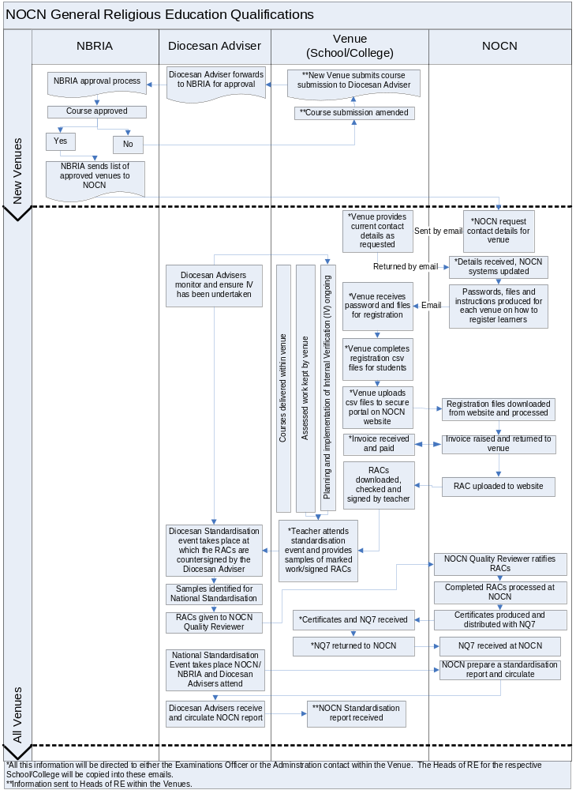
6. Schedule for Heads of RE and Teachers – 2010-2011
Administrative Calendar of Events available at p.84 of this guide.

Date | Event/Task
September/  October | Venues newly approved by NBRIA, details sent to NOCN, see process flowchart, p.5
September/  November 2010 | Heads of RE from venues attend a Diocesan Adviser Meeting, which includes:  - Update on NOCN awards  - Agreeing date of diocesan standardisation event  - Agreeing and planning visits for monitoring and ensuring Internal Verification (IV) has been securely undertaken by each venue
30 September 2010 | Provide NOCN Quality Reviewers with:  - Assessment strategy and plan for the year.  - IV plan for the year.
Autumn to Summer | - Deliver course(s)  - Prepare a range of assessment tasks  - Assess and mark students’ work  - Track student progress  - Record achievement  - Diocesan Adviser visits
10 December 2010 | Students to be registered by this date to avoid late registration fee. Any students registered after this date will be charged a late registration fee of £5 per student
29 April 2011 | Final deadline for registration. No registrations will be accepted after this date
Spring/ Summer | Carry out Internal Verification (IV) in line with IV plan
On completion of course(s) | Summer first half-term (at the latest)  Complete NOCN form IV07  On completion of the course teachers must check, sign and date RACs in preparation for attendance at the Diocesan Standardisation Event
Summer first half-term | Provide agreed samples of assessed and marked work for Diocesan Standardisation event
Summer second half-term | Participate in Diocesan Standardisation event with completed IV07 and RACs for signing off by the Diocesan Advisers

7. Key Things Teachers Need to Know

Qualification Details

- There is one Qualification Guide – this includes information on all four qualifications, Entry Level, Level One, Level Two and Level Three.

- Each qualification contains one unit of assessment and the achievement of the qualification is determined by the successful achievement of this unit.

- All Teachers delivering the course should have a copy of the Qualification Guide in addition to this Teacher Handbook.

- The unit of assessment has two pages:

  - Page one sets out the Learning Outcomes and the Assessment Criteria for the level
  - Page two give details of the assessment activities for the unit

- Each unit comprises of Learning Outcomes and Assessment Criteria for the level.

- Learning Outcomes set out what the student is expected to know understand or be able to do.

- Assessment Criteria specify the standard a student is expected to meet to demonstrate that a learning outcome, or set of learning outcomes, has been achieved. See Technical Specification- Level Descriptors Document A/04 which provides information and guidance on each level.

- All the Learning Outcomes must be achieved i.e. meet all the Assessment Criteria at the appropriate level, for a student to be awarded the qualification.

  - Units are pass or fail units – there is no compensation across learning outcomes.

- Each qualification has 30 learning hours.

- All teachers delivering the NOCN General Religious Education course should have a copy of the Qualification Guide in addition to the Teacher Handbook.

- Venues will need to register their students for the qualification at one level only. (See Section 13 Administrative guidelines).

- The Guidelines for Assessment document A/02 provides information on assessment for teachers to ensure that students are properly assessed and have been given every opportunity to achieve the qualification.

- Assessment Activities are either defined as Optional or Prescribed. The Assessment Definitions Document A/01 provides guidance on the assessment activities, how the learning may be assessed and what the evidence should include.

- Where an assessment activity is Prescribed - these activities must be used within the assessment strategy.

- Where an assessment activity is Optional teachers may choose a range of the most appropriate activities to meet the needs of their students.

Registration

    - Teachers are responsible for checking that, prior to the Learner Registration form being submitted:
      - the learner is registered against the correct level
      - the learner has not already achieved the qualification at the level they are being entered against. If they are registered against a qualification they have already achieved they will not be re-awarded unless a request is made to NOCN.

Assessment

- Assessment Tasks are what the student does in the assessment activity.

- NOCN benchmark Assessment Tasks, which are available on the NOCN website, can be used or adapted as appropriate.

- Each Assessment Task can address one Learning Outcome or several Learning Outcomes.

- An Assessment Task sheet template should be used to set out the task and the Learning Outcomes and the Assessment Criteria the task is intended to cover.

- Student’s work must be marked by the teacher to show where the Learning Outcomes and Assessment Criteria have been met.

- Evidence of achievement for each Learning Outcome must be recorded for each student by the teacher.

- Records of assessment and the evidence generated by the student must be kept.

- When students have achieved all the Learning Outcomes to the required Assessment Criteria the teacher should complete and sign the Recommendation for Award of Credit (RAC) and provide to NOCN. Learners cannot be added to the RAC by the venue.

- Units are pass or fail units – there is no compensation across learning outcomes.

Internal Verification

- A programme of Internal Verification (IV) must take place in each venue to sample and evaluate assessment practices and decisions.

- Your Diocesan Adviser must countersign the venue’s IV report form to evidence that they are satisfied with the appropriateness and rigour of the IV system.

- Diocesan Advisers should ensure that venues understand that they need to provide you with samples of marked work for Diocesan and National standardisation events.

Diocesan Standardisation and Recommendation for the Award of Credit

- At Diocesan Standardisation events the Diocesan Advisers will check and countersign the RAC if they are satisfied that the assessment decisions are valid and reliable - they will do this through sampling assessment decisions themselves and through countersigning the venues’ IV Report Form.

- The NOCN Quality Reviewers will collect the RACs, check and ratify them and forward to NOCN for certification.

- It is important to check that the RACs have been completed accurately and that they have been signed by both the teacher and the Diocesan Adviser before giving to the NOCN Quality Reviewer.

- NOCN will send certificates to individual venues together with an NQ7 form that the venue must complete and return confirming receipt.

- Venues should then distribute certificates to students.

- Assessment

Each venue has a copy of the course proposal approved by NBRIA which they should use to plan their scheme of work and individual lessons to ensure that all the learning outcomes of the qualifications have been covered.

NB: Not everything taught in the syllabus needs to be assessed.

8.1 Unit Assessment

Achievement of a unit is through internally set, internally assessed, internally verified and externally verified assessment activity at the appropriate level (see NOCN Level Descriptors (A/04)) with defined assessment tasks clearly mapped to the Assessment Criteria.

- Venues should devise a range of assessment tasks to meet the specification for assessment detailed for each unit. The tasks must use the assessment activities detailed in the assessment grid provided on each unit i.e. page 2 of the unit. If an assessment activity is Prescribed, it must be used to assess the unit. If an assessment activity is Optional, venues may choose a range of the most appropriate activities to meet the needs of their students.

- Assessment tasks should be scrutinised by the Internal Verification team to ensure reliability and validity of assessment tasks.

8.2 Assessment Activities

Activities are the methods used for assessing, and are outlined in the Assessment Definitions Document.

The Assessment Definitions (A/01) document can be found at the end of this section and on the NOCN website @ www.nocn.org.uk

Example: Discussion/Oral Q&A

The evidence of participation for this is likely to be within the teacher’s records e.g. a witness statement or record of the class discussion with the teacher’s acknowledgement of student’ participation. This evidence on its own is not sufficient, student’s work must be included as well e.g. a tape/video, student notes of the discussion or an entry re the discussion in a learning log. See below

  - 8.3 Assessment Tasks (see assessment task sheet template at the end of this section)

Assessment Tasks are what the student does in the assessment activity.

Examples:

(a) Written Q&A is the activity
the questions required to be answered is the assessment task.

(b) Discussion is the activity
the question/statement discussed is the assessment task.

(c) The Reflective Log is the assessment activity,
what the student was required to do is the assessment task e.g. ‘Today’s speaker discussed ……….. what are your opinions on this’ or explain why you do or do not agree with the speaker’.

At Entry and Level 1 it is likely that there will be separate assessment tasks for each Assessment Criteria. At Levels 2 and 3 an assessment task could meet several assessment criteria.

All assessment tasks should be carefully mapped against the assessment criteria. The suite of assessment tasks should cover all the assessment criteria.

8.3.1 Assessment Task Sheet Template (coversheet) A/03

An A/03 form (or similar) is to be completed for each assessment task. Only one form need be completed even if more than one Learning Outcome or Assessment Criteria is being assessed in one assessment task.

8.3.2 Student Evidence

The assessment tasks must allow each student to provide evidence of achievement for all the assessment criteria at least once e.g. individual work sheet, essay, written account, learning log. The teachers’ records of participation in group tasks would need substantiating by the student’s own work e.g. notes, diagrams, and (for Entry Level) pictures.

Where there is group work, the individual’s contribution should be highlighted. If for some reason this is not possible, each student must record in writing their contribution and the venue must retain these records.

Venue devised assessment tasks should be clearly mapped against the assessment criteria. These will be scrutinised by Diocesan Advisers and NOCN Quality Reviewers against the unit specification and NOCN Assessment Definitions document to ensure reliability and validity of assessment. Venues will be required to provide samples of students’ evidence (assessed and marked work) for diocesan and national standardisation events.

8.3.3 Marking Tasks

Tasks should be marked against the identified assessment criteria in the unit and judged to be either achieved or not achieved and the achievement recorded for each student.

Where a series of tasks is set, students must demonstrate the achievement of the required standard identified in the assessment criteria across the tasks in order to achieve the unit.

Units are either achieved or not achieved. All learning outcomes and assessment criteria must be completed successfully by each student for the unit to be awarded.

The Assessment Task Sheet Template (coversheet) A/03 form (or similar) is to be completed by teacher for each student on completion of each assessment task.

Records of assessment and samples of assessed work must be made available to the Internal Verification team and the Diocesan Adviser.

Venues will be required to provide samples of marked assessment tasks for diocesan and national standardisation activity.

8.4 Reasonable Adjustments

For students requiring different assessment arrangements, please refer to the NOCN Reasonable Adjustments and Special Considerations Policy (PO/1) in section 10 of this handbook.

8.5 Recording Achievement

To record a student’s performance in each unit venues may use the exemplar forms available on the NOCN website. The forms can be used to record a student’s performance for individual tasks, mapped against the unit assessment criteria, and to confirm completion of a complete unit evidenced by the task.

8.6 Assessment Summary

To achieve the qualification the student must achieve and produce individual evidence of all the assessment components for the units on at least one occasion.
1. Case Studies

Consideration of a particular, relevant situation or example, selected by the teacher or by students, which enables students to apply knowledge to specific situations. May be used as a collective / group activity and discussed in a group of students or by an individual student. Or may be used with individual students as a written activity through case study materials and student responses.

 | Activity | The learning may be assessed through: | Evidence could include:
Entry Level | Case studies should be simple, immediate and familiar to the student. Discussion should be short, structured and supervised (group or one-to-one). Written work should be short structured and supervised. | Teacher observation  Class discussion  One to one  Group discussion  Written work | Teacher record of observation  Plus at least one of  Student notes  Audio/video/photographic record  Written work
Level One | Case studies should be limited in range, familiar and require a narrow range of knowledge. Discussion should be structured and involve a limited degree of judgement (group or one-to-one). Written work should be structured and involve a limited degree of judgement. | Teacher observation  Class discussion  One to one  Group discussion  Written work | Teacher record of observation  Plus at least one of  Student notes  Audio/video/photographic record  Written work
Level Two | Case studies should allow the application of knowledge in a number of areas and contexts. Discussion should be directed but should allow for a degree of autonomy (group). Written work should be directed but allow for a degree of autonomy (GL = 500 words). | Teacher observation  Class discussion  One to one  Peer/self assessment  Group discussion  Written work | Teacher record of observation  Plus at least one of  Student notes  Audio/video/photographic record  Written work
Level Three | Case studies should allow the application of knowledge in a range of complex areas, in a variety of familiar and unfamiliar contexts. Discussion should be guided but self-directed (group). Written work should allow for autonomy, evaluation and reasoned judgements to be made (GL = 1000 words). | Teacher observation  Class discussion  One to one  Peer/self assessment  Group discussion  Written work | Teacher record of observation  Plus at least one of  Student notes  Audio/video/photographic record  Written work
2. Oral Question and Answer

Specific, open or closed questions for immediate response. Can range from quite formal questions, for example, an oral test, to a quick, fun way of finding out where students are up to, for example, a quiz. Allows response and questioning from students and immediate feedback from teacher.

 | Activity | The learning may be assessed through: | Evidence could include:
Entry Level | Process should be informal and non-threatening and questions should cover a narrow range of areas. Students should be supported in answering and given a number of opportunities to respond. | Responses by both teacher and individual students. | Teacher record of observation  Plus at least one of  Student notes  Audio/video/photographic record  Written work
Level One | Process should be informal and should include both open and closed questions covering a narrow range of knowledge. Students should be encouraged by the use of supplementary questions. | Responses by both teacher and individual students. | Teacher record of observation  Plus at least one of  Student notes  Audio/video/photographic record  Written work
Level Two | Open and closed questions should be included, covering a number of topics. Students should be encouraged to expand on their answers. | Responses by both teacher and individual students. | Teacher record of observation  Plus at least one of  Student notes  Audio/video/photographic record  Written work
Level Three | Questions should cover a wide range of knowledge and contexts. They should allow responses to unfamiliar and unpredictable problems. The process may be time limited and formal, or may be a structured two-way discussion. | Responses by both teacher and individual students. | Teacher record of observation  Plus at least one of  Student notes  Audio/video/photographic record  Written work

3. Written Question and Answer/Test/Exam

Specific, open and closed questions for immediate response. Can range from formal exams and tests, to a quick, fun way of finding out where students are up to, for example, a quiz. Allows response and questioning from students and feedback from teacher.

 | Activity | The learning may be assessed through: | Evidence could include:
Entry Level | Process should be informal and non-threatening and questions should cover a narrow range of areas. Possible use of multi-choice questions. | Assessment by teacher. | Student’s written responses with teacher feedback.
Level One | Process should be informal and non-threatening. Questions should encourage students to make use of knowledge rather than just testing recall. | Assessment by teacher or external marker (for exams/tests). | Student’s written responses with teacher feedback.
Level Two | Open and closed questions should be included, covering a number of areas. Students should be encouraged to make use of / interpret knowledge rather than just testing recall. May be time limited. | Assessment by teacher or external marker (for exams/tests). | Student’s written responses with teacher feedback.
Level Three | Questions should cover a wide range of knowledge and contexts, and allow responses to unfamiliar and unpredictable problems. Students should be encouraged to make use of / interpret knowledge rather than just testing recall. The process may be time limited. | Assessment by teacher or external marker (for exams/tests). | Student’s written responses with teacher feedback

4. Essay

A discursive, written response to a question or statement which involves the student in finding and presenting information and opinion in a structured way, which normally includes an introduction, the information/opinions/evaluation/analysis and a conclusion.

 | Activity | The learning may be assessed through: | Evidence could include:
Entry Level | It would be unlikely that an essay would be used as an assessment activity at Entry Level as it would not be appropriate for the student. However, it could be used in a very simple form to allow students to demonstrate recall and comprehension in a narrow range of ideas. | By teacher against clear criteria. | Marked essay and teacher feedback.
Level One | The essay subject should be simple and the response should be descriptive and not analytical or evaluative. A narrow range of applied knowledge and demonstration of basic comprehension would be expected. Students should be given detailed information on how to structure the essay and on the criteria for achievement. | By teacher against clear criteria. | Marked essay and teacher feedback.
Level Two | The essay subject should be familiar and the response should demonstrate the ability to interpret information, make comparisons and apply knowledge and demonstrate comprehension in a number of different areas. Students should be given information on the expected structure of the essay and criteria for achievement.  GL = 500 words. | By teacher against clear criteria. | Marked essay and teacher feedback.
Level Three | The essay subject should allow the student to access and evaluate information independently, to analyse information and to make reasoned judgements and demonstrate comprehension of relevant theories. Students should be given information on possible structures for an essay and for the criteria for achievement. GL = 1000 words. | By teacher against clear criteria. | Marked essay and teacher feedback.

5. Report

A record of an activity and / or a summary of research which presents information in a structured way. Does not include opinion, but may include analysis or evaluation. May be presented in written or oral form.

The learning may be assessed by: Teacher for written report. Teacher and/or peers for oral presentation of report.

Evidence could include: Written report with teacher feedback. Notes for oral presentation with teacher and/or peer feedback.

 | Activity | The learning may be assessed through: | Evidence could include:
Entry Level | Report should be oral and informal. The information or activity being reported on should be simple and familiar. Students should be supported in preparing and giving a report and given a number of opportunities to respond. | Assessment by teacher. | Written report with teacher feedback
Level One | Report could be presented orally or in written format. Oral presentation should be informal. Information used in the report should be readily available and activities should be in familiar contexts. Students should be clear on the expected structure and criteria for the report and given support on planning and presentation. | Assessment by teacher. | Written report with teacher feedback or student notes of oral presentation with teacher feedback.
Level Two | Report could be presented in orally or in written format. Oral presentation should be to a familiar audience. Information should be from a range of sources and activities, should be from familiar or unfamiliar but predictable contexts. Students should be clear on possible structures for the report and the criteria for achievement. GL = 4 minutes for oral / 500 words for written. Students should be given guidance on planning and presentation. | Assessment by teacher and / or peers for oral presentation. | Written report with teacher feedback or student plan for oral presentation with peer and/or teacher feedback.
Level Three | Report could be presented orally or in written format. Oral presentation should be formal and could include a range of methods. Information should be from a wide range of sources and should be evaluated. Activities should be well defined but could be unfamiliar or unpredictable. Students should be clear on the criteria for achievement but would be expected to decide on the format and structure of the report. GL = 8 minutes for oral/1000 words for written | Assessment by teacher and or peers for an oral presentation. | Written report with teacher feedback or plan for oral presentation with peer and/or teacher feedback.
6. Project

A specific task involving private study and research for individuals or groups. Normally involves selection of a topic, planning, finding information and presenting results orally or in writing.

 | Activity | The learning may be assessed through: | Evidence could include:
Entry Level | Task should be simple, familiar, informal and supervised. It should involve repetitive and predictable processes. | Assessment through teacher observation and questioning during and at end of process. | Teacher record plus at least one of following student notes, plans, reports, student log or audio/video/annotated photographic record.
Level One | Task should be selected with support from teacher to allow the demonstration of knowledge and skills in a range of predictable, structured and familiar contexts. | Assessment through teacher observation and questioning during at the end of the process. | Teacher record plus at least one of following student notes, plans, reports, student log or audio/video/annotated photographic record.
Level Two | Task should be selected with teacher guidance to allow the demonstration of knowledge and understanding in a range of areas and contexts, and the interpretation of information. The project should be completed within an agreed timescale. | Assessment through teacher/student discussion during and at the end of the process, and through self-assessment. | Teacher record plus at least one of following student notes, plans, reports, student log or audio/video/annotated photographic record.
Level Three | Task should be selected with teacher guidance to allow the demonstration of knowledge and skills in a range of areas and contexts, and to show the use of reasoned judgements. The project should be planned and completed within an agreed timescale. | Assessment through teacher/student discussion and self-assessment. | Teacher record plus at least one of following student notes, plans, reports, student log or audio/video/annotated photographic record.

7. Production of artefact

Production of a relevant artefact selected by the teacher or by students, which enables students to demonstrate skills and to apply knowledge.

 | Activity | The learning may be assessed through: | Evidence could include:
Entry Level | Artefact should be simple, familiar and informal. Its production should be supervised and involve repetitive and predictable processes. | Assessment through teacher/peer observation, one to one tutorial, discussion, self-assessment and questioning during and at end of process. | Teacher record plus at least one of following student notes, plans, reports, student log, audio/video/annotated photographic record and completed artefact.
Level One | Artefact should be selected with support from teacher to allow the demonstration of skills and apply knowledge in a range of predictable, structured and familiar contexts. | Assessment through teacher/peer observation, one to one tutorial, discussion, self-assessment and questioning during and at end of process. | Teacher record plus at least one of following student notes, plans, reports, student log, audio/video/annotated photographic record and completed artefact.
Level Two | Artefact should be selected with teacher guidance to allow the demonstration of skills and the application of knowledge in a range of areas and contexts. A degree of student autonomy should be encouraged within the scope of the demonstration. The artefact should be completed within an agreed timescale. | Assessment through teacher/peer observation, one to one tutorial, discussion, self-assessment and questioning during and at end of process. | Teacher record plus at least one of following student notes, plans, reports, student log, audio/video/annotated photographic record and completed artefact.
Level Three | Artefact should be selected with teacher guidance to allow the demonstration of skills and application of knowledge in a range of areas and contexts. Production of the artefact should be guided but self-directed. Production of the artefact should be planned and completed within an agreed timescale. | Assessment through teacher/peer observation, one to one tutorial, discussion, self-assessment and questioning during and at end of process. | Teacher record plus at least one of following student notes, plans, reports, student log, audio/video/annotated photographic record and completed artefact.

8. Role Play/Simulation

Use of a situation selected by the teacher or by students, to enable students to practice and apply skills and to explore attitudes.

 | Activity | The learning may be assessed through: | Evidence could include:
Entry Level | Role-plays should be simple with scenarios that are familiar to the student. Role-plays should be short, structured and supervised. | Assessment through, teacher/peer observation, one to one tutorial, discussion and self-assessment. | Teacher record of observation plus at least one of following student notes, tutorial notes, audio/video/annotated photographic record or student log.
Level One | Role-plays should be limited in range, be familiar and require a narrow range of skills. Role-plays should be structured and involve limited degree of student choice. | Assessment through, teacher/peer observation, one to one tutorial, discussion and self-assessment. | Teacher record of observation plus at least one of following student notes, tutorial notes, audio/video/annotated photographic record or student log.
Level Two | Role-plays should allow the application of skills in several areas and contexts. Role-plays should be directed, but allow for a degree of student autonomy. | Assessment through teacher/peer observation, one to one tutorial, discussion and self-assessment. | Teacher record of observation plus at least one of following student notes, tutorial notes, audio/video/annotated photographic record or student log.
Level Three | Role-plays should allow the application of skills in a range of complex areas and in a variety of familiar and unfamiliar contexts. | Assessment through teacher/peer observation, one to one tutorial, discussion and self-assessment. | Teacher record of observation plus at least one of following student notes, tutorial notes, audio/video/annotated photographic record or student log.

9. Written Description

Consideration of a particular subject, situation or example selected by the teacher or by students, which enables students to apply knowledge to specific situations and to present them in written format.

 | Activity | The learning may be assessed through: | Evidence could include:
Entry Level | Subjects should be simple and familiar to student. Written work should be short, structured and supervised. | Assessment through teacher assessment and discussion. | Teacher record of observation and feedback, plus student’s summary of discussion or completed work.
Level One | Subjects should be limited in range, be familiar and require a narrow range of knowledge. Written work should be structured and involve limited degree of judgement. | Assessment through teacher assessment and discussion. | Teacher record of observation and feedback, plus student’s summary of discussion or completed work.
Level Two | Subjects should allow the application of knowledge in a number of areas and contexts. Written work should be directed but should allow for a degree of autonomy. GL = 500 words. | Assessment through self-assessment and teacher assessment. | Teacher record of observation and feedback, plus student’s summary of discussion or completed work.
Level Three | Subjects should allow the application of knowledge in a range of complex areas, in a variety of familiar and unfamiliar context. GL = 1000 words. | Assessment through self-assessment and teacher assessment. | Teacher record of observation and feedback, plus student’s summary of discussion or completed work.

10. Practical Demonstration

A practical demonstration of a skill/situation selected by the teacher or by students, to enable students to practise and apply skills and knowledge.

 | Activity | The learning may be assessed through: | Evidence could include:
Entry Level | Practical demonstrations should be simple with situations that the student is familiar with. They should be short, structured and supervised. | Assessment through teacher/peer observation, one to one tutorial, discussion and self-assessment. | Teacher record of observation plus at least one of following student notes/ tutorial notes, audio/video/ annotated photographic record or student log.
Level One | Practical demonstrations should be limited in range, be familiar and require a narrow range of skills and knowledge. | Assessment through teacher/peer observation, one to one tutorial, discussion and self-assessment. | Teacher record of observation plus at least one of following student notes/ tutorial notes, audio/video/ annotated photographic record or student log.
Level Two | Practical demonstrations should allow the application of skills and knowledge in several areas and contexts. A degree of student autonomy should be encouraged within the scope of the demonstration. | Assessment through teacher/peer observation, one to one tutorial, discussion and self-assessment. | Teacher record of observation plus at least one of following student notes/ tutorial notes, audio/video/ annotated photographic record or student log.
Level Three | Practical demonstrations should allow for the application of skills and knowledge in a range of complex areas and in a variety of familiar and unfamiliar contexts. | Assessment through teacher/peer observation, one to one tutorial, discussion and self-assessment. | Teacher record of observation plus at least one of following student notes/ tutorial notes, audio/video/ annotated photographic record or student log.

11. Group Discussion

Discussion of a topic or situation selected by the teacher or by students, to enable students to share knowledge and thoughts and to assess their learning.

 | Activity | The learning may be assessed through: | Evidence could include:
Entry Level | Discussions should be simple with subjects that are familiar to the student. The discussion should be short, structured and supervised. | Assessment through teacher, peer observation, one to one tutorial discussion and self-assessment. | Teacher record of observation plus student notes/tutorial notes, audio/video record or student log.
Level One | Discussions should be limited in range, cover topics that are familiar to the student. These should require a narrow range of skills. The discussion should be structured and involve a limited degree of student choice. | Assessment through teacher, peer observation, one to one tutorial discussion and self-assessment. | Teacher record of observation plus student notes/tutorial notes, audio/video record or student log.
Level Two | Discussions should allow for consideration of several topics covering a number of contexts. The discussion should be directed, but allow for a degree of student autonomy. | Assessment through teacher, peer observation, one-to one tutorial discussion and self-assessment. | Teacher record of observation plus student notes/tutorial notes, audio/video record or student log.
Level Three | Discussion should allow for consideration of a range of complex topics and in a variety of familiar and unfamiliar contexts. | Assessment through teacher, peer observation, one to one tutorial discussion and self-assessment. | Teacher record of observation plus student notes/tutorial notes, audio/video record or student log.

12. Performance/Exhibition

A performance or exhibition or music or drama with an audience, or a rehearsal or student demonstration for individuals or groups.

 | Activity | The learning may be assessed through: | Evidence could include:
Entry Level | The performance/exhibition should be simple, informal and supervised. | Assessment through peer assessment, self-assessment and/or teacher observation. | Teacher record plus at least one of following student’s notes, plans, audio/video / annotated photographic record of performance/ exhibition, peer records, student log and summary of feedback.
Level One | The performance/exhibition should be limited in range, familiar and require a narrow range of knowledge. | Assessment through peer assessment, self-assessment and/or teacher observation. | Teacher record plus at least one of following student’s notes, plans, audio/video/ annotated photographic record of performance / exhibition, peer records, student log and summary of feedback.
Level Two | The performance/exhibition should be chosen with teacher guidance to allow the demonstration of knowledge and understanding in a range of areas. Provide the opportunity for interpretation of the chosen piece. | Assessment through peer assessment, self-assessment and/or teacher observation. | Teacher record plus at least one of following student’s notes, plans, audio/video/ annotated photographic record of performance/ exhibition, peer records, student log and summary of feedback.
Level Three | The performance/exhibition should be chosen with the teacher to allow for the application of knowledge in a range of complex areas, in a variety of contexts. Performance should be guided but self-directed. | Assessment through peer assessment, self-assessment and/or teacher observation. | Teacher record plus at least one of following student’s notes, plans, audio/video/ annotated photographic record of performance/ exhibition, peer records, student log and summary of feedback.
13. Reflective log or diary

A description, normally in writing but may be oral, by the student reflecting on how and what they have learned. Often completed at regular intervals during the learning process thus allowing discussion on individual progress and how further learning could be supported.

 | Activity | The learning may be assessed through: | Evidence could include:
Entry Level | The reflection process should normally be oral and supported. It may be supplemented by the use of drawings or diagrams. Students should be asked to describe simply what they have learned with direction from the teacher. | Assessment by student with teacher support. | Reflective log assessed and marked by the teacher.
Level One | The reflection process should be written and may be in the form of brief, structured notes. Student should be asked to record what they have student at regular intervals and advised on what information to include. Students should make limited judgements on what has been learned in terms of, for example, usefulness or interest. | Assessment by student supported by teacher through tutorials. | Reflective log assessed and marked by the teacher.
Level Two | The reflection process should be written in a structured format that allows some autonomy in recording. Students should be asked to record regularly what they have learned and to make judgements on the learning in terms of, for example, usefulness, interest, how it has extended their knowledge/skills, what else they need to learn. | Assessment by student supported by teacher through tutorials. | Reflective log assessed and marked by the teacher.
Level Three | The reflection process should be written and students given guidance on appropriate methods. Students should be asked to record regularly what they have learned and to make judgements on how effective the learning process has been in terms of, for example, usefulness, interest, extension of knowledge/skills, their own learning style and what else they need to learn. | Assessment by student, discussed with the teacher. | Reflective log assessed and marked by the teacher.

14. Practice File

A structured collection of documents from real situations such as work or voluntary activity, which evidence the application of knowledge and/or skills e.g. minutes, reports, brochures, plans, witness statements, letters or e-mails. The documents should be mapped to specific learning outcome/s in a unit of assessment. May need a short explanation of how the particular document evidences achievement of a specific learning outcome.

 | Activity | The learning may be assessed through: | Evidence could include:
Entry Level | Practice evidence should be simple and specific. Students should be directed on what to include. The teacher should map the evidence to specific learning outcome/s. | Assessment through discussion with the teacher. | Student’s document/s and teacher feedback.
Level One | Practice evidence should demonstrate the application of a narrow range of skills and / or knowledge. Students should be given detailed guidance on what documents would be appropriate, how the evidence should be presented, and on mapping to learning outcomes. | Assessment through discussion with the teacher. | Student’s document/s and teacher feedback.
Level Two | Practice evidence should be chosen from a number of possible contexts to demonstrate application of a range of skills and/or knowledge. Students should receive guidance on the type of document which could be appropriate, for example, a list, and advice on how to ensure the documents evidence specific learning outcomes, for example, highlighting sections, notes and on how the file should be presented. | Assessment through discussion with the teacher. | Student’s document/s and teacher feedback.
Level Three | Practice evidence should be chosen to demonstrate the application of knowledge and skills in a range of complex activities. Students should be expected to select appropriate and relevant evidence with minimal guidance, and to present the evidence in a structured format with sufficient information to demonstrate achievement. | Assessment through discussion with the teacher. | Student’s document/s and teacher feedback.

These guidelines have been written for teachers, internal verifiers and qualifications managers. They should be used to ensure that students are properly assessed, giving them every opportunity to achieve their qualifications.

The Purpose of Assessment

The purpose of assessment is to:

(a) Monitor students’ progress, i.e. find out what students have learnt
(b) Provide evidence of what students have learnt
(c) Support and motivate students to achieve their learning aims
(d) Identify areas of strength and weakness and plan future learning
(e) Identify how well students have learnt, so that courses can be improved to better meet their needs

Issues in Assessment

The following issues must be considered when writing assessment tasks:

(a) Validity – assessment must measure what it is supposed to measure
(b) Reliability – the assessment result must be replicable with different students
(c) Fitness for purpose – assessment must be appropriate for the students and the qualification
(d) Transparency – students must know what is being assessed
(e) Authenticity – assessment must allow students to show that their work is their own
(f) Sufficiency – assessment must allow students to provide enough evidence of their learning

Types of Assessment

Assessment should be an ongoing process and will normally include the following:

(a) Initial/diagnostic assessment takes place before, or at the start of a course. This type of assessment is used to identify students’ needs so that appropriate learning programmes can be planned
(b) Formative assessment is continuous throughout a course, and involves feedback and support being given to students. Formative assessment may be informal, such as verbal feedback, or formal, such as written feedback on students’ work
(c) Summative assessment takes place at key points during a course. Assessment decisions are made about students’ achievements in relation to learning outcomes and assessment criteria, and students are given feedback about the reasons for the decision

Responsibility for Assessment

Teachers are responsible for assessment, although self and peer assessment can help students to develop evaluative skills and understand the assessment process.

Assessment Activities

There are a number of different assessment activities which can provide students with appropriate opportunities to show what they have learnt. The activities available for the qualifications are listed in the Qualification Guide, some of which are optional and others prescriptive. The activities cross-reference to the NOCN Assessment Definitions document, which gives further details about the design of the activity, and the evidence of completing the activity.

Please note: students must meet the requirements of all the assessment criteria in a unit to be awarded the qualification.

Assessment Feedback

Teachers give ongoing feedback to students. This may be verbal and it may include some written feedback. It will always be:

(a) Be clear, constructive, motivational and appropriate for the students
(b) Comment on the students’ work and not the students themselves
(c) Identify students strengths and weaknesses, and say how to improve
(d) Tell students how they have progressed, and what they need to do next

The Role of Internal Verification and Diocesan Adviser

Internal Verifiers and Diocesan Adviser check the quality of the assessment process. Teachers must ensure that evidence of the process is available for verification, both in their own records and in students’ portfolios. Internal Verifiers and Diocesan Adviser will check for:

(a) Appropriate use of the optional and prescriptive assessment activities
(b) Appropriate assessment tasks, set at the right level and enabling students to show their learning
(c) Ongoing clear and constructive feedback
(d) Clear assessment decisions about students’ achievement which follow from the feedback
(e) Complete and accurate assessment records
(f) Cross-referencing of students’ work to the learning outcomes and assessment criteria
(g) Students’ work that is sufficient, authentic and current

Assessment Strategy

The purpose of a documented Assessment Strategy for the delivery of the NOCN General Religious Education Qualifications is to show how a venue will assess and record achievement in a consistent way.

It should include the following information:

- Who is involved in the assessment process

- How assessment will be delivered, with an outline of the assessment activities (methods of assessments) and assessment tasks (what the student does in the assessment activity

- When assessment will take place

- How and why students are placed on a particular level: initial assessment

- How and when feedback will be provided to the candidates

- How assessment will be monitored and recorded

The exemplar form shown below may be used to provide this information for quality review purposes.

General Religious Education Level 1

Name of Venue:

The Assessment Team

Name of Internal Verification Co-ordinator
Names of Assessors

The Assessment Process

The following assessment activities will take place
An assessment activity can address more than one assessment criterion.

Assessment Criteria | Assessment Activity | Assessment Task | Week | Alternative method if learner absent
1.1
1.2
2.1
2.2
3.1
3.2
4.1
5.1
6.1
7.1
8.1

Feedback and recording information
Summarise how feedback will be given to the student and what records will be maintained

Note to teacher: This task sheet would typically be used to set a written piece of work, which each student completes individually. The task sheet and the written work provides the evidence of assessment.

Student Name: |  | Date:
Level:

(Enter Level of Qualification i.e. E3, 1, 2, 3)
Assessment Activity:
(Select the appropriate Assessment Activity from the Assessment Information on the back of the unit)

Assessment Task:
(Enter Description of the assessment task)

Which Assessment Criteria are being covered by the assessment task?  (eg 3.1, 3.2, 5.1, 6.1) | Assessment Criteria:
Teacher assessment/comments
(Enter Teachers assessment on student’s work)

Teacher Signature: | Date:

Note to teacher: This task sheet would typically be used to provide evidence of assessment for a group discussion. The first part provides details of the task, and the second part enables the teacher to comment on the contribution of each student.

Level:

(Enter Level of Qualification i.e. E3, 1, 2, 3)

Assessment Activity:
(Select the appropriate Assessment Activity from the Assessment Information on the back of the unit)

Assessment Task:
(Enter Description of the assessment task)

Which Assessment Criteria are being covered by the assessment task?  (eg 3.1, 3.2, 5.1, 6.1) | Assessment Criteria:

Assessment Record: Teacher Observation of Group Discussion

Student Name | Passed  ✓ | Not Passed  ✗ | Teacher’s Comment

Teacher Signature | Date:

Level | Intellectual Skills and Attributes | Processes | Accountability
Entry | Employ recall and demonstrate elementary comprehension in a narrow range of areas with dependency on ideas of others  Exercise basic skills  Receive and pass on information | Operate mainly in closely defined and highly structured contexts  Carry out processes that are repetitive and predictable  Undertake performance of clearly defined tasks  Assume a limited range of roles | Carry out directed activity under close supervision  Rely entirely on external monitoring of output and quality
1 | Employ a narrow range of applied knowledge and basic comprehension  Demonstrate a narrow range of skills  Apply known solutions to familiar problems  Present and record information from readily available sources | Show basic competence in a limited range of predictable and structured contexts  Utilise a clear choice of routine responses  Co-operate with others | Exercise a very limited degree of discretion and judgement about possible actions  Carry out responsibility for quality and quantity of output  Operate under direct supervision and quality control
2 | Apply knowledge with underpinning comprehension in a number of areas  Make comparisons  Interpret available information  Demonstrate a range of skills | Chose from a range of procedures performed in a number of contexts, some of which may be non-routine  Co-ordinate with others | Undertake directed activity with a degree of autonomy  Achieve outcomes within time constraints  Accept increased responsibility for quantity and quality of output subject to external quality checking
3 | Apply knowledge and skills in a range of complex activities, demonstrating comprehension of relevant theories  Access and evaluate information independently  Analyse information and make reasoned judgements  Employ a range of responses to well defined but often unfamiliar or unpredictable problems | Operate in a variety of familiar and unfamiliar contexts using a range of technical or learning skills  Select from a considerable choice of procedures  Give presentations to an audience | Engage in self directed activity with guidance/evaluation  Accept responsibility for quality and quantity of output  Accept limited responsibility for the quantity and quality of output from others

9. Internal Verification

  - The Internal Verification Plan

Each venue’s IV team, usually consisting of all staff teaching the course, will need to make a plan for the year that identifies the IV activities that are intended to take place - in order to undertake On-Course monitoring and End of Course checking.

A NOCN Checklist for Internal Verifiers (IV/02) can be used to support the team to ensure the IV team have all the information they need. Similarly, the Internal Verification Planning (IV/03) form can be used to set out a plan for the year.

  - Sampling Strategy

The IV team will need to devise an appropriate sampling strategy for the qualifications being delivered. The following documents can be used or alternatives designed as appropriate.

- Guidelines for Sampling and Internal verification ( IV/04)
- Guidelines for Internal Verification Factors (IV/05)
- NOCN Internal Verification Sampling Record (IV/06)

9.3 Internal Verification Report

The NOCN Internal Verification report (IV/07) must be completed by the venue and countersigned by the NBRIA Diocesan Adviser.

- NOCN Internal Verification Report (IV/07)
- NOCN Guidelines for Completing the Internal Verification Report (IV/08)

These guidelines have been written for internal verifiers and qualification managers.

They outline the reasons for internal verification, and set out the minimum requirements for a rigorous internal verification process.

The guidelines should be used to develop an internal verification process that is appropriate for each venue.

What is internal verification?

Internal verification may be defined as:

'a process undertaken by a providing organisation in which assessment practices and decisions are regularly sampled and evaluated and findings are acted upon to ensure consistency and fairness'.

What is the purpose of internal verification?

The purpose of internal verification is to ensure that:

(a) Assessment is appropriate, consistent, fair and transparent
(b) Students are clear about assessment requirements and are given opportunities to achieve against the assessment criteria
(c) Evidence of student achievement is mapped to the assessment criteria
(d) Students' portfolios are complete and ordered
(e) Award of credit is valid and reliable
(f) Teachers receive ongoing support and development

The foundation of internal verification

The following activities must take place to underpin the internal verification process:

Planning for internal verification

A plan of internal verification activity must be developed indicating what will happen, when it will happen and who will be involved.

Induction of new teachers

New teachers must:

(a) Be supplied with the NOCN General Religious Education Qualification Guide, the Teachers Handbook and assessment materials
(b) Clearly understand assessment requirements and procedures

Update for all teachers

All teachers must:

(a) Know the name of the person who will manage the internal verification process and the name of the internal verifier
(b) Know how internal verification will happen, when it will happen and who will be involved
(c) Be informed about issues raised through previous internal verification, diocesan verification and standardisation activity

The internal verification process

On-Course Monitoring

The internal verifier(s) should:

(a) Sample assessment to ensure:

  - assessment tasks are standard and appropriate
  - assessment decisions are fair and consistent
  - assessment records are clear

(b) Ensure students understand assessment requirements
(c) Provide advice and support for teachers
- Identify good assessment practice
- Record internal verification activities and findings, list action points, and report to teachers and Diocesan Advisers

End of Course Checking

The internal verifier(s) should:

(a) Monitor progress against previous action points
(b) Ensure assessment records are complete and accurate
(c) Ensure evidence of achievement is appropriate, standardised and mapped to the assessment criteria
(d) Record internal verification activities and findings, list action points, and report to teachers and Diocesan Advisers

1. Planning for Internal Verification
Do I: | ✓
Understand NOCN assessment requirements and procedures?
Know the name of the person I should liaise with regarding internal verification, and how to contact them?
Know the name of the Diocesan Adviser, and how to contact them?
Know the name of the NOCN Quality Reviewer, and how to contact them?
Know what to do with my completed internal verification report?
Do I have and understand: | ✓
An up-to-date Internal Verifiers Guidelines?
Copies of the assessment tasks being used in the venue?
Copies of assessment recording forms being used in the venue?
Internal verification reporting and recording forms?
Previous internal verification, diocesan verification, diocesan and national standardisation reports?
A copy of the NOCN Appeals Procedure for assessment?

2. Selecting the Sample for Internal Verification
Do I: | ✓
Know the names of the teachers I need to meet?
Know if any of the teachers are new?
Know if any parts of the course are new eg assessment tasks?
Have a list of students for each teacher?
Know at which level the students are studying?

3. On-Course Monitoring
Do I: | ✓
Know where and when I need to go to internally verify?
Do I Have: | ✓
An up-to-date Qualification Guide?
Copies of the assessment tasks being used in the venue?
Copies of assessment recording forms being used in the venue?
Internal verification reporting and recording forms?
Previous internal verification, diocesan verification, diocesan and national standardisation reports?
A copy of the Appeals Procedure for assessment?
Have I:
Completed and distributed my internal verification report?

4. End of Course Checking
Do I have? | ✓
Previous internal verification, diocesan verification, diocesan and national standardisation reports?
An up-to-date Qualification Guide?
Copies of the assessment tasks being used in the venue?
Copies of assessment recording forms being used in the venue?
Internal verification reporting and recording forms?
A copy of the Appeals Procedure for assessment?
The RAC form?
Have I:
Completed and distributed my internal verification report?

Name of Venue:

The Internal Verification Team

Name of Internal Verification Co-ordinator
Names of Internal Verifiers

Internal Verification Sampling Strategy

Describe IV sampling strategy:

The Internal Verification Calendar

NOCN recommends that venues carry out a minimum of three IV sessions over the course of the year. The following activities should be included in these IV meetings as appropriate:
- Follow up on Reports/actions from last year etc
- Induction of new staff
- Checking assessment tasks - to ensure they are fit for purpose
- Confirming sampling strategy
- Sampling of learners work, assessment decisions and records
- Identifying any issues and planning
- Final IV event and completion of records including IV07
- Preparation for diocesan standardisation

Date of IV meeting | Planned Activities | Progress/Date  achieved

After each meeting the appropriate sections of the IV07 should be updated
These guidelines have been written for internal verifiers and qualification managers in venues. They outline the reasons for sampling, explain how to devise sampling strategies for internal verification and describe how this impacts on quality review and standardisation. These guidelines should be used to develop sampling strategies that are appropriate for your qualifications.

What do Internal Verifiers Sample?

Internal verifiers are responsible for monitoring the quality of assessment, and therefore sample assessment practices and decisions. This includes students’ portfolios which contain assessed work, and teachers’ own records.

The Purpose of Sampling

It is not usually possible or necessary to internally verify every aspect of assessment at each internal verification event. A properly selected representative sample should identify any issues with assessment practices and decisions.

Selecting a Representative Sample

To select a representative sample, internal verifiers must take account of different factors which may impact on the quality of assessment. These factors are used to devise a sampling strategy. It is essential to understand that the sampling strategy determines the size of the sample and not vice versa. As the number of factors increases, the size of the sample normally increases. The key factors are:

- Previous internal verification reports | - Assessment tasks
- Previous quality review reports | - Good practice
- Teachers | - Reasonable adjustment
- Assessment activities – optional and prescribed | - Borderlines

Further details are attached to these guidelines, but the key points to note in selecting a sample are:

- The internal verifier must select the sample, but teachers can add to the sample if they want a particular issue to be raised. Diocesan Verifiers may also ask the internal verifier to monitor certain aspects of assessment.

- Each teacher should be part of the sample

- It is not necessary to sample every factor at every internal verification event. The sampling strategy should allow for different factors to be sampled over a period of time.

Using the Selected Sample

Internal verifiers should check the selected sample in two ways:

- By checking all the assessment for any given student, to ensure that assessment is appropriate, consistent and complete for that student.

- By checking selected learning outcomes across a number of students to ensure that assessment is consistent for all students.

It is good practice to retain and compare examples of assessment from previous years to ensure consistency over a number of years.

Sampling and Quality Review

What do Diocesan Advisers Sample?

Diocesan Advisers sample evidence of internal verification and assessment.

The Sampling Process

Diocesan Verifiers liaise with internal verifiers, in venues to:

- Make interim visits to courses to monitor progress and give advice

- Undertake final verification events to check internal verification records and evidence of assessment

The following factors may be considered when selecting the sample

Factor | Significance

1. Previous Reports
Previous internal verification reports | Findings from previous internal verification must be monitored e.g. if the previous report recommended using a different assessment task, the new assessment task should be part of the sample and be checked at the next internal verification.

2. Course Delivery
Teachers | Internal verification should check the quality of assessment by all teachers.  Particular attention should be given to new and inexperienced teachers.
Assessment activities/tasks | Different assessment activities/tasks should be checked to ensure they are appropriate for the students and the course.

3. Course Content
Unit levels | The different levels of the qualifications should be sampled to ensure the complexity of assessment is appropriate at each level.

4. Students
Student profile | Assessment must allow all students to achieve. The sample should include students of different gender etc.
Reasonable adjustment | Students may have been granted reasonable adjustment, such as the aid of a reader or note taker. These arrangements should be sampled to ensure they are consistent with other arrangements.
5. Teachers and Diocesan Advisers Selection
Borderlines | Teachers and Diocesan Advisers may ask Internal Verifiers to sample students’ work which is considered borderline.
Good practice | Teachers and Diocesan Advisers may ask Internal Verifiers to check assessment that has worked particularly well, so good practice can be shared.

Name of venue:

Teacher

No. of Students on Course No of Students Sampled

(List names below)
Name of Internal Verifier

Name of Student | Assessment Criteria and Level | Agree with Assessment Decision |  | Date and  Feedback to assessor
Name of Student | Assessment Criteria and Level | Yes ✓ | No ✓ | Date and  Feedback to assessor

Action points/development plan:  Assessor comments: | Status of decision:

Signature of Internal Verifier: Date:

Assessor: Date:

Name of Venue:

Name of Internal Verifier:

1. Action Points in Last Year’s Internal Verification Report
Have action points from last year’s internal verification reports been completed by the deadline?
Yes No Partially

Comments:

2. Sampling Strategy
- Explain how and why you selected the sample for internal verification:

- Describe how effective the sampling strategy was:

3. Action Points from IV meetings.
List actions/issues arising from Internal verification meetings and comment on their status:
Meeting 1
Date:

Meeting 2
Date:

Meeting 3
Date:

4. Assessment Activities and Assessment Tasks
- Are assessment activities in accordance with the Qualification Guide, and the Assessment Definitions document?

- Comment on how well the assessment tasks are set at the appropriate level and in line with the Level Descriptors document?

(c) Comment on how well the assessment tasks measure what they are supposed to measure i.e. were they valid?

- Comment on how transparent the assessment tasks are i.e. do students know and understand what is to be assessed?

(e) Comment on how reliable the assessment tasks are i.e. the assessment results are the same with different students and different teachers?

- Comment on how the assessment tasks give opportunities for all students to provide relevant, authentic and sufficient evidence?

- Comment on how the assessment tasks for the unit as a whole provide opportunities for all students to demonstrate their ability to meet all the assessment criteria for the unit?

4. Assessment Outcomes
(a) Have assessment decisions been clearly recorded and transparent?

Yes No Partially

Comments:

(b) Have assessment decisions been appropriate and consistent?

Yes No Partially

Comments:

5. Recommendations for the Award of Credit (RAC)
Is the RAC form complete and accurate?

Yes No

Comments:

6. Good Practice
Identify areas of good practice in assessment.

7. Improvement Action Plan
Identify action points, including who is responsible for taking the action, and by when it should be completed:

Action | Responsibility | Timescale

8. Diocesan Adviser Comments
Diocesan Adviser to comment on appropriateness and rigour of internal verification process:

Signature of Teacher Date

Signature of Diocesan Adviser Date

Introduction

The Internal Verification Report Form includes a number of questions which require a ‘Yes’, ‘No’ or ‘Partially’ answer. It also includes spaces for ‘comments’. It is essential that comments are made if any of the answers are ‘No’ or ‘Partially’.

1. Action Points in Previous Internal Verification reports

As internal verifier, you need to find out if the action points raised in previous internal verifier and/or diocesan verifiers’ reports have been completed. If not, what are the reasons for non-completion?

2. Sampling Strategy

You need to explain how and why you selected the sample for internal verification, so it is clear that a representative sample has been chosen. Further details are provided in the NOCN document 'Sampling and Internal Verification Guidelines', IV/04.

Use the Internal Verification Sampling Record (IV/05) to show the number of students on the course, which students were sampled and whether you agree with the assessment decisions, if any have been taken at that time.

3. Assessment Activities and Assessment Tasks

In this section of the report form you are asked to make judgements about whether assessment is appropriate. The design and presentation of assessment tasks is critical, to enable students to provide evidence of meeting the assessment criteria.

4. Assessment Outcomes

Following an assessment task, the teacher must tell the student if he or she has achieved against the stated assessment criteria. As internal verifier, you need to ensure that teachers are making appropriate decisions for each individual student, applying the same standard to all students, and tracking progress towards achieving the qualification.

5. Recommendations for the Award of Credit (RAC)

The RAC form is used to recommend the award of the qualification to NOCN. It is essential that this form is accurate and complete, to ensure that all students who have successfully completed the qualification are recommended for the award. It is equally essential to ensure that any students who have not completed the qualification are not recommended.

6. Good Practice

Report on areas of good practice in assessment practices and assessment decisions.

7. Improvement Action Plan

You need to record action points resulting from your internal verification activity, to ensure that assessment practices and decisions are improved. State who is responsible for taking the action, and by when it should be completed.

8. Diocesan Adviser Comments

Your Diocesan Adviser will check on your internal verification process and make comments in this section of the form. A rigorous internal verification process is essential to ensure and improve the quality of the assessment process.

9. Standardisation

The standardisation process for the qualifications is set out in the NOCN Standardisation Document S/01 which is on page 56 of this handbook.

There are two tiers of standardisation:

- Diocesan
- National

9.1 Diocesan

The Diocesan Adviser arranges a date for the diocesan standardisation event with Heads of RE and the NOCN Quality Reviewer for the summer term. (The date must be set for at least two weeks before 11 July 2011 which is the date that has been set for the national standardisation event)

Some samples of evidence to be considered will have been identified nationally. These must be included at diocesan standardisation events but are not exclusive – other evidence may be considered to meet diocesan need.

Venues are responsible for:

- Providing marked samples of work.

- Attending and participating in the standardisation event

Diocesan Advisers are responsible for:

- Collecting evidence from all venues in their diocese i.e. samples of marked work

NOCN Quality Reviewers are responsible for:

- Facilitating the standardisation event
- Selecting samples with the Diocesan Adviser to be made available for the national standardisation event

- Ensuring reports are completed and distributed as set out in the Standardisation Document S/03.

National

On 11 July 2011 the national standardisation event will take place. The participants will comprise the NOCN Quality Reviewers and the Diocesan Advisers.

Diocesan Advisers will be responsible for:

- Attending and participating in the national standardisation event

- Circulating the national standardisation report to Heads of RE in their respective dioceses

NOCN will be responsible for:

- Facilitating the standardisation event

- Identifying and publishing benchmark samples.

- Producing and circulating a national standardisation report.

Purpose

- To ensure consistency in the application of level and credit across the qualifications
- To promote consistency of practice in assessment and verification
- To inform the NOCN quality improvement cycle, including training and development
- To ensure that different assessment activities allow for the generation of appropriate assessment evidence, with direct reference to the Assessment Definitions document.
- To share good practice
- To identify national exemplary benchmarks

Process

There are 2 tiers of standardisation activity – Diocesan and National. The tiers are related as follows:

- Diocesan Standardisation samples evidence from venues internal verification and feeds back the outcomes to the venues.
- National Standardisation samples evidence considered at Diocesan Standardisation and feeds back the outcomes to Diocesan Advisers to inform venues.

Standardisation is planned by NOCN Quality Reviewers and Diocesan Advisers together to ensure that samples flow between tiers.

Diocesan Advisers are responsible for collecting evidence from venues. Participants at Diocesan Standardisation events then select a further, smaller sample to send to National Standardisation.

However, the samples agreed by Quality Reviewers and Diocesan Advisers are not exclusive, e.g. any venue may wish to make additional samples to meet its need. The relationships between the tiers is summarised on the following pages.

 | Diocesan | National
Facilitator | NOCN Quality Reviewer | NOCN Lead Officer
Participants | Diocesan Advisers, NOCN Quality Reviewers and venue representatives | NOCN Quality Reviewers and Diocesan Advisers
Sample of evidence considered by the participants | - As agreed between Diocesan Advisers and NOCN Quality Reviewers  - Other evidence collected to meet regional need  - Collected by Diocesan Advisers | - As agreed between NOCN Lead Officer and Diocesan Advisers  - Identified by the participants at each Diocesan Standardisation event
Progression to further standardisation | A further selection from the samples will be made available for National Standardisation | NOCN will retain a sample to inform national and regional exemplary benchmarks
Reporting | SF1 for use by participants at the meeting if required  SF2 completed by the NOCN Quality Reviewer and sent to venues and NOCN  SF3 completed by the NOCN Quality Reviewer and the Diocesan Adviser and sent to NOCN with each sample, explaining why the sample has been sent | SF1 for use by participants at the meeting as required  SF2 completed by NOCN Lead Officer and sent to Diocesan Advisers and venues

Standardisation Flowchart

The key elements of the standardisation process are shown below:

Planning Standardisation
- NOCN Lead Officer consults with Diocesan Advisers to identify samples for National Standardisation. These samples must be considered at Diocesan Standardisation. | - NOCN Quality Reviewers and Diocesan Advisers identify other samples which they wish to be considered at Diocesan Standardisation as appropriate.

Diocesan Standardisation
- NOCN Quality Reviewer facilitates the Diocesan Standardisation events, including evidence identified for National Standardisation.
- Participants complete SF1.
- NOCN Quality Reviewer completes SF2.
- Meeting selects sample of evidence to forward to NOCN for National Standardisation with SF2.
- SF3 attached to each sample and sent to NOCN.

National Standardisation
- NOCN holds National Standardisation event, and identify exemplars.
- Participants complete SF1.
- NOCN Lead Officer completes SF2.
- NOCN circulates SF2 to Diocesan Advisers to inform venue, along with exemplars for retention.

SF1 – Sample Report Form: Participants
SF2 – Summative Report Form: Facilitator
SF3 – National Standardisation: Sample Cover Sheet

SF1

Sample Report Form: Participants

Standardisation Tier: | Diocesan | National
Level:

Venue Name: |  | Event Date:

This form includes a number of statements relating to the assessment process. Participants are asked to evaluate the samples of evidence they are given against the statements, to improve consistency of assessment practices and decisions and establish benchmarks.

1. Assessment Activities

Assessment activities must be in accordance with the Qualification Guide, Unit Plus template and the Assessment Definitions document

Evaluate:

2. Assessment Tasks

Assessment tasks must:

(a) Be at the appropriate level for the qualification, in line with the Level Descriptors document

Evaluate:

(b) Be valid, i.e. clearly measure the knowledge, understanding and/or skills that are set out in the learning outcomes of the unit of assessment

Evaluate:

(c) Be reliable, i.e. produce the same assessment result in different circumstances

Evaluate:

(d) Be transparent, i.e. students are clear about what is being asked of them, and how it relates to the assessment criteria

Evaluate:

(e) Give opportunities for students to provide relevant, authentic and sufficient evidence

Evaluate:

(f) Give opportunities for students to demonstrate their ability to meet all the assessment criteria for a unit

Evaluate:

3. Students’ Work

Students’ work must clearly meet the requirements of the assessment tasks, demonstrating that they have met the standards required to achieve the unit.

Evaluate:

4. Good Practice

Please highlight any examples of good practice

5. Key Issues/Action

Please list key issues/action for NOCN, NBRIA and/or venue

6. Authorisation

Signed: ____________________________________ Date: __________________

Print name: ____________________________________

SF2

Summative Report Form: Facilitator

Standardisation Tier: | Diocesan | National
Level:

Facilitator:
Date of standardisation:

Please use this form to summarise the key points of discussion raised by the participants, to improve consistency of assessment practices and decisions across the qualifications.

1. Assessment Activities
Comments:

2. Assessment Tasks

Comments:

3. Students’ Work

Comments:

4. Good Practice

Comments:

5. Key Issues/Action

Comment:

6. Authorisation

Signed: ______________________________________ Date: _____________

Print name: ____________________________________

SF3

National Standardisation: Sample Cover Sheet

The purpose of this form is to comment on a sample of evidence requested by NOCN lead Officer and the Diocesan Advisers for national standardisation. The form should normally be completed by the Diocesan Adviser and be attached to a copy of the sample. The sample may be retained centrally to promote standardisation over time.

The sample must include:

- Assessment Task
- Student’s Work
- Teacher’s Feedback

1. Source of Evidence
(a) Venue Name:
(b) Student’s Name: | (c) Student Ref:

2. Sample Details
(a) Unit Level:
(b) LO/AC Evidenced:
Or write ‘whole unit’.

3. Commentary
Please use this section to explain how the attached sample will contribute to clarifying and achieving national standards, eg representative of the region, example of good practice, innovative assessment, borderline pass/fail, result of reasonable adjustment, neither ‘P’ or ‘O’.

4. Form Completed By
Name: | Signature: | Date:

5. Authorised by NOCN Quality Reviewer
Name: | Signature: | Date:

11. Policies

This section details the policies that Diocesan Advisers need to refer to for NOCN guidance on the following issues:

- Reasonable Adjustments and Special Considerations Policy
- Application/Record for Reasonable Adjustment NQ12-13
- Enquiries, Appeals and Complaints Policy
- Code of Practice – Suspected Malpractice

Introduction

NOCN’s policy on assessment is to give all students equal access and opportunity to demonstrate their achievements. This is to ensure that arrangements are made to take account of particular requirements, without giving unfair advantage over other students. Through this, NOCN aims to ensure that student achievement is properly represented to other relevant bodies, such as employers and educational establishments.

To support this policy, NOCN takes advice from relevant professional bodies for example those with expertise in disabilities and learning difficulties. NOCN continues to develop and refine its practice through regular review and feedback from these bodies as well as from Venues, students and NOCN Quality Reviewers.

NOCN qualifications are developed to national standards of knowledge, skills and competences. These are defined in the units of assessment as learning outcomes and assessment criteria. The assessment grids or benchmark assessments and/or where appropriate external assessments, ensure that the required standards are met; these cannot be altered outside of NOCN’s qualification approval processes.

Reasonable Adjustments

Reasonable adjustments may be made/requested, for students with particular requirements. The nature of any reasonable adjustments depends on the particular requirements as well as on the programme of learning and assessment methods, and its implementation is appropriate at all levels of achievement.

Reasonable adjustments are generally not appropriate where the student’s particular difficulty directly affects performance in the actual attributes to be assessed. It should also be noted that reasonable adjustments would not be needed by every student at Entry Level.

NOCN use the Joint Council for Qualifications Regulations and Guidance Relating to Candidates with Particular Requirements Policy in making arrangements for reasonable adjustments at Entry Level.

Reporting on the approval and the implementation of reasonable adjustments will be included in the NOCN Quality Reviewer report.

Venue responsibilities

- Any particular requirements of an individual student must have been recognised by the venue currently making appropriate provision. The arrangements proposed must reflect the student’s normal way of working. The student should therefore have experience of and practice in the use of any arrangement proposed for the reasonable adjustment for assessment, unless the need arises from a temporary injury or condition.
- The venue must ensure that the reasonable adjustments will assist the student to demonstrate attainment without affecting or circumventing the assessment requirements for the qualification. Students cannot be given credit for skills they are unable to demonstrate independently.
- The venue is asked to record the details of all reasonable adjustments that are used at the discretion of the venue on NQ12-13. This record must be brought to the attention of NOCN.
NOCN has differentiated between reasonable adjustments that can be used at the discretion of a venue, and those that require permission from NOCN.

Arrangements which can be used at the discretion of the Venue

The venue officer responsible for the qualification may make any of the following arrangements for a student, without application to NOCN, provided that such arrangements do not confer an unfair advantage.

- Low vision aids, overlays
- Brailing of non-secure assessment material
- Amplification, taped questions and responses
- Supervised rest breaks
- Use of a Reader*
- Use of an Amanuensis*
- Use of a Practical Assistant*
- Use of a Communicator*
- Bilingual dictionaries with an allowance of additional time
- Transcription of a student’s written responses
- Word processor
- Use of a Prompter

* A description of the activities allowed by each type of helper is described below.

Readers, Amanuenses, Communicators and Practical Assistants

When a Reader, an Amanuensis or a Communicator assists a student, help must not be given with the subject matter being assessed. This support must not give the student an unfair advantage or disadvantage. It must not invalidate the assessment. Additional time may also be available and a separate room will be necessary if the student is to dictate responses. The Head of venue should ensure that Readers, Amanuenses and Communicators and Practical Assistants are acceptable and responsible adults, familiar with the subject matter being tested and have worked with the student before the examination. A relative of the student may not act as a Reader, Amanuensis or Communicator.

Readers

A Reader is required to read, on request, all or part of the assessment or any part of the student’s response. The Reader must read accurately and at a reasonable rate. The Reader may repeat as necessary any instructions given on an assessment, as well as the questions and answers already recorded. The Reader may assist a visually impaired student using tactile diagrams, graphs and tables to obtain the information, which the printed paper would give to a sighted student. The Reader must, if required, spell out any word, which occurs in the assessment. In addition, in Entry Level Assessments a Reader may decode certain terms in order to give the student access to the assessment but no explanation of technical terms may be given. The Reader must be prepared for periods of inactivity. In English, Welsh, Irish and Other Languages, the Reader must not be used for any reading test.

Amanuenses

An Amanuensis is required to write out answers given by the student. The Amanuensis must be able to write legibly or type, at a reasonable speed and should have a working knowledge of the subject. The Amanuensis must write down the answers exactly as they are dictated. The Amanuensis must draw or add to diagrams strictly in accordance with the student’s instructions. The student will not be expected to indicate spellings. The Amanuensis should work at the student’s pace. In English, Welsh, Irish and Other Languages, the Amanuensis must not be used for any writing test.

Communicators

A Communicator is required to communicate questions to the student upon request. A Communicator should use a means of communication which is appropriate to the needs of the student and may include saying a word or phrase; rephrasing orally; use of the appropriate signing mode; writing. The Communicator should give the essence of the student’s signed response in the assessment without inferring any meaning that was not clear in the signed response. Students who are signing their responses must not be in a position to see other students’ signed responses. The Communicator should work at the student’s pace. In English, Welsh, and Irish Speaking and Listening Tests and Other Languages Speaking Tests, the Communicator must not be used.

Practical Assistants

A Practical Assistant is required to help a student in Practical Assessments, to carry out tasks at the student’s instruction and ensure the safety of the student. This support must not give the student an unfair advantage. The Practical Assistant must work strictly in accordance with the student’s instructions and should not perform tasks independently of the student.

Arrangements which require permission from NOCN

Arrangements, other than those listed above will require permission from NOCN and applications for these must be submitted on form NQ12-13.

Internal Assessment

Arrangements that require NOCN permission include alteration to given assessment methods and/or arrangements. The venue must put in writing the particular requirements of the student and the proposed arrangements to NOCN which will have authority to give approval to the proposed alterations to the assessment methods.

Special Considerations

The overall principles of the policy are that the Special Considerations claimed:

- Do not give students an unfair advantage over other students.
- Do not mislead users about the level and extent of attainment
- Do not compromise the integrity or credibility of the qualification, for the student concerned, or other students.
- Are clearly tracked for audit, with supporting documentation where appropriate.

Conditions for eligibility

Students, who are fully aware of the requirements for assessments and have been affected at or near the time of assessment by circumstances beyond their control, may be eligible for Special Considerations post assessment. Please note that assessment for NOCN qualifications may take place at any time so Special Consideration will be in exceptional circumstances only.

Circumstances could include:

- Temporary illness or indisposition at the time of assessment, for example, severe asthma attack, severe migraine or broken limb.
- Emotional distress, for example, recent bereavement of close family member or severe domestic crisis at time of assessment.
- Severe disturbance during the assessment, for example, fire or accidental event.

Students should not apply for Special Consideration for minor illness or minor disturbance.

Students should not be assessed if they are not in a fit state to take the assessment or if they cannot meet the minimum requirements for assessment.

Applying for Special considerations

The venue should apply the criteria for Special Consideration and make any appropriate arrangements, including informing NOCN at the first opportunity.

The venue should complete a ‘Request for Special Consideration’ form, PO2- V1, for each student requesting special consideration. This should specify the circumstances and the arrangements made to support the student (for example, extra time). The form should be returned with the student’s work and copies of any original supporting evidence/certification to NOCN, within seven days of the end of the assessment period. Venues should retain a copy of each form and the original documentation for three years.

Name of Venue:

Please complete Section 1 or 2 as appropriate. See NOCN General Religious Education - Reasonable Adjustments and Special Considerations Policy for guidance.

1. Record of Adjustments used at the discretion of the venue

Student Registration Number | Students’  Name | Description of Reasonable  Adjustments Required

Venue Contact Name

Venue Contact Signature

Date

2. Request to NOCN for Adjustments for Internal Assessment only

A request for reasonable adjustments is detailed below:

Student Registration Number | Students’  Name | Description of Reasonable  Adjustments Required

Venue Contact Name

Venue Contact Signature

Date

For office use only
NOCN Approved Yes No
Reason
Signed Name
Date
Please return this application/record for reasonable adjustments to Jaffer.Idris@nocn.org.uk
Procedures for Dealing with Enquiries about Results for NOCN Qualifications

NOCN is required to have in place a system whereby students and venues can enquire about their results.

- Enquiries about availability of results

In most instances student and venue enquiries relate to when results and/or certificates will become available, usually in the following circumstances:

1. Recommendations for credit awards for internally assessed units have not yet been received from the venue.
2. Quality review to verify results has not yet taken place.
3. The verified results are in NOCN, but have not yet been checked for accuracy and processed.

In all cases above, NOCN will:

1. Record the enquiry, logging contact details for responding to the student or venue.
2. Within two working days of the enquiry, assess the status of the results. This will include internal investigation, but also may include contacting the venue, Diocesan Adviser or NOCN Quality Reviewer.
3. Once the status of the results has been established the student and venue will be contacted with the outcomes and a clear response given with respect to:

- The explanation of the reasons for the delay.
- A timescale within which results will be issued.

In all cases regardless of the mode of enquiry (e.g. telephone, e-mail, letter) a written record of the response will be forwarded to the student or venue. If a written response is not required a file note of the response will be made.

If a full response cannot be given within two days of the enquiry, the student or venue must be contacted within the two-day period with:

- Confirmation that the enquiry is being dealt with.
- A timescale when a full response will be provided to the student or venue.

In all cases:

- The student or venue will receive communication within two working days.
- The full response to the enquiry will be within ten working days.

The Diocesan Adviser will be informed of the outcome.

2. Enquiries about Results

Students and venues may enquire about actual results, in most instances, enquiries relate to non-achievement of qualifications.

Students’ or venue enquiries about the results of the qualification achievement, which are assessed through internally, set tasks.

Where a student or venue enquires about the non-achievement a qualification, the following procedure will be followed by NOCN.

1. Record the enquiry, logging contact details for responses.
2. Where the student has not already requested information from the venue, the student should be advised to make the enquiry directly to the venue. The student should also be advised that if the venue fails to respond to the enquiry, they should contact NOCN again. A file note to this affect should be made.
3. Where the student has already enquired with the venue, but feels further information is necessary, NOCN will respond to the enquiry.
- Within two working days of the enquiry, NOCN will assess the position of the results with respect to the enquiry. This will include:

(a) Contacting the teacher for factual information
  - Contacting the Diocesan Adviser and NOCN Quality Reviewer for factual information
(c) The student or venue will be informed of any information or action with a timescale for receipt of the outcomes of the enquiry.

5. The factual outcomes of the NOCN investigation will be conveyed to the student in writing. If the factual information conveyed confirms non-achievement of the qualification, the student will be forwarded a copy of the appeals procedure. The Diocesan Adviser will be informed of the outcome.

- If the factual investigation shows that an error was made and the student should have been awarded the qualification the student will be informed. The following is the minimum information to be conveyed:

- That an error had been made in their results.
- An apology for the error and an explanation as to how the error occurred.
- A copy of NOCN complaints procedure.

- In all cases the student will receive communication including details of when the outcomes of the enquiry will be available. The full outcomes of the enquiry will be available to the student within twenty working days from the date of the original enquiry.

- Other Enquires

Any enquiries that fall outside these procedures, especially any enquiries which may indicate a failure in quality assurance, must be notified immediately to the NOCN Director of Quality in writing. In particular, but not exclusively, this includes results incorrectly awarded to students for internally assessed units.

NOCN Arrangements for Considering Appeals and Complaints concerning NOCN Qualifications and Units of NOCN Qualifications

Introduction

This document sets out NOCN's procedures for considering appeals and complaints about NOCN Qualifications.

Appeals and Complaints

This procedure is intended to ensure that any appeals or complaints received by NOCN are dealt with quickly, fairly and effectively. NOCN aims to resolve appeals and complaints promptly. However, these matters can be complex and may require scrutiny of extensive documentation. NOCN will aim to reach its final conclusion within three months of receiving the written appeal or complaint.

The Appeals/Complaints procedure may be used to:

- Appeal against a decision concerning a venue’s application to offer the qualifications.
- Appeal by a student against an internal assessment decision, once the venue’s own appeals process has been exhausted.
- Appeal and/or complaint by a venue against the contents of a NOCN Quality Reviewer Report or conduct during a quality review visit.
- Appeals against the outcome of an investigation into suspected malpractice.
- Appeal by a venue against the decision to decline its request for reasonable adjustment arrangements.
- Appeal by a centre, or venue concerning removal of its approved status to deliver the qualifications.

Appeals on the outcomes of internal assessment should be made as soon as possible to the venue following the assessment decision. Once the venue’s own process is exhausted, any appeal to NOCN should then be made within four weeks of the student receiving the outcomes of the venue’s Appeal Process.

NOCN will consider appeals or complaints from individual students or their advocates, groups of students or their representatives, or from a venue or a group of venues.

Procedure
The following procedure will be used when an appeal or complaint is made to NOCN concerning the qualifications. An appeal or complaint will normally be made in writing although, where this presents difficulty, other means of communicating will be accepted.

Stage 1

The Chief Executive or Representative of NOCN will acknowledge the appeal or complaint within five working days of receipt. S/he will also determine whether the matter falls within the scope of NOCN’s remit as outlined above. Where the appeal or complaint is not within its scope, the Chief Executive or Representative will write to the appellant/complainant giving the reasons why the appeal or complaint cannot be acted upon. If the appellant/complainant should follow an alternative complaints/appeals procedure, the matter will be referred as appropriate.

Stage 2

Within 15 working days the Chief Executive or Representative will seek:

- Relevant information and documentation from both the appellant/complainant and any other parties, for example, NOCN Quality Reviewer.

Within 10 working days of receiving the full documentation, the Chief Executive or Representative will consider whether the evidence presented is sufficient to reach a decision. If it is not, further documentation may be requested from relevant parties, or further clarification from the complainant/appellant.

Once the Chief Executive or Representative is satisfied that all relevant documentation is present, s/he shall reach an initial conclusion on the matter and write to the complainant/appellant, providing a judgement on each point raised and referencing this judgement with relevant evidence. The initial conclusions will, if appropriate, identify any recommendation or implications of the outcome.

The appellant/complainant will be invited to comment on the factual accuracy of NOCN’s initial conclusion within 10 working days.

The Chief Executive or Representative will consider any additional information provided before reaching a final conclusion. A final conclusion will be confirmed to the appellant/complainant within 10 working days. Diocesan Adviser will be informed of the outcome.

Independent review

If the appeal is unresolved or if the appellant/complainant is dissatisfied with the decision s/he may request that the appeal or complaint be referred to the Chair of NOCN Board of Trustees for review. The NOCN chair will undertake the review with two independent members. The NOCN Chair will respond within ten working days. The decision of the NOCN Chair is final.

Outcomes of an Appeal

- Where the outcome of an appeal against an assessment decision is such as to bring into question the accuracy or results of other students in the same assessment, NOCN will take appropriate steps to protect the interests of all students and the integrity of the qualification.

- NOCN will report annually to the NOCN Board of Trustees on the operation of its appeals and complaints arrangements (including enquiries related to appeals or complaints). This Report will cover the number and nature of enquiries and appeals submitted and their outcomes. Relevant records and data will be shared with the regulatory authorities on request.

Fees

1. Venue Enquiry

An enquiry by a venue, on the results of a cohort of students, will be charged at £50 flat fee, plus £1 per student in the cohort.

NOCN will produce a venue report for the venue.

2. Individual Student Enquiry

An enquiry about an individual student’s results (from the student or the venue) will be charged at £25 flat fee.

NOCN will provide a report for the student.

3. Refunds

If the assessment decision is reversed a full refund will be made to the venue/student.

Guidelines and Arrangements for Dealing with Suspected Malpractice with Reference to NOCN qualifications

- Introduction

1.1 This document aims to:

• Define malpractice in the context of assessment.
• Set out the rights and responsibilities of NOCN, NBRIA, venue staff and students in relation to such matters
• Describe the procedures to be followed in cases where there is reason to
suspect that the regulations have been broken

1.2 NBRIA officers responsible for the qualification are expected to supervise all investigations resulting from an allegation of malpractice. NBRIA officers and venue staff must report suspected malpractice to NOCN, failure to do so may result in certificates not being issued and registrations not being accepted.

1.3 NOCN reserves the right to withhold the issuing of results of assessment while investigations are ongoing. Depending on the outcome of the investigation results may be released or permanently withheld.

- Malpractice

2.1 Malpractice is deemed to be those actions and practices, which threaten the integrity of assessment and certification. The term ‘malpractice’ is intended to encompass other similar terms such as ‘non-compliance’, ‘misadministration’ and ‘professional misconduct’.

- Venue Staff Malpractice

3.1 The following are examples of malpractice by venue staff. Other instances of malpractice may be considered by NOCN at their discretion:

• Assisting or prompting students with the production of answers.

- Student Malpractice

4.1 The following are examples of malpractice by students. Other instances of malpractice may be considered by NOCN at their discretion:

• Copying from another student (including using IT to do so)
• The inclusion of inappropriate, offensive or obscene material in assessment tasks
• The deliberate destruction of another’s work
• Plagiarism
• Behaving in such a way as to undermine the integrity of the assessment
• Acting in a disruptive manner

5. Procedures for investigating alleged malpractice

5.1 Allegations of malpractice must be reported to NOCN by NBRIA officers, teachers, NOCN Quality Reviewers, managers, students and members of the public. When dealing with alleged malpractice, NOCN will deal primarily with the NBRIA officers, or his/her nominated representative, responsible for the qualification or unit. In certain circumstances, for example, when a student’s account of events differs with that of NBRIA’S, NOCN may deal directly with the student or their representative.

5.2 NOCN will seek to establish the full facts and circumstances of any alleged malpractice.

6. Malpractice discovered by the Venue or NBRIA

6.1 If malpractice is discovered, full details of the case must be submitted at the earliest opportunity to the Chief Executive of NOCN.

7. Malpractice discovered by NOCN

7.1 If malpractice is discovered by a NOCN Quality Reviewer, or has been reported to NOCN by a student or member of the public, full details of the alleged malpractice will be reported to the Centre. The NBRIA Officer will be required to conduct a full investigation into the alleged malpractice and to submit a written report.

8. Anonymous reports

8.1 Anonymous reports will only be acted upon if there is supporting evidence, or if the nature of the report warrants it. In these cases the NBRIA Officer will be informed and asked to comment or investigate.

9. Access to evidence – confidentiality of evidence

9.1 NOCN will not normally withhold from NBRIA any evidence relevant to cases of suspected malpractice. Occasionally it may be necessary to do so, for example where it is necessary to protect the identity of an informant. In all such cases NOCN will provide summaries of evidence and a statement as to why evidence itself cannot be presented in its original form.

9.2 It is at the discretion of the NBRIA Officer as to the means by which evidence is presented to the individuals suspected of malpractice. Nevertheless NOCN requires that individuals subject to a malpractice investigation have access to all evidence against them and are provided with sufficient time in order to allow them to prepare full responses.

10. Investigation by NBRIA into suspected malpractice by students

10.1 It is the responsibility of the NBRIA Officer to carry out an investigation, to submit a full written report of the case and to provide supporting evidence to NOCN.

10.2 Students suspected of malpractice should be made fully aware, in writing at the earliest opportunity of the nature of the alleged malpractice and of the possible consequences should malpractice be proven.

10.3 Students suspected of malpractice must be given the opportunity to respond, preferably in writing, to allegations made.

10.4 Students suspected of malpractice must be made aware of the routes for appealing should a judgement be made against him or her. Full details of the NOCN appeals procedure for NOCN qualifications is available from NOCN.

  - In rare cases where it is necessary for NOCN to interview a student/s in the pursuance of an investigation, NOCN undertake to only do this in the presence of the NBRIA Officer, or other senior member of staff, and then only after ensuring that the student has been given the opportunity to be accompanied by an advocate.

11. Investigation of suspected malpractice by members of staff

11.1 Investigations into any case of suspected malpractice against a member of staff must normally be carried out in the first instance by the NBRIA Officer, in conjunction with NOCN.

11.2 Investigations into any case of suspected malpractice against the NBRIA Officer must be carried out by the Chair of the Governing Body of NBRIA, and reported to NOCN when complete.

11.3 Any member of staff suspected of malpractice must be made fully aware, in writing, at the earliest opportunity of the nature of the suspected malpractice and the possible consequences should malpractice be proven.

11.4 Any member of staff suspected of malpractice must have the opportunity to respond, preferably in writing, to allegations made.

11.5 A member of staff suspected of malpractice must be aware of the routes for appealing.

11.6 In serious cases of suspected staff malpractice, it may be necessary for a member of NOCN staff to be present at an interview with the staff member concerned.

11.7 A report on cases where members of staff are found to have committed malpractice, together with details of the action taken by the NBRIA Officer, may be made available to others, for example, the Governing Body, the Police, if NOCN decides that the circumstances of the case are sufficiently serious to warrant such reports being made.

12. Reporting

12.1 It is the responsibility of the NBRIA Officer to submit to NOCN a full written report of an investigation and to provide the following where appropriate:

• A statement of the facts, a detailed account of the circumstances and details of any investigations carried out by the venue.
• Written statement(s) from the Diocesan Adviser or other staff concerned.
• Written statement(s) from the student(s) concerned.
• Information from the Centre’s procedures for advising students and staff of NOCN regulations.
• Unauthorised material found in the assessment room.
• Any work of the student and any associated material that is relevant to the investigation.

13. The response of NOCN to reports

13.1 Where an investigation indicates evidence of malpractice, NOCN will appoint a panel, chaired by a member of the NOCN Board and comprising of both NOCN Board members and external members, to scrutinise the alleged malpractice. The panel will comprise of at least three members, with NOCN Board members being in the minority.

13.2 The panel may delegate responsibility for deciding certain straightforward cases to named officers of NOCN.

13.3 The panel must establish that correct procedures have been followed in the investigation of cases.

  - The panel, or officers acting under delegated authority, will determine:

• Whether the assessment regulations have been broken.
• Where the culpability lies for the breach of regulations.
• Appropriate measures to be taken to protect the integrity of the assessment and to prevent future breaches.
• The nature of the sanctions to be applied/action to be taken.

13.5 Each case of suspected malpractice will be considered and judged on an individual basis in the light of all information available.

13.6 NOCN will impose sanctions on individuals found guilty of breaking assessment regulations in order to:

• Maintain the integrity of the assessment and confidence in assessment.
• Ensure that there is nothing to gain from breaking the regulations.
• Deter others from doing likewise.

14. Sanctions applied against members of staff and NBRIA Officers

14.1 Where an investigation establishes a malpractice by a member of staff, any subsequent disciplinary action against the member of staff concerned must be the responsibility of NBRIA.

14.2 NOCN will consider whether the integrity of its assessment might be jeopardised if a member of staff found to have indulged in unfair practice were to be involved in the conduct, supervision or administration of NOCN assessments in the future.

14.3 Where a member of staff has been found guilty of malpractice, NOCN has the right to impose special conditions on the future involvement in assessment by that member of staff, whether this involves the conduct, supervision or administration of assessments.

14.4 NOCN may refuse to accept assessment entries from a venue where malpractice is established.

14.5 NOCN may withdraw Centre approval to deliver the NOCN qualifications where malpractice is established.

15. Sanctions applied against students

NOCN may, at its discretion, impose the following sanctions against students found guilty of breaking the regulations:

• The student is issued with a warning.
• The student loses all credit gained for a unit.
• The student is disqualified from the whole qualification.
• The student is barred from entering for one or more assessments for a set period of time. (This penalty may be applied in certain circumstances with any of the other penalties above).
Notes:

• In the case of serious malpractice NOCN may report the case to the Police.
• The NBRIA Officer retains sole discretion to take any further action they themselves deem appropriate.

16. Applying sanctions

16.1 The application of sanctions are at the discretion of NOCN and will reflect the particular circumstances of each case and any mitigating factors.

16.2 Sanctions will be based only on the evidence presented.

16.3 All sanctions must be justifiable and reasonable in their scale and consistent in their application.

16.4 For reasons of consistency of approach in the application of sanctions, NOCN will not take into account any consequential effects of a particular sanction which might arise from the circumstances of the individual.

16.5 Sanctions applied will remain on record at NOCN.

17. Communicating decisions to students, staff and NBRIA

17.1 The NBRIA Officer will be informed of decisions in writing as soon as possible after decisions are made. It is the responsibility of the NBRIA Officer to communicate the decision to the individuals concerned and to pass on warnings in cases where this is indicated.

18. Exchange of information with other Awarding Bodies and Authorities

18.1 The majority of cases of malpractice are essentially confidential between the individual Centre and NOCN, but there are certain cases that may have wider implications. In cases of serious malpractice, in order to preserve the integrity of the assessment, it may be necessary for information to be exchanged amongst other Awarding Bodies, regulatory authorities and/or the Police.

18.2 In all instances of serious malpractice, NOCN will automatically report the case to the regulatory authorities. All other cases will be reported on request.

18.3 NOCN will inform the regulatory authorities whenever it finds evidence that certificates may be invalid and agree appropriate remedial action.

19. Appeals

19.1 NOCN has established procedures for considering appeals arising from the outcomes of an investigation into malpractice. This appeal procedure is available from NOCN.
12. Venue Checklist

1. General | ✓
For each venue:

- Do I have the name of the member of staff in each venue with responsibility for the NOCN qualifications?
- Do I have the names of the teachers delivering the qualification/s?
Do I have a copy of the following documents:

- Qualification Guide
- Teacher Handbook
Do staff have access to the NOCN website in order to read/download all other relevant documents/exemplars?
Have I been briefed by my Head of RE?

2. Assessment
- Do I have a copy of the assessment strategy and plan for the year?
- Do I understand the assessment requirements?
- Have I devised a range of assessment tasks?
- Do I know the process in place to scrutinise assessment tasks?
- Do I know that I will need to provide samples of marked assessment tasks for Diocesan and National standardisation activity?

3. Internal Verification
- Do I know the names of our Internal Verification team?
- Do I have a copy of the IV plan for the year?
- Do I have a copy of the IV sampling strategy?
- Do I know the date(s) for our IV events

4. Recommendation for the Award of Credit (RAC)

Have we completed the RACs correctly?

Have we signed and dated the RAC?

Are they ready to be taken to the Diocesan Standardisation event for the Diocesan Advisers to countersign? The RACs must be taken to the Standardisation event for signing.

5. Diocesan Standardisation
Do I understand the standardisation requirements i.e. what samples are required?
Do I know the date and venue for the Diocesan Standardisation event?
Have we collected samples of marked work to send to the Diocesan Adviser?

13. Administrative Guidelines
Administrative calendar of events
Date | Event for NOCN | Event for Venues
August 2010 | - NOCN send out contact details held on venues to Examination Officers /Administration contacts for update by email | - Venues confirm details with NOCN
August 2010 | - NOCN send out registration guidance, passwords for access to the secure website portal and files for registration to Examination Officers/Administration Officers by email  - NOCN process registration details, produce RAC which is uploaded to secure website portal | - Venues receive registration files  - Venues register students by uploading files to a secure website portal  - Venues to download RAC from Secure Website and check for accuracy any amendments need to be notified to NOCN prior to the Standardisation event, no changes to be made to the RAC.
August - November 2010 | - NOCN process registration details, produce RAC which is uploaded to secure website portal | - Venues register students by uploading files to a secure website portal  - Venues to download RAC from Secure Website and check for accuracy any amendments need to be notified to NOCN prior to the Standardisation event, no changes to be made to the RAC.
December 2010 | - NOCN process registration details, produce RAC which is uploaded to secure website portal | - Venues register students by uploading files to a secure website portal  - Venues to download RAC from Secure Website and check for accuracy any amendments need to be notified to NOCN prior to the Standardisation event, no changes to be made to the RAC.  - Students to be registered by Friday 10th December 2010 to avoid late registration fee
January to March 2011 | - NOCN process registration details, produce RAC which is uploaded to secure website portal | - Venues register students by uploading files to a secure website portal  - Venues to download RAC from Secure Website and check for accuracy any amendments need to be notified to NOCN prior to the Standardisation event, no changes to be made to the RAC.  - Students registered after Friday 10th December 2010 will be charged a late registration fee of £5 per student  - Final deadline for registration Friday 29th April 2011  - No registrations will be accepted after this date
Jan 2011  April 2011 | - NOCN to invoice all Venues for Learner Registrations (Received July - Dec 2010)  - NOCN to invoice any late Learner Registrations (Received Jan – Apr 2011) | - All Venues who have uploaded students will be invoiced for their Learner Registrations  - All Venues who have uploaded students late will be invoiced for their Learner Registrations
June 2011 |  | - Heads of RE or representative from Venue attend Diocesan Standardisation events with the RACs signed by teachers
July to September 2011 | - RACs processed and certificates sent out to the Venues  - NOCN send out contact details held on Venues to Examination Officers /Administration contacts for update by email | - Certificates received at Venue  - Venues confirm details with NOCN

All Venues

Updating contact details

NOCN will confirm the contact details direct with the venues on an annual basis and this will be done by email. Any amendments to contacts throughout the year need to be documented on ‘Centre Information Update Form’ which can be found on the NOCN Secure Website under Key Documents. Once completed the form will need to be submitted to ces.registrations@nocn.org.uk

Registration files

On receipt of the confirmed contact details of the venue, NOCN will send out an email which includes registration guidance, passwords for access to the secure website portal and information to access files for registration. The two electronic files are for information on your venue and course information (Centre Information file) and for registering students (Registration file for students) both are available to download from the website, details below.

In order that the Recommendation for the Award of Credit form (RAC) is manageable it is advisable to submit one registration file per qualification based on each year and class:

File 1 - NOCN Level 1 Award in General Religious Education – Y12 – Class 1
File 2 - NOCN Level 1 Award in General Religious Education – Y12 – Class 2
File 3 - NOCN Level 2 Award in General Religious Education – Y13 – Class 3

Logging into the Secure Area as a Centre to download registration forms

The website address is www.nocn.org.uk
All venues will have been provided with a username and password in the email sent regarding registration.

The username should be input into the box marked ‘Username’ at the right of the screen

The password should be input into the box marked ‘Password’ at the right of the screen

Then press ‘Login’

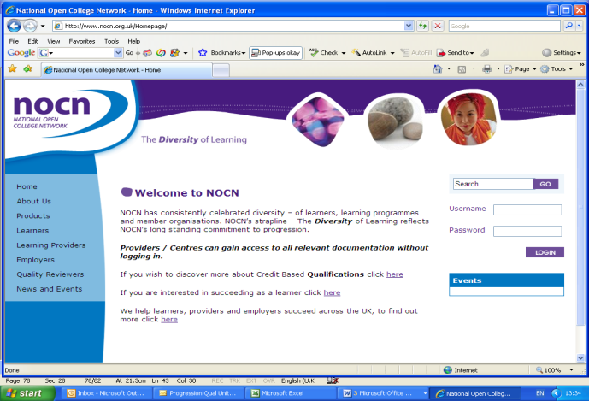

The venue will then need to select the ‘Learning Providers’ option on the menu on the left of the screen, then select the ‘Recognised Centre Area’ and finally select the ‘Form Bank’. This is done by moving across the menus from left to right. The view that you will see is shown below.

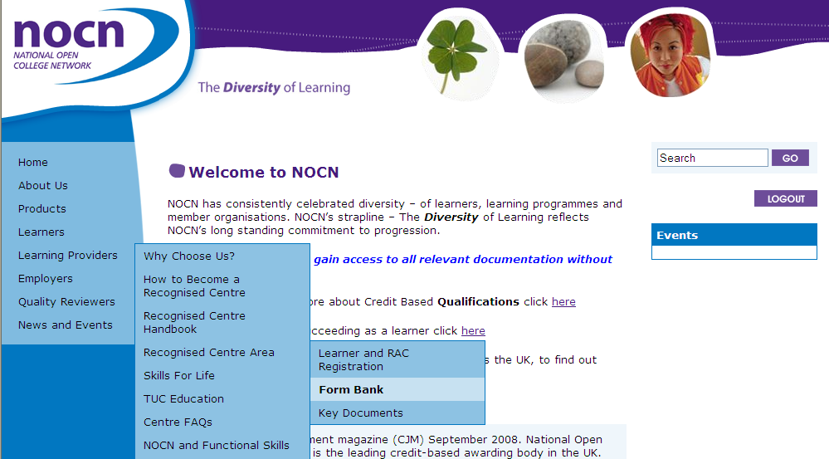

The two files are then available to download and save, see below. This is done by selecting the files and selecting whether to open or save.

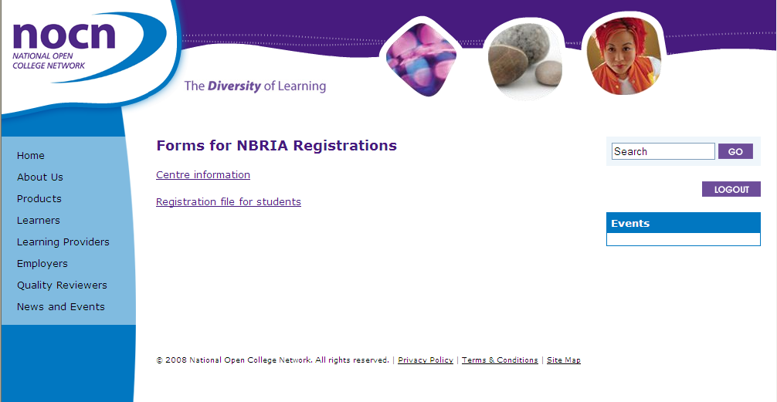

Centre Information file

The Centre Information file requires the following fields to be completed:
NOCN Centre ID Number | Course Code | Course Title | Start Date | End Date | Provider Course Reference | Teacher Name
The NOCN Centre ID Number will be provided for each venue in the first email that is sent | See below* | See below* | This is the start date of delivery of the qualification for the registered students | This is the expected time for completion of students on this course | This is a reference that is particular to the group of students ie the class and enables them to be identified as a group | This is the name of the teacher that will be delivering the course

Course Code/Title*

The course codes are:

Course Code | Course Title
130987 | NOCN Entry Level Award in General Religious Education (Entry 3) (QCF)
130986 | NOCN Level 1 Award in General Religious Education (QCF)
130985 | NOCN Level 2 Award in General Religious Education (QCF)
130988 | NOCN Level 3 Award in General Religious Education (QCF)

Registration file for students

For office use only | Provider Course Reference | ULN | Surname/  Family name | First Name | Middle Name | Date of birth | Postcode | Gender Code | Ethnicity Code | Employment Code | Student Support Code
The Registration file for students requires the following fields to be completed:

- For office use only – please leave this column blank

- Provider Course Reference - this is a reference that is particular to a group of students, ie class, and enables them to be identified as a group

- ULN - the Unique Learner Number for the learner

- Surname/Family name – it is the responsibility of the venue to ensure that these names are entered correctly as this information appears on students’ certificates

- First name – again it must be entered correctly as this information appears on students’ certificates

- Middle name – again it must be entered correctly as this information appears on students’ certificates

- The Date of Birth of the student which must be in the format dd/mm/yyyy

- The Postcode of the student’s home address – as it appears with a space between two sections and the alpha characters in upper case eg DE45 1AE

- The Gender Code for each student must be entered. The details for each code are shown below:

Gender | Code
Male | M
Female | F
Not Specified | NS

- The Ethnicity Code for each student must be entered. The details for each code are shown below:

Ethnicity | Code
White British | 01
White Irish | 02
Any Other White Background | 03
Mixed White and Black Caribbean | 04
Mixed White and Black African | 05
Mixed White and Asian | 06
Any Other Mixed Background | 07
Indian | 08
Pakistani | 09
Bangladeshi | 10
Any Other Asian Background | 11
Caribbean | 12
African | 13
Any Other Black Background | 14
Chinese | 15
Any Other Ethnic Group | 16
Not Stated | 99

If you use different ethnicity codes we have mapped these to the NOCN codes and can be found on the NOCN website under Learning Providers/Recognised Centre Area/Key Documents

- The Employment Code for each student must be entered. The details for each code are shown below:

Employment | Code
Employed Full Time | FT
Employed Part Time | PT
Unwaged Not Seeking Work | UN
Full Time Student | FS
Unemployed Seeking Work | RE
Not Specified | NS

- The Student Support Code for each student must be entered. The details for each code are shown below:

Student Support | Code
Student considers they have a learning difficulty | 1
Student does not consider that they have a learning difficulty | 2
No information provided | 3

An example of a completed registration file is as follows:

Provider Course Ref | ULN | Surname/  Family name | First Name | Middle Name | Date of birth | Postcode | Gender Code | Ethnicity Code | Employment Code | Student  Support  Code
Yr12-0910 | 1002525467 | Jones | Jenny | Anne | 12/09/1990 | S33 OZA | F | 02 | FS | 3
Yr12-0910 | 1005283786 | Smith | Fred |  | 13/03/1989 | DE45 1AE | M | 10 | FS | 2

When registering learners is it important the follow checks are made before the document is uploaded:
- Check all learners have been included on the registration file for students
      - Check that the learners are registered against the correct level
      - Check that the learner has not already achieved the qualification at the level they are being registered against. If they are registered against a qualification they have already achieved they will not be re-awarded unless a request is made to NOCN.

Once both the electronic files are completed they should be saved as a csv file. When saving the document, the option to save as a csv file should be shown, if not, please add .csv to the end of the document.

Registration process

NOCN will no longer accept emailed registration files. There is a website secure portal which each school has access to useful information in relation to the registration process. The secure portal is where schools need to upload the registration files and download the Recommendation for the Award of Credit files.

Logging into the Secure Area as a Centre to upload Registrations

The website address is www.nocn.org.uk
All venues will have been provided with a username and password in the email sent regarding registration.

The username should be input into the box marked ‘Username’ at the right of the screen

The password should be input into the box marked ‘Password’ at the right of the screen

Then press ‘Login’

The venue will then need to select the ‘Learning Providers’ option on the menu on the left of the screen, then select the ‘Recognised Centre Area’ and finally select the ‘Learner and RAC Registration’. This is done by moving across the menus from left to right. See below.



The following screen will appear:

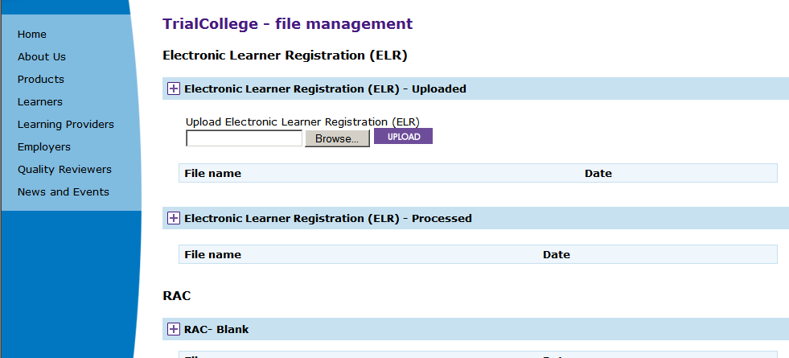

To upload Student Registration csv files:

- Press the Browse button, this will show your own electronic filing system
- Find the file which needs to be uploaded and double click on it
- The name will then appear in the box
- Press Upload
- The following screen will appear stating that ‘Electronic Learner Registration (ELR) File Uploaded’
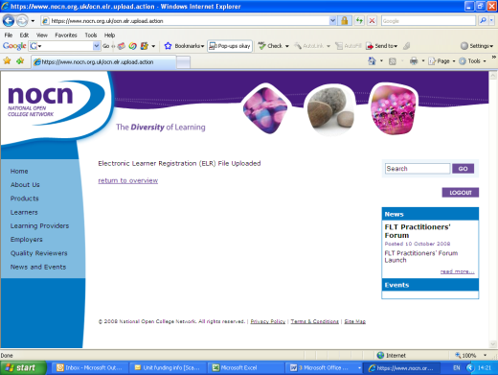

If you press ‘return to overview’ on that screen it will display that the file has been uploaded and the date, see below

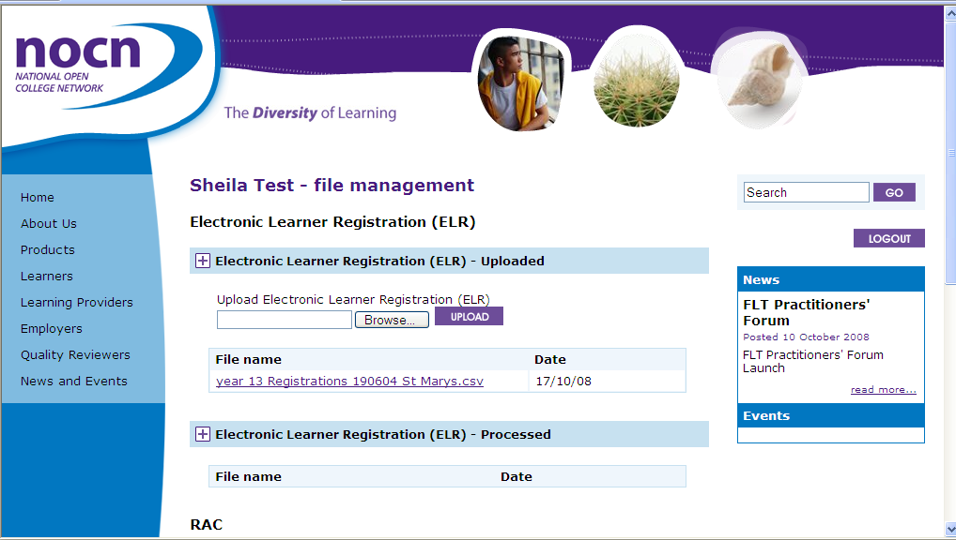

NOCN will process the Learner Registration forms and once processed the document will be moved to the “Electronic Learner Registration (ELR) - Processed” section. This allows the venue to check that the document has been processed and the date it was processed.

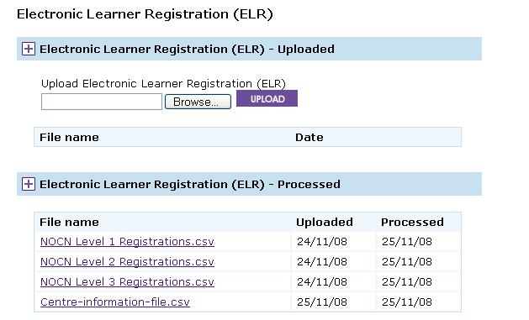

Please note that it is the responsibility of the venue to ensure that all data provided is accurate as this appears on the certificate.

Centre Information File

The same process that is documented above will need to be followed to upload the Centre Information file.

Payment Details

A charge of £27.00 per student, per registration, will be invoiced to the venue by NOCN.

- Students registered after Friday 10 December 2010 will be charged an additional late registration fee of £5 per student

- Final deadline for registration Friday 29 April 2011

- No registrations will be accepted after Friday 29 April 2011

- If there are any changes required following registration of learners an administration charge will be applied

There is a facility to pay either by cheque or by BACs. For those venues wanting to pay by BACs the details are as follows:

Name of Bank: Natwest Derby City
Sort Code: 60-12-01
Account Number: 88150062

Please note that the charge documented above is a registration charge therefore any students withdrawn after registration will not be refunded.

If you have any further queries or require clarification then please do not hesitate to contact us at the following email address ces.registrations@nocn.org.uk

Completing the Registration Process

NOCN will process the registration files and upload the Recommendation(s) for the Awards of Credit (RACs) onto the venue’s page on the website. The venue will be able to see the progress of their registrations when they log onto the site using their username and password.

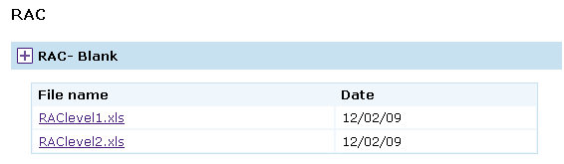

Please ignore the sections “RAC - Complete” and “RAC – Processed” on the website. These are not applicable with these qualifications.

The venue will be responsible for downloading the RACs from the Secure Portal. The venue will need to check the RAC for accuracy and any discrepancies must be reported to NOCN for amendment, please refer to the section on ‘Guidance on completing the RAC’. Only approved changes as documented within the section ‘guidance on completing the RAC’ can be made by the venue to the RAC document.

The RAC is used to claim the qualification that students have achieved on the course and must be completed by the teacher. Further information on assessment and the verification process is available from the Diocesan Advisers.

Guidance on completing the Recommendation for the Award of Credit

An RAC is in two sections. The example below is a copy of a correctly completed RAC. The first is a cover sheet that is used for the Teacher to sign to confirm that the students listed on the second page have met the requirements for the units indicated. The Diocesan Adviser countersigns to confirm that this programme has been quality assured in accordance with NOCN’s guidelines and procedures. The final signature is from the Quality Reviewer.
Recommendations for the Award of Credit – cover sheet

Line indicates withdrawn student studentstudent
Recommendation for Award of Credit (Second Page)

Programme Title: General Religious Education
Run Name / Course Title:
OPUS Programme ID: 118990
Run ID: 1187618

Student Number | Unique Learner Number | Surname | Forename | Module:  Unit: DD1/1/QQ/001  General Religious Education  1 [R/500/9837]  Credits = 3, Level =1
8515335 |  | Jones | Jenny
8515336 |  | Smith | Fred | ✓

Pre-printed information: Pre-printed information should not be amended except for spelling mistakes. In no circumstances should unit information be amended on this form. Please contact NOCN should any of the pre-printed information be inaccurate (except spelling mistakes which should be amended on the RAC form). An email can be sent to ces.registrations@nocn.org.uk

Withdrawn students: If a student has withdrawn from the course then please place a line through the students’ name on the RAC to indicate that he/she is withdrawn.

Additional students: The cut off date for final registrations is Friday 29 April 2011, no further learners will be accepted after this date. If a RAC has been produced and further students need to be included you can do this up to Friday 29 April 2011. You must submit all additional students details on a separate registration file to NOCN. A late fee will be applied if this is after Friday 10 December 2010. Learners should not be added to the RAC. If you have queries regarding this then please email ces.registrations@nocn.org.uk

Student name: Please check that the student names are spelt correctly. Any amendments to names should be corrected on the RAC form. This is to avoid inaccuracies appearing on students’ certificates. If inaccuracies appear from information supplied by the venue there will be a charge of £25.00 for a replacement certificate.

Recommending Credit: The teacher must recommend the qualification to be awarded to students by placing a tick against the unit(s) achieved either electronically or by using a pen. Pencil is not acceptable. Please do not use words or any other symbols to signify a pass or a fail. The teacher should sign the RAC once all recommendations are complete

Verifier signature: The Diocesan Advisers sign off the RACs at the Diocesan Standardisation event and then they will be ratified by the NOCN Quality Reviewers.

Please do not use tippex to delete any information on the RAC.

The RAC is returned to NOCN by the Quality Reviewer and, if completed accurately, then the certificates will be produced.

Certification

Once NOCN has received an accurately complete RAC the certificates will be produced. The certificates will be sent along with a report detailing the students that have achieved and at what level (Qualification Achievement Details, see below) and a NQ7 form (see next page).

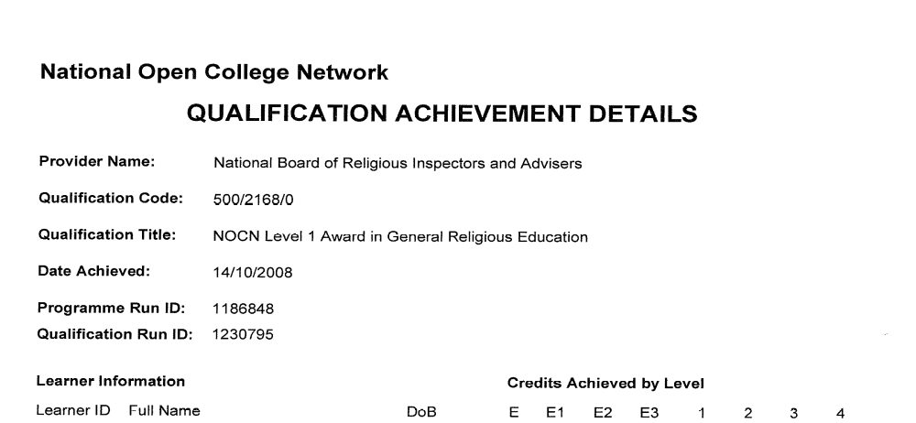

The NQ7 form is shown below and details the number of certificates that have been included which will correspond to the number listed on the Qualification Achievement Details report. This must be signed by the venue on receipt of the certificates and then returned to the address on the form by either fax or post.

Independent in this context means that the independent member is not and has not been a member of NOCN board or committee, or an employee, moderator or assessor, at any time during the past seven years. In addition, the independent members will have had no interest or involvement in the complaint/appeal.

