The Catholic values this term are:
Faithfilled and Hopeful
Today’s Wednesday Word is ‘Calm’.
The Gospel Of Mark- Jesus calming the Sea
Adapted from Mark 4:35-41 The 12th Sunday of Ordinary Time, Year B

towards Jesus and his Kingdom
o f justice and peace.”
Po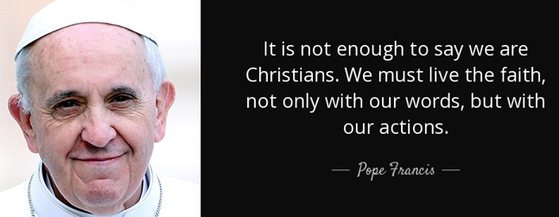pe Francis
when we journey towards Jesus and his Kingdom
of justice and peace.”
Pope Francis
“Advent is a time when we journey towards Jesus and his Kingdom
of justice and peace.”
Pope Francis
“Advent is a time when we journey towards Jesus and his Kingdom
of justice and peace.”
Pope Francis
““Advent is a time when we journey towards Jesus and his Kingdom
For Wednesday Word Mark 13:33-37 The 1st Sunday of Advent, Year B 2020

What is this Sunday’s Gospel Mark 4; 35-41
Jesus said to his disciples, “Let us cross over to the other side of the Sea of Galilee.” And leaving the crowd behind they set off.
Then it began to blow a gale and the waves beat upon the boat so that it was almost filled with water. Jesus was asleep in the stern of the boat, his head on a cushion.
They woke him and said to him, “Master, do you not care? We are going down!”
And he woke up and rebuked the wind and said to the sea, “Quiet now! Be calm!” And the wind dropped, and all was calm again.
Then he said to them, “Why are you so frightened? How is it that you have no faith?” They were filled with awe and said to one another, “Who can this be? Even the wind and the sea obey him.”

What is today’s Gospel teaching us?
Its basically teaching us when times are difficult or we are stressed, to remain faithfilled and hopeful, keep your faith and trust in God.
The Gospel is teaching us God wants us to bring peace and calm to others too.
By calming the storm and even the sea and wind listening to him, it shows Jesus really is the Son of God, the most powerful.
The Gospel helps us to reflect on the calmness Jesus was able to bring to the choppy waters. Sometimes in life, we need to mirror Christ example and remain calm and keep our faith that things will be ok, even when things look at their worse, there is always the knowledge God hears our cries for help, our anxieties and needs, and cares for us all unconditionally. We have nothing to be afraid of.
- Is there anyone you know at school, at work or in the community who may be troubled, frightened or upset?
- What can you do to help them?
- What reassurance can you give them to make them feel calm?
Calmness is an inner peace that is good for our well-being. Calm people can help others to keep calm too.
The more we get to know and trust Jesus, the calmer and more at peace we become within ourselves.

“Advent is a time when we journey towards Jesus and his Kingdom
of justice and peace.”
Pope Francis
Prayer to say as a family:
Dear Lord Jesus,
Please help me to stay calm when life is stormy and show me how I can help others to stay calm too. Amen
St John Fisher, Pray for us. #thefisherway

