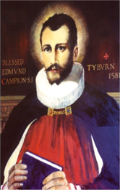 St. Edmund Campion Pray for Us

Dear Parents and Carers

As a school community we were saddened to hear that Rev. Fr. Patrick Joyce has died. He had been the parish priest at St. Mary & St. John Church in Gravelly Hill for many years prior to his retirement and had been a great friend to, and supporter of, St. Edmund Campion School.

On the evening of Thursday 11th February at 6pm the body of Fr. Joyce will be received into St. Mary & St. John Church. The Requiem Mass will then take place at Erdington Abbey on Friday 12th February at 10.00am. Attendance at both masses is by invite only. However, both the Reception Mass and the Requiem Mass are being live streamed and can be followed at
www.facebook.com/groups/frjoycefuneral. We pray for the repose of his soul.

We also pray for the repose of the soul of Canon Giles Goward who died recently. He was the Rector of St. Mary’s College Oscott. Over the years we have been glad to welcome students for the priesthood from the college to our school to gain pastoral experience as part of their formation. As a staff group we also spent a memorable day on retreat at St. Mary’s last year benefitting from the beautiful grounds and the history of the college and chapel.

Eternal rest grant unto them O Lord
And let perpetual light shine upon them.
May they rest in peace.
Amen

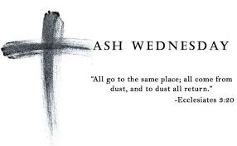
The Season of Lent

The season of Lent had only really just begun last year when we entered the first lockdown of the pandemic. As we approach Lent this year we find ourselves in another lockdown with the restrictions that has placed on all aspects of our lives. As a school community we also feel these restrictions acutely.

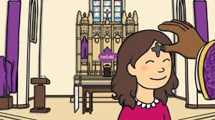
The calendar this year means that Ash Wednesday, which marks the beginning of Lent, takes place on Wednesday 17th February during the half-term break. There will be masses on Ash Wednesday in our local parishes and you will be able to find out the times of these by checking on individual parish websites. The link to St. Chad’s Cathedral that you will find later in this newsletter will also take you to information on the live streaming of mass on Ash Wednesday. It is possible that Redemptorist Publications will also provide mass so please check the link to their ‘Mass Online’ service on Ash Wednesday.

What is Ash Wednesday?

The link below gives a brief description of the significance of Ash Wednesday in the Catholic tradition:
https://youtu.be/fK2tLii4R34

Children’s Liturgy
A short liturgical resource to help you with praying together and listening to the Word of God as a family has been prepared by Redemptorist Publications and can be viewed on the link below:
https://youtu.be/GtSHkJLEcRg

What’s Going On in our Local Parish Communities

Here is a link to the Erdington Abbey parish newsletter:
http://www.erdingtonabbey.co.uk/eacontent/uploads/2021/02/Bulletin-5th-Sunday-in-Ordinary-Time-7-Feb-21.pdf

Here is a link to the parish newsletter of St. Nicholas Church in Boldmere:
https://www.stnicholasboldmere.co.uk/uploads/6/2/5/9/62597781/ot_5.pdf

Here is a copy of the parish newsletter of Christ the King Church in Kingstanding:
Here is a copy of the parish newsletter of St. Margaret Mary’s, Perry Common:

Here is a link to the parish newsletter of Holy Cross & St. Francis Church in Walmley:
https://www.hcsf.org.uk/bulletin-for-the-week-beginning-7th-february-the-fifth-sunday-in-ordinary-time/

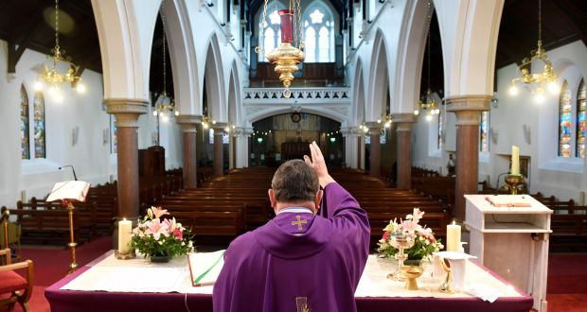
Mass Online
You will be able to access mass each day and every Sunday streamed live from St. Chad’s Cathedral and here is the link to access these:
www.stchadscathedral.org.uk

Redemptorist Publications also continue to make Sunday mass available online after 12 midday every Saturday. Mass is celebrated by Fr. Denis McBride C.Ss.R from the Redemptorist community in Chawton, Hampshire.
www.rpbooks.co.uk/holy-mass-online

Scripture Reflection – 6th Sunday in Ordinary Time – Leviticus 13:1-2 ,44-46
Mark 1:40-45
At today’s mass we hear the story of a man with leprosy. Having heard in the first reading from the book of Leviticus that people who suffered from this dreadful disease were not only isolated from their community, but also had to shout as they walked by that they were unclean.

It is unsurprising therefore that the man with leprosy in the gospel asks Jesus to cure him. His request however was framed in an interesting way:

‘If you want to, you can cure me.’

Does this tell us that the man had heard of Jesus’ healing works and that he had faith in him to take away his illness and isolation? The reply that Jesus gave to him is one that should give each of us a great sense of hope even in what we think of as normal times never mind in this time of lockdown:

‘Of course, I want to!’ he said. ‘ Be cured!’

With faith we know that when we ask for his help Jesus always wants to listen and heal us.

Let us Pray
Lord, You invite all who are burdened to come to you.
Allow Your healing Hand to heal me.
Touch my soul with Your compassion for others;
touch my heart with Your courage and infinite Love for all;
touch my mind with Your Wisdom,
and may my mouth always proclaim Your praise.
Teach me to reach out to You in all my needs,
and help me to lead others to You by my example.
Most loving Heart of Jesus, bring me health in body and spirit that I may serve You with all my strength.
Touch gently this life which you have created, now and forever.
Amen.

