Today’s Wednesday Word is ‘NEW START’
Gospel: John 1: 35-42)
Today’s Gospel refers to Jesus as ‘The Lamb of God’ and Simon Peter as ‘The Rock.
- In this Gospel, we hear about the two disciples of John the Baptist making a new start.
- They may not have known what John meant when he said ‘Look, there is the Lamb of God,’ but they knew what he wanted them to do:
- They had to start afresh and get close to Jesus. Once John’s disciples got to know Jesus, they couldn’t wait to tell their friends and share their joy with them.
- Regardless of our past, God is always ready to help us to begin again.
- God invites each one of us to ‘Come and See’ – to make a New Start with Him, each and every day.
- John’s followers made a new start after discovering Jesus. This new year in 2021 presents an opportunity for us to make a new start.
- What new starts in 2021 have you made?
- How are your new promises/ resolutions going to help you or others?
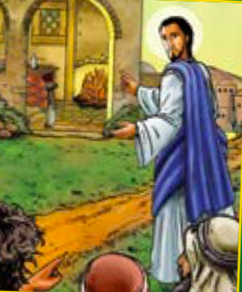What new starts in 2021How are your new promises/ resolutions going to help you or others?
St John Fisher …Pray for
#thefisherway
Wednesday Word – NEW START- Wednesday 13th January 2021

“Advent is a time when we journey towards Jesus and his Kingdom
of justice and peace.”
Pope Francis
“Advent is a time when we journey towards Jesus and his Kingdom
of justice and peace.”
Pope Francis
“Advent is a time when we journey towards Jesus and his Kingdom
of justice and peace.”
Pope Francis
“Advent is a time when we journey towards Jesus and his Kingdom
of justice and peace.”
Pope Francis
““Advent is a time when we journey towards Jesus and his Kingdom
For Wednesday Word Mark 13:33-37 The 1st Sunday of Advent, Year B 2020

“Advent is a time when we journey towards Jesus and his Kingdom
of justice and peace.”
Pope Francis

