Monday 22nd February

WELCOME: In the name of the Father and of the Son and of the Holy Spirit. Amen.
This week our theme is Lent and Temptation
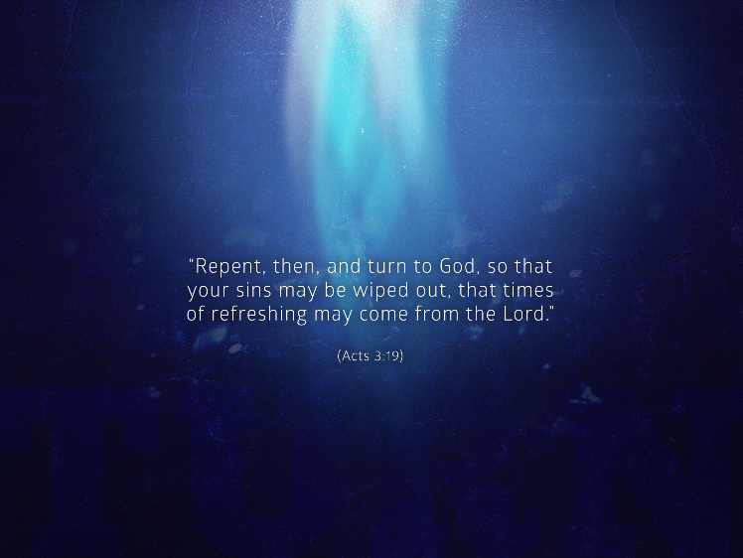

WORD: Matthew 4:1-5
At that time Jesus was led by the Spirit into the desert to be tempted by the devil. He fasted for forty days and forty nights and afterwards was hungry. The tempter approached and said to him, “If you are the Son of God, command that these stones become loaves of bread. He said in reply, “It is written: One does not live on bread alone, but on every word that comes forth from the mouth of God.” Then the devil took him to the holy city and made him stand on the parapet of the temple and said to him, “If you are the Son of God, throw yourself down.

WORSHIP: We pray that this fast of forty days makes this a holy season of self-denial. By rejecting the devil’s temptations he has taught us to rid ourselves of the hidden corruption of evil, and so to share his paschal meal in purity of heart, until we come to its fulfilment in the promised-land of heaven. Lord in your mercy. Hear our prayer.
WITNESS: How can we use the forty days of Lent as a retreat —making time to be more reflective and pray?

MEDITATION (click on the link and turn on the sound)
https://www.loyolapress.com/retreats/being-mindful-start-retreat/
We conclude our prayer in the name of the Father and of the Son and of the Holy Spirit. Amen

