Year 6: Unit F – Lent
Unit scripture
Lk. 15: 19-31 – The Parable of the Rich Man and Lazarus
Mt. 6: 1-8, 16-18 – The Teaching of Jesus on Prayer, Fasting and Almsgiving
Mt. 25: 31-45 – The Parable of the Sheep and the Goats.
Mt. 5: 1-12 – The Beatitudes of Jesus
Lk. 6: 20-26 Jn. 4: 1-40 – The Samaritan Woman at the Well
Genesis: 18: 20-32 – Abraham appeals to God.
Psalm 51 – A Psalm seeking God’s Mercy and Forgiveness
Scripture video links

The Parable of the Rich Man and Lazarus
https://www.youtube.com/watch?v=rZOM1W69ZOY&feature=youtu.be Clideo.com
www.youtube.com/watch?v=2FH0y-mSl0k ShareFaith Kids

Mt.6:1-8,16-18 – The Teaching of Jesus on Prayer, Fasting and Almsgiving
https://www.youtube.com/watch?v=j0IwNCDmYZw

The Parable of the Sheep and the Goats
https://www.warrencampdesign.com/parables/parable.5e.sheep-and-goats.html LifeKids

The Samaritan Woman at the Well
https://www.youtube.com/watch?v=0cdw1KH-eU8 GraceLink
https://youtu.be/QszHeIUsbTQ The Gospel Project for Kids
https://youtu.be/6Vf3rqnoG5c The Bible Story LifeKids
https://youtu.be/kM6KzGeBXZ8

Abraham appeals to God
https://youtu.be/BbPJgVWPpPM
*Please note after14 minutes in of the video, Abraham appeals to God

Lenten videos
Lent Video- 40 Days of Jesus in The Desert
https://www.youtube.com/watch?v=2Xb8-mkSNSg&feature=youtu.be
Ash Wednesday & Lent for Kids: https://www.youtube.com/watch?app=desktop&v=eDvf527E8Dg TradKidsTV
Lenten symbols: https://www.youtube.com/watch?app=desktop&v=MX4HcWGD_Rc
Lent Explained: https://www.youtube.com/watch?v=ukIBEWtlqDg
Ash Wednesday and Lent in 60 seconds-with Lego:
https://www.youtube.com/watch?app=desktop&v=beWSVFNPw0s Trideo Media
Catholic Kids Media- Ash Wednesday and Lent: https://www.youtube.com/watch?app=desktop&v=axNEQaBKI9g
Lent- Catholic Central: https://www.youtube.com/watch?app=desktop&v=QJBMw2pQZiA
BBC Bitesize: What is Lent? https://www.bbc.co.uk/bitesize/topics/ztkxpv4/articles/z77jf4j

Share with your family every day of Lent the CAFOD Family Lent Calendar https://cafod.org.uk/Education/For-families/Family-Lent-Calendar-2021
or the Missio Lent Calendar.
https://missio.org.uk/lent/

Suggested Activities

The Samaritan Woman at the Well
Write the next episode in the Story of the Samaritan Woman. Think about some of the things she would have told her friends and neighbours the next day. Imagine her thoughts and feelings the next time she went to the well to draw water.
Think about the imagery of water. Where else is there water in scripture? Is there a link here? How is water used in the sacraments? e.g. Baptism and the Mass
How is water used in the Church? e.g blessing oneself when entering church, blessing things to make them holy.

Examination of Conscience
What might you include in an Examination of Conscience?
Write a version which could be used during the Season of Lent as a personal reflection each day.
Or
Can you create an Examination of Conscience calendar for younger children to use on a weekly basis?

Psalm 51
Using a psalm format, create a prayer asking for forgiveness. You might want to use words and images found in Psalm 51.

The Beatitudes of Jesus
Read, reflect and pray The Beatitudes of Jesus (Mt. 5: 1-12) using Lectio Divina (an ancient way of praying with sacred reading).

The Sacrament of Reconciliation
Imagine you were meeting somebody who had never heard about the Sacrament of Reconciliation. What would you tell them? How would you explain its importance?

Lent
Make a table listing the teachings of Jesus in one column, why they are important in another and in a third column add some thoughts and ideas about what people can do to live out this teaching of Jesus during the Season of Lent.

Think about some real-life scenarios where they have the choice of being selfish or being generous. Children should identify the consequences of their choice.
In the news, who has demonstrated being grateful and generous or encouraging others to be generous? e.g. Marcus Rashford, Sir Captain Tom Moore etc.

How much do you know about Lent? True or False quiz
https://cdn2.hubspot.net/hubfs/275132/_catholicmom/Lesson%20Plans/lent_tf.pdf
Please see https://www.catholicmom.com/resources for other similar Lenten activities etc.
Create your own Lenten calendar:
http://religiouseducation.rccdsb.edu.on.ca/wp-content/uploads/sites/26/2010/06/MyLentenCalendar.pdf

Listen to the song: ‘You Make Beautiful Things’ by Gungor https://www.youtube.com/watch?v=3Cp6F2orRYo
Key questions
Lent
Why do you think Jesus wanted his disciples to pray, fast and give alms? Provide three reasons why these religious practices are important. Which of these do you think are the most important?
Which of these do you need to concentrate on the most for yourself?
Do you think it’s hard or easy to say sorry? Explain why.
Do you think it’s hard or easy to forgive? Explain why.
How do you think Christians in the world today can help to build God’s Kingdom on Earth, for example how can we solve the problem of poverty?

Pray
- Stations of the Cross
- Different Acts of Contrition
- Examination of Conscience

St. Ignatius of Loyola prayer of the hand
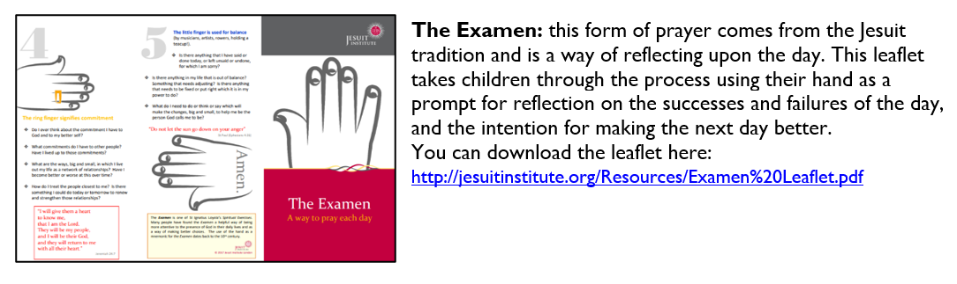
Making the Lenten Journey-praying in colour activities for Lent
https://prayingincolor.com/tag/lent

