Wednesday 29th April 2020 Collective Worship – St Thomas Aquinas
If you can, it might help to set aside a space for prayer, light a candle to focus.
Collective Worship
- Start with the Sign of the Cross
- Take time to read today’s scripture passage (Matthew 14:22-33)

22 Jesus made the disciples get into the boat and go on ahead to the other side of the lake, while he sent the people away. 23 After sending the people away, he went up a hill by himself to pray. When evening came, Jesus was there alone; 24 and by this time the boat was far out in the lake, tossed about by the waves, because the wind was blowing against it.
25 Between three and six o'clock in the morning Jesus came to the disciples, walking on the water. 26 When they saw him walking on the water, they were terrified. “It's a ghost!” they said, and screamed with fear.
27 Jesus spoke to them at once. “Courage!” he said. “It is I. Don't be afraid!”
28 Then Peter spoke up. “Lord, if it is really you, order me to come out on the water to you.”
29 “Come!” answered Jesus. So Peter got out of the boat and started walking on the water to Jesus. 30 But when he noticed the strong wind, he was afraid and started to sink down in the water. “Save me, Lord!” he cried.
31 At once Jesus reached out and grabbed hold of him and said, “What little faith you have! Why did you doubt?”
32 They both got into the boat, and the wind died down. 33 Then the disciples in the boat worshiped Jesus. “Truly you are the Son of God!” they exclaimed.

Short Reflection
This famous Gospel passage will be read this coming Sunday, so we are reading it ahead in order to prepare us for ‘Good Shepherd Sunday’ where we will be focusing on vocations. Deacon Owen from the Vocation’s Office has prepared an assembly which can be shown on Monday.

Peter took his first courageous step as he climbed over the side of the boat. He was looking at Jesus, not at the water. He responded with Jesus' invitation: ‘Come’. So often the way out of depression, fear or anxiety is not a thought or a consideration, but a physical step. At the moment we might be afraid of what is happening in the world. We are out of routine and also hear sad stories on the news. It is time for me to take a risk, and find myself strong enough to walk forward, keeping my eyes on the Lord like Peter did.

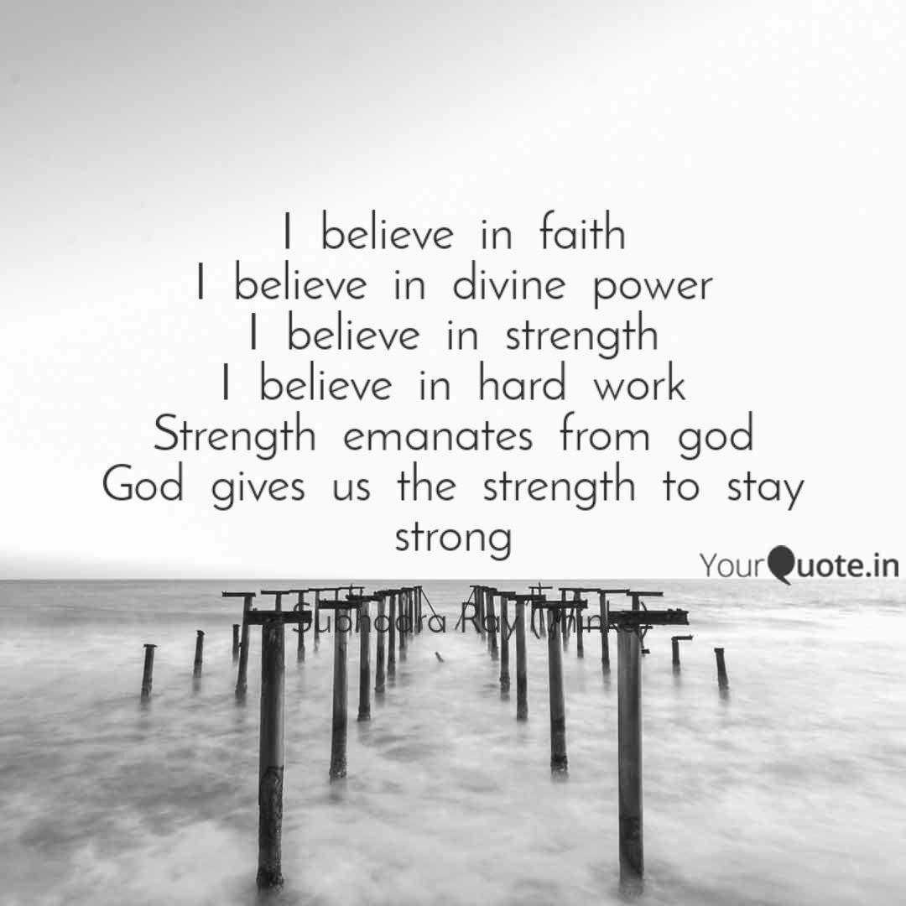

- Our Father
Our Father, Who art in heaven,
Hallowed be Thy Name.
Thy Kingdom come.
Thy Will be done,
on earth as it is in Heaven.
Give us this day our daily bread.
And forgive us our trespasses,
as we forgive those who trespass against us.
And lead us not into temptation,
but deliver us from evil. Amen.

- School Prayer
Christ, you are the centre of our school community
Help us to live together in peace
Help us to love one another as you have loved us
Help us to learn your ways so that the truth will set us free.
Amen

- St Thomas Aquinas, Pray for us

- Finish with the Sign of the Cross
Suggested song for the day: ‘Will you come and follow me’ (The Summons )by John L Bell
https://www.youtube.com/watch?v=o469PRLdbHU

