Tuesday 28th April 2020 Collective Worship – St Thomas Aquinas
If you can, it might help to set aside a space for prayer, light a candle to focus.
Collective Worship
- Start with the Sign of the Cross
- Take time to read today’s Gospel John 6:30-35

The people said to Jesus, ‘What sign will you give to show us that we should believe in you? What work will you do? Our fathers had manna to eat in the desert; as scripture says: He gave them bread from heaven to eat.’
Jesus answered:
‘I tell you most solemnly,
it was not Moses who gave you bread from heaven,
it is my Father who gives you the bread from heaven,
the true bread;
for the bread of God
is that which comes down from heaven
and gives life to the world.’
‘Sir,’ they said ‘give us that bread always.’ Jesus answered:
‘I am the bread of life.
He who comes to me will never be hungry;
he who believes in me will never thirst.’

Short Reflection
If we accept Jesus and allow ourselves to grow in love of Him, we will find that He is the "bread of life" for which we hunger. What is preventing you from seeing and experiencing Jesus as the bread of life? What preconditions are you laying down before you encounter Him?
We sometimes approach Jesus in the same way, asking for what we need, expecting a particular answer. Jesus wants to open our hearts to receive what God is offering; sometimes it is not the answer we want.
For example we may ask God to let us see our friends and family just for one hour during lockdown. We may also ask him to stop people dying of the Cornavirus. We must pray to God for those who are sick or dying and ask for His love to be poured down on them and their families.

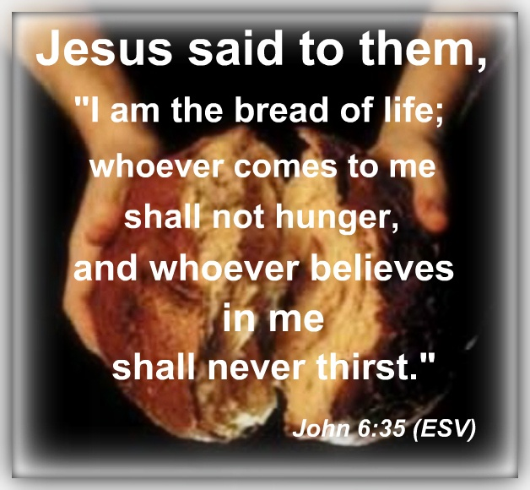
- Our Father
Our Father, Who art in heaven,
Hallowed be Thy Name.
Thy Kingdom come.
Thy Will be done,
on earth as it is in Heaven.
Give us this day our daily bread.
And forgive us our trespasses,
as we forgive those who trespass against us.
And lead us not into temptation,
but deliver us from evil. Amen.

- School Prayer
Christ, you are the centre of our school community
Help us to live together in peace
Help us to love one another as you have loved us
Help us to learn your ways so that the truth will set us free.
Amen

- St Thomas Aquinas, Pray for us

- Finish with the Sign of the Cross
Suggested song for the day: ‘Bread of Life – by Jo Boyce and Mike Stanley
https://www.youtube.com/watch?v=COo9G3V0dx4

