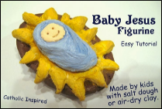******

**Prayer for All Souls Monday November 2nd**

**Jesus, dear Saviour,**

On this day we prayerfully remember all our loved ones who have died.

Please give them comfort and hope and may they be at peace, knowing that they will rest in God’s arms eternally.

Thank you for our memories of them and for the good times we shared.

We ask You, please, through their intercessions, to deepen our faith, strengthen our hope and increase our love that we, too, may someday stand before You, ready to enter Your Holy kingdom.

**Amen**

**CAFOD**

**World Gifts:** CAFOD have a range of alternative virtual charity gifts that can transform lives. For a small donation, you can gift water, health care packs or even a goat! Follow the link for more details: https://worldgifts.cafod.org.uk/

**Virtual Visits:** CAFOD have developed virtual visits so a volunteer can explore and share the work of CAFOD with your class. More details can be found: https://cafod.org.uk/Education/For-teachers/CAFOD-in-your-area

**Interactive Advent Calendar:** Each day of Advent can be marked through the use of the CAFOD Interactive Advent Calendar. This gives a range of facts and challenges for each day. The calendar will be available on the CAFOD website from the start of Advent.

**CPD:** Connecting classrooms through global learning CPD is available free of charge from CAFOD. This is part funded by the British Council and will provide a range of interactive teaching ideas. https://cafod.org.uk/Education/For-teachers/Connecting-Classrooms-CPD

**Home School Learning:** Resources available; https://cafod.org.uk/Education/Primary-teaching-resources/Home-learning-primary

**Advent traditions from around the world**

You can use opportunities to explore Advent around the world. You could use https://www.whychristmas.com/cultures/

A traditional celebration in Poland is to decorate booths in the village and city squares with called Joselki with Christmas themes and are on display from early December to New Year’s Day. Special efforts are made by families and businesses to make their booth the favourite, with scenes from the Christmas story. Small gifts, sweets and Christmas Cards are distributed from the booths to passers-by, and normally carolling troops move from booth to booth on Christmas Eve, after which villagers makes their way to the Church to celebrate the Christmas Vigil Mass.

**Bambinelli**

Last year we had a phenomenal response to the Bambinelli initiative. Why not make this an annual Advent tradition in school? Represent baby Jesus and ask your Priest to bless them on the third Sunday of Advent (Gaudete Sunday).

**Missio – Assembly and Resources**

**November – We remember those who have died.**

This year, **Mission Together** have created a new **All Saints’ Assembly** to remind students that the saints in heaven intercede for us and how they offer an example of lives of holiness. students can discover how saints from each of the five continents are an inspiration to people everywhere. The assembly can be delivered in full or you may wish to reflect on each saint separately throughout the month.

For this month of the Holy Souls Missio have a **Liturgy and Activities for Holy Souls** in which students learn that Jesus has shown us that God’s love is so great, even death cannot separate us from Him. The prayers and activities help children to know that even though we may not understand when someone dies, we can always ask God to comfort us.

Missio’s resources can be found; <https://missiontogether.org.uk/resources-by-month/calendar-november/>

**Jesse Tree**

The Jesse Tree is an Advent tradition that many Christians use to prepare for the coming of Christ at Christmas. ‘It is a great way to teach children about the descendants of Jesus linking the Old Testament to the New Testament as an Advent countdown calendar.’

The name comes from Isaiah 11:1: “But a shoot shall sprout from the stump of Jesse, and from his roots a bud shall blossom.” It starts on December 1st with Creation and ends with the birth of Jesus on December 25th.

All through Advent, we hear scripture readings at Mass that remind us of the ancestors of Jesus. The basic concept behind a Jesse Tree is that you have one ornament for each day in December, and it counts down to the coming of Christ on the 25th. Each ornament stands for a person or event from the Old Testament that leads up to the coming of Christ. Every day, you can hang an ornament on the tree that symbolises that biblical event and share a piece of scripture about that Bible story.

There are various Jesse Tree resources available including instructions on how to make one on Pinterest and Catholic Icing: https://www.catholicicing.com/jesse-trees/

You can order a free printed version of the Jesse Tree:

https://www.Godwhospeaks.uk/the-god-who-speaks/education/advent-jesse-tree/

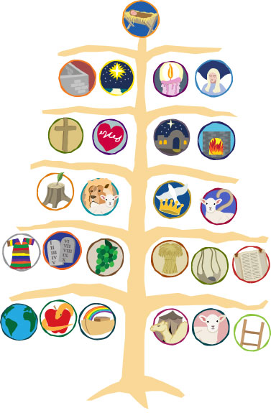

**Prayer Focus**

Prayer focus cloths should be green which is the Liturgical season of Ordinary Time until the season of Advent begins on Sunday 29th November when they change to purple.

November is the month for the Holy Souls in the Church’s Liturgical year.

Studentscould be invited to share their prayer intentions for friends and family members who have died and those who have no one to pray for them. A popular method of collecting prayer intentions is in the form of a Remembrance book or a basket placed upon a prayer focus.

**Advent**

Gradually build up the Nativity scene over Advent but the figure of baby Jesus must not be included until the last day of term. You may also wish to include images which relate to your Advent fundraising.

**“And the word became flesh and dwelt among us”**

**John 1:14**

**Staff/tutor Noticeboard Autumn 2**

***Follow @BhamDES***

**Dates for the Diary\***

**November**

**The Pope’s Prayer Intention for November:** **Artificial Intelligence**

Mon 2 All Souls Day

Tues 3 Memorial of St Martin De Porres

Thurs 4 Memorial of St. Charles Borromeo

Mon 9 Feast of the Dedication of the Lateran Basilica

Tue 10 Memorial of St Leo the Great

Wed 11 Memorial of St Martin of Tours

Thurs 12 Memorial of St Josaphat

Mon 16 Memorial of St Edmund of Abingdon

Memorial of St Margaret of Scotland

Tue 17 Memorial of St Hilda

Wed 18 Memorial of the Dedication of the Basilica of Ss Pater & Paul

Sun 22 Solemnity of Our Lord Jesus Christ, King of the Universe (World Youth Sunday)

Mon 23 Memorial of St Clement

Memorial of St Columban

Tues 24 Memorial of St Andrew Dung-Lac

Weds 25 Memorial of St Catherine of Alexandria

Mon 30 Feast of St Andrew, Apostle

**December**

**The Pope’s Prayer Intention for December:** For a Life of Prayer

Tue 1 Feast of St Edmund Campion

Thur 3 Memorial of St Francis Xavier

Fri 4 St John Damascene

Mon 7 Feast of St Ambrose

Tue 8 Solemnity of the Immaculate Conception

Wed 9 St John Diego Cuauhtlatoatzin

Thur 10 Memorial in Staffordshire of St Edmund Ginnings

Fri 11 Memorial of St. Damasus I

Mon 13 Memorial of St. John of the Cross

*\*For a complete list of dates, readings and colours please refer to the Archdiocese of Birmingham Ordo 2019-2020.*