Un mondo che prega insieme – One World Praying Together
Mercoledì 13 maggio 2020 – Wednesday 13th May 2020
The month of May is the month we dedicate to our Lady. We pray to Mary and ask for her intercession to help us through life and all the happiness and challenges it brings. Today, as we contemplate the glorious mysteries and the wonderful Good News that our Lord brings to us every day of our lives. We ask our Lady’s help to keep us all well, strong, courageous, generous and positive, knowing that there is hope and much more happiness to come in our lives.
Today, I am sending the Holy Rosary in Italian, with some Art of Italian masters on which to focus while praying. The Mysteries that we contemplate today and every Wednesday and Sunday are the Glorious Mysteries (I Misteri Gloriosi.) The Resurrection (La Risurrezione), The Ascencion (L’Ascensione), The Descent of the Holy Spirit (La Pentecoste), The Asumption (L’Assunzione di Maria) and The Crowning of Mary Queen of Heaven (L’Incoronazione di Maria, regina del cielo).
Il segno della Croce (Sign of the Cross): “In the name of the Father, the Son and of the Holy Spirit.” Amen
Nel nome del Padre, e del figlio, e dello Spiritu Santo. Amen.
Il Credo degli Apostoli – The Apostles’ Creed: “I believe in God, the Father Almighty, creator of heaven and earth and in Jesus Christ, His only son, our Lord, who was conceived by the Holy Spirit, born of the virgin Mary, suffered under Pontious Pilate, was crucified, died and was buried. He descended into hell, the third day he rose again from the dead; He ascended into Heaven, sitteth at the right hand of God, the Father Almighty, from thence He shall come to judge the living and the dead. I believe in the Holy Spirit, the Holy Catholic Church, the communion of saints, the forgiveness of sins, the resurrection of the body, and life everlasting. Amen”
Io credo en Dio, Padre onnipotente, creatore del cielo e della terra; e en Gesù Cristo, suo unico Figlio, nostro Signore, e quale fu concepito di Spririto Santo, nacque da Maria Vergina, patì sotto Ponzio Pilato, fu crocifisso, morì e fu sepolto, discese agli inferi, il terzo giorno riscusitò da morte, salì al cielo siede alla destra di Dio Padre onnipotente; di la verrà a giudicare I vivi e I morti. Credo nello Spirito Santo, la santa Chiesa cattolica, la Comunione dei santi, la remisione dei pecatti, la risurrezione della carne, la vita eterna. Amen.
Padre Nostro – The Our Father: “Our Father who art in Heaven, hallowed be Thy name, Thy kingdom come, Thy will be done on earth as it is in Heaven. Give us this day our daily bread and for give us our trespasses as we forgive those who trespass against us, and lead us not into temptation but deliver us from evil. Amen.”
Padre nostro che sei nei cieli, sia santificato il tuo nome, venga il tuo regno, sia fatto la tua voluntà come in cielo così in terra. Dacci oggi il nostro pane quotidiano, e rimetti a noi I nostri debiti come noi li rimettiamo ai nostri debitori, e non ci indurre in tentazione, ma liberaci dal male. Amen.
Ave María – The Hail Mary: “Hail Mary full of grace, the Lord is with thee, blessed art thou amongst women and blessed is the fruit of thy womb Jesus. Holy Mary, mother of God, pray for us sinners now and at the hour of our death. Amen.”
Ave, o Maria, piena di grazia, il Signore è con te. Tu sei bendetta fra le donne e bendetto è il frutto del tuo seno Gesù. Santa Maria, Madre di Dio, prega per noi peccatoti, adesso e nell’ora della nostra morte. Amen
La Gloria – The Glory Be: “Glory be to the Father, the Son and the Holy Spirit, as it was in the beginning, is now and ever shall be, world without end. Amen”
Gloria al Padre, e al Figlio e allo Spirito Santo. Come era nel principio, ora e sempre, nei secoli dei secoli. Amen
La Risurrezione Raphael

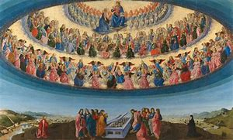
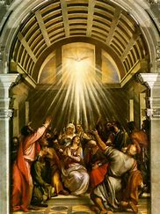
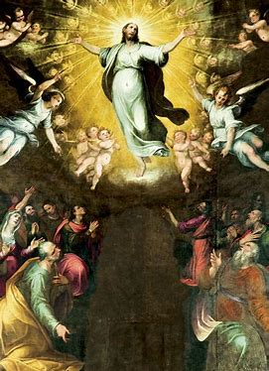
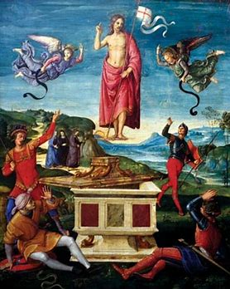
L’Assunzione della Virgen Maria Francesco Botticini
La Discesa dello Spirito Santo Tiziano
L’Ascensione di Gesù
Nicolò Circignani
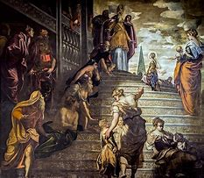
Il Coronamento di Maria Tintoretto

