**Reflection on Psalm 106**

This Sundays psalm is from Psalm 106 with the response " O, give thanks to the Lord, for his love endures."

The verses are focused on perils experienced at sea. They are about ships facing troubles, fears about drowning and in general it is a prayer for help and safety for those at sea. It ends praising God for his care and protection for those that sail, for ultimately, God's love endures.

Many of you I am sure will have heard last weekend of the story of the real-life Jonah! Michael Packard who, whilst lobster fishing was caught and then spat back out again from a humpback whale!! Anyone listening to his testimony and watching how emotional he got whilst describing what he obviously thought was "this is it" cannot be failed to be moved.  Michael talks about his thoughts and emotions as it dawns on him where he is and what is about to happen.

Of course, for Michael, thank God, he has a miraculous recovery. The whale spits him out and he is able to get away. He lives to see another day!  And just like the psalmist, tells us God's love has endured.

And although, it would be far-fetched to liken our covid experiences with the traumatic experiences of Michael, it may feel fair to say that we feel at times we are in the mouth of a whale. We think we are moving forward, getting back to our "normality" and our security, the job we know well and thrive in doing. Only to have the goal posts changed again and for us to be left wondering - "is this it?"

But in peril, danger and uncertainly, our faith is what must sustain us. The psalmist ends by praising God who has calmed the waters. These troubled waters will also, at some time, calm. And we will know God's love has endured.

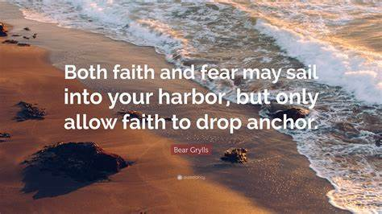

Until then, let us pray that our love and support of one another may calm the waters for those around us.

With love and prayers for a wonderful ......and calm..... weekend,