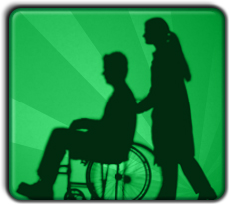
Read the case studies below.
Make notes on whether the life should be SAVED or allowed to DIE and explain why you think this.
Jodie and Mary were conjoined twins, born in Manchester in 2000. Doctors predicted that, if no intervention occurred, Jodie and Mary would both die in around three months. They also said that if you separated them, one of the twins would certainly die, while the other twin would probably live.
A man has killed several people and been found guilty. He is on death row in Texas. There is possible evidence, which would prove his innocence.

Diane Pretty was a terminally ill British woman who fought a legal battle to allow her husband to help her commit suicide
Sian is 18, and is working. She has done well since leaving school. She hopes to continue and get promotion. She has a steady boyfriend, David. They hope one day to marry. David is at university. He is studying religion and hopes to be a teacher. She is pregnant and thinks she should have an abortion.
"Baby Theresa," was born in Florida in 1992. She effectively had "no brain", and doctors predicted that she would die within two weeks. Her parents asked the doctors to use her organs to save other lives if possible.
The doctors were prevented from taking organs from Baby Theresa by Florida law. Doing so would involve killing Baby Theresa, which would be illegal. Baby Theresa died at 9 days old. By this stage, her organs were no longer of any use.

