Prayer service for Students during the coronavirus pandemic

READER 1)

(slide 2-6)

Pope Francis’ Prayer to Mary during the coronavirus pandemic
O Mary,
you always shine on our path
as a sign of salvation and of hope.
We entrust ourselves to you, Health of the Sick,
who at the cross took part in Jesus’ pain, keeping your faith firm.
You, Salvation of the Roman People,
know what we need,
and we are sure you will provide
so that, as in Cana of Galilee,
we may return to joy and to feasting
after this time of trial.
Help us, Mother of Divine Love,
to conform to the will of the Father
and to do as we are told by Jesus,
who has taken upon himself our sufferings
and carried our sorrows
to lead us, through the cross,
to the joy of the resurrection. Amen.
(Slide 7) Why Should we pray? (teacher reads this out)
This is an occasion for all of us – especially in families – to pray more intensely for each other and especially for those who have succumbed to the illness. We should pray also for those at the frontlines – especially doctors, nurses and medical staff and other carers, including clergy – that the Lord will protect them as they place their own wellbeing at risk in the service of all.
Bishops are suggesting that the following prayers be recited at this time:
(SLIDE 8)
Extract from Saint Patrick’s Breastplate
Christ with me,
Christ before me,
Christ behind me,
Christ in me,
Christ beneath me,
Christ above me,
Christ on my right,
Christ on my left,
Christ when I lie down,
Christ when I sit down,
Christ when I arise,
Christ in the heart of everyone who thinks of me,
Christ in the mouth of everyone who speaks of me,
Christ in every eye that sees me,
Christ in every ear that hears me.

SLIDE 9 – listen to an Irish version of the prayer above – the youtube link is in the notes below the slide
https://www.youtube.com/watch?time_continue=44&v=08GiSEUAGC8&feature=emb_title

BIDDING PRAYERS – (see separate sheet – 10 bidding prayers – each child can read a prayer each)

(1 reader)
(SLIDE 11)
Memorare
Remember, O most gracious Virgin Mary,
that never was it known that anyone who fled to your protection,
implored your help, or sought your intercession was left unaided.
Inspired with this confidence,
I fly to you, O Virgin of virgins, my Mother.
To you I come, before you I stand, sinful and sorrowful.
O Mother of the Word Incarnate,
despise not my petitions, but in your mercy, hear and answer. Amen.

(SLIDE 12)The poem ‘Lockdown’ (1 reader or teacher)

An Act of Spiritual Communion (teacher explain)
This is a simple and loving act of Spiritual Communion we are called to make in these times, while we are unable to attend Mass and receive the Eucharist:

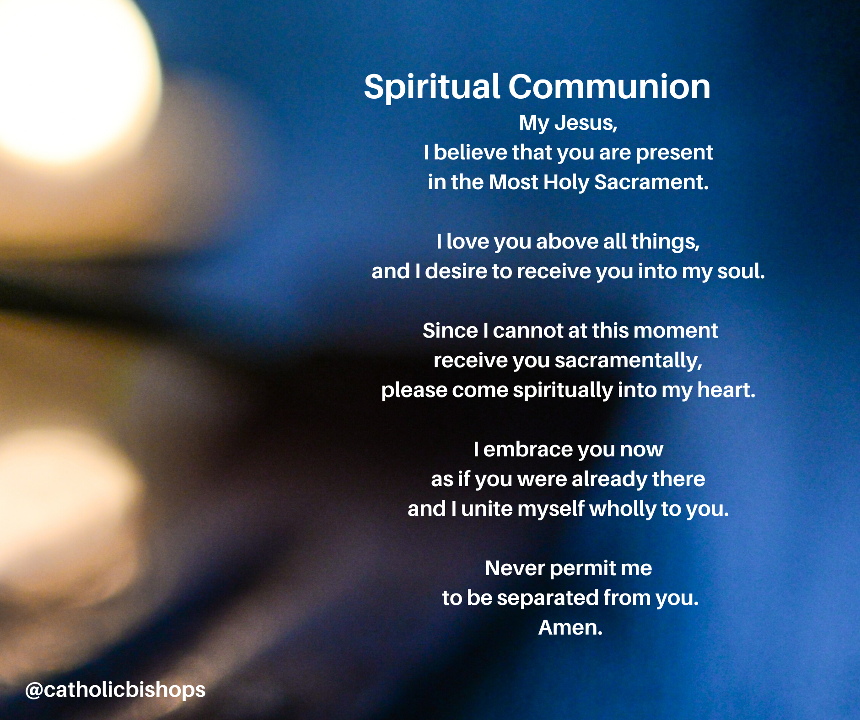
SLIDE 14 (all read together)
A Coronavirus Prayer
Loving and healing God,
we, the people of St Thomas Aquinas turn to you in prayer,
confident that you are with us and with all people in every moment.
We stand before you as people of hope, trusting in your care and protection.
May your faithful love support us and soothe the anxiety of our hearts.

