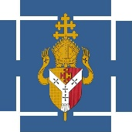
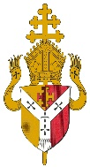
Diocesan Education Service
Certificate of Thanksgiving for
Dedicated Service to Catholic Education

The Diocesan Education Service is pleased to announce the introduction of a Certificate of Thanksgiving for Dedicated Service to Catholic Education. The certificate is awarded by the Diocese and is signed by Bishop David McGough, who has responsibility for Catholic schools, on behalf of the Archbishop.
The certificate may be awarded to those individuals working in Diocesan schools who have made an especial contribution to Catholic Education through their dedicated service on the occasion of their retirement.
School leaders, including governors, may nominate suitable candidates for this award and will need the support of the parish priest/chaplain of the school
The Application Form must be submitted to Fr Jonathan Veasey on behalf of the Trustees of the Archdiocese , outlining the reasons why the nominee would be a suitable candidate to receive it. Please note that this certificate is in recognition of service over and above what would normally be expected. This award is not open to those school leaders who are eligible to receive the Ubi Caritas Award.
Application Forms can be downloaded from the DES website www.bdes.org.uk

Diocesan Education Service

Application form for
Certificate of Thanksgiving for
Dedicated Service to Catholic Education

Name of Nominee
(as it would be written on the certificate)
Role in school
Briefly outline the reasons why the nominee is deserving of this award:
Name of Nominator &
Role in school
Name & signature of Parish Priest

Return Name and Address for the Certificate

Date the certificate is required by

Please send the completed form to: Mrs B. Harding, PA to Director, Diocesan Education Service, Don Bosco House, Coventry Road, Coleshill B46 3EA or b.harding@bdes.org.uk

