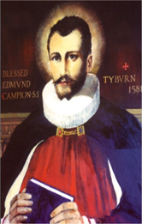 St. Edmund Campion Pray for Us
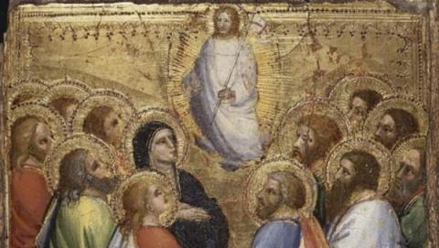

Dear Parents and Carers

This week as we continue to journey through the Easter season we celebrate one of the great feasts of the church – The Ascension of Our Lord.

As we know Jesus became man and lived life and all that goes with humanity including suffering, despair and death. All things that we as human beings and members of God’s family experience.

The feast of the Ascension takes us beyond any human experience and allows us to begin to imagine what it means to live in a world where Jesus is King.

We will be attending mass for the feast of the Ascension on Thursday, and will be joining the staff and pupils of St. Peter and St. Paul Primary School via a Zoom link when mass will be celebrated by Fr. Joe McLoughlin from the parish church of St. Peter and St. Paul.

We thank our Academy colleagues and Fr. Joe for enabling us join with them in this celebration.

Eid ul-Fitr

We remember this week our Muslim sisters and brothers as they commemorate the end of the month long fast during Ramadan.

Eid ul -Fitr means ‘the festival of breaking the fast’ and is a time when family, friends and the local community come together to enjoy a feast of food and everyday blessings.

Eid is a time of great joy and the celebration is looked forward to with gifts being exchanged after a time of fasting, prayer and self-reflection.

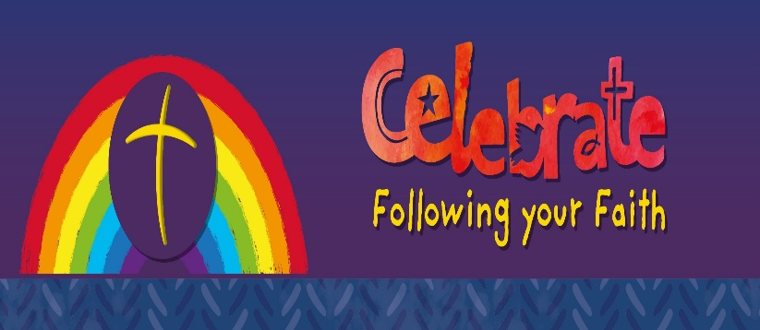

Children’s Liturgy
A short liturgical resource to help you with praying together and listening to the Word of God as a family has been prepared by Redemptorist Publications and can be viewed on the link below:

https://youtu.be/jTj3XOr_1sE

What’s Going On in our Local Parish Communities

Here is a link to the Erdington Abbey parish newsletter:
http://www.erdingtonabbey.co.uk/eacontent/uploads/2021/05/Bulletin-6th-Sunday-of-Easter-9-May-21.pdf

Here is a link to the parish newsletter of St. Nicholas Church in Boldmere:
https://www.stnicholasboldmere.co.uk/uploads/6/2/5/9/62597781/easter_6.pdf

Here is a copy of the parish newsletter of Christ the King Church in Kingstanding:

Here is a copy of the parish newsletter of St. Margaret Mary’s, Perry Common:

Here is a link to the parish newsletter of Holy Cross & St. Francis Church in Walmley:
https://www.hcsf.org.uk/bulletin-for-the-week-beginning-9th-may-the-sixth-sunday-of-easter/

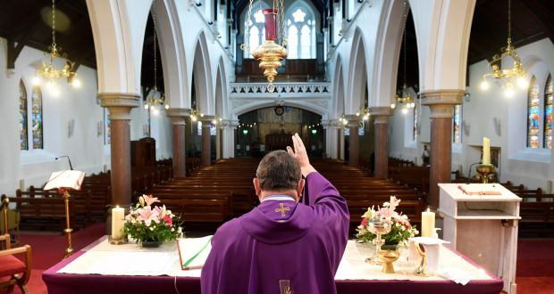
Mass Online
You will be able to access mass each day and every Sunday streamed live from St. Chad’s Cathedral and here is the link to access these:
www.stchadscathedral.org.uk

Redemptorist Publications also continue to make Sunday mass available online after 12 midday every Saturday. Mass is celebrated by Fr. Denis McBride C.Ss.R from the Redemptorist community in Chawton, Hampshire.
www.rpbooks.co.uk/holy-mass-online

Scripture Reflection – 7th Sunday of Easter Acts 1:15-17, 20-26. John 17:11-19
In the gospel of John this week Jesus, aware of his pending arrest which will lead to his crucifixion, suffering and death, is not praying to God his Father for himself but for his disciples. This prayer can be summarized with these simple few words,

‘That they be one like us.’

His prayer for his disciples and friends was that they be true to his name after he was no longer with them and that they be sent into the world to spread the truth.

Fortunately for us all the disciples did continue to see that their mission was only just beginning after they had witnessed the resurrection, as we read in the Acts of the Apostles that they chose Matthias to bring their number back to twelve after the betrayal of Judas.

He was called by God just as we are.

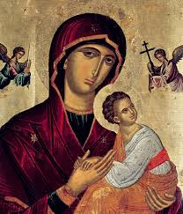
The month of May is dedicated to Our Lady

Holy Mary, Mother of God,
you have given the world its true light,
Jesus your Son – the Son of God.
You abandoned yourself completely to God’s call
and thus became a wellspring of the goodness
which flows forth from him.
Show us Jesus.
Lead us to him.
Teach us to know him and love him so that
we too can become capable of true love
and be fountains of living water
in the midst of a thirsting world. Amen.

Pope Benedict XVI

