The Wednesday Word this week Wednesday 30th June 2021 is ‘Welcome’ The Gospel is from Mark 6: 1-6 14th Sunday of Ordinary time.
The Catholic Values this term are Faithfilled and Hopeful.
The Gospel Mk 6: 1-6
Jesus went to his hometown and his disciples accompanied him. With the coming of the sabbath he began teaching in the synagogue and most of them were astonished when they heard him. They said,
“Where did the man get all this? What is this wisdom that has been granted him, and these miracles that are worked through him? This is the carpenter, surely, the son of Mary, the brother of James and Joset and Jude and Simon? His sisters, too, are they not here with us?” And they would not accept him. And Jesus said to them, “A prophet is only despised in his own country among his own relations and in his own house.” And he could work no miracle there, though he cured a few sick people by laying his hands on them. He was amazed at their lack of faith.
So what does the Gospel teach us?
Well, the people who were most familiar with Jesus welcomed him at first. They readily acknowledged his wisdom and his miracles. But they were not prepared to put their faith in him, to go further and see that God was at work in him and so, in the end, they rejected Jesus.
Although it’s good to admire Jesus, it’s putting our faith in him which helps us to realize that he is the Son of God – the incredible presence of God on earth among us. If we recognise this and welcome Jesus into our lives, then he has a chance to work among us, to strengthen us and to guide us to do good in the world.
Enjoy a special time together listening to your child’s thoughts about this Sunday’s Gospel and this Wednesday’s word, which is WELCOME. 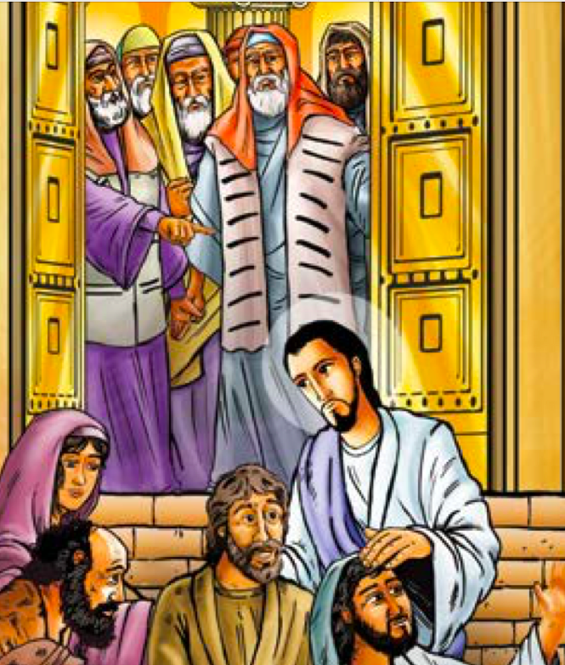 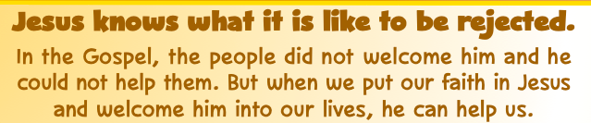
  - Dear Lord Jesus, Please help us to welcome all visitors into our home.St John Fisher….Pray for us!
“Let us be challenged by Jesus’ words and actions and welcome his call.” (Pope Francis)
Pope Francis

St John Fisher ….Pray for us!

